Java Tutorial

Our core Java programming tutorial is designed for students and working professionals. Java is an [object-oriented](https://www.javatpoint.com/java-oops-concepts), class-based, concurrent, secured and general-purpose computer-programming language. It is a widely used robust technology.

What is Java?

Java is a **programming language** and a **platform**. Java is a high level, robust, object-oriented and secure programming language.

Java was developed by *Sun Microsystems* (which is now the subsidiary of Oracle) in the year 1995. *James Gosling* is known as the father of Java. Before Java, its name was *Oak*. Since Oak was already a registered company, so James Gosling and his team changed the name from Oak to Java.

**Platform**: Any hardware or software environment in which a program runs, is known as a platform. Since Java has a runtime environment (JRE) and API, it is called a platform.

170.9K

13 Clever Gimbal Tricks You Need to Master

Java Example

Let's have a quick look at Java programming example. A detailed description of Hello Java example is available in next page.

**Simple.java**

1. **class** Simple{
2. **public** **static** **void** main(String args[]){
3. System.out.println("Hello Java");
4. }
5. }

[**Test it Now**](https://compiler.javatpoint.com/opr/test.jsp?filename=Simple)

Application

According to Sun, 3 billion devices run Java. There are many devices where Java is currently used. Some of them are as follows:

1. Desktop Applications such as acrobat reader, media player, antivirus, etc.
2. Web Applications such as irctc.co.in, javatpoint.com, etc.
3. Enterprise Applications such as banking applications.
4. Mobile
5. Embedded System
6. Smart Card
7. Robotics
8. Games, etc.

Types of Java Applications

There are mainly 4 types of applications that can be created using Java programming:

1) Standalone Application

Standalone applications are also known as desktop applications or window-based applications. These are traditional software that we need to install on every machine. Examples of standalone application are Media player, antivirus, etc. AWT and Swing are used in Java for creating standalone applications.

2) Web Application

An application that runs on the server side and creates a dynamic page is called a web application. Currently, [Servlet](https://www.javatpoint.com/servlet-tutorial), [JSP](https://www.javatpoint.com/jsp-tutorial), [Struts](https://www.javatpoint.com/struts-2-tutorial), [Spring](https://www.javatpoint.com/spring-tutorial), [Hibernate](https://www.javatpoint.com/hibernate-tutorial), [JSF](https://www.javatpoint.com/jsf-tutorial), etc. technologies are used for creating web applications in Java.

3) Enterprise Application

An application that is distributed in nature, such as banking applications, etc. is called an enterprise application. It has advantages like high-level security, load balancing, and clustering. In Java, [EJB](https://www.javatpoint.com/ejb-tutorial) is used for creating enterprise applications.

4) Mobile Application

An application which is created for mobile devices is called a mobile application. Currently, Android and Java ME are used for creating mobile applications.

Java Platforms / Editions

There are 4 platforms or editions of Java:

1) Java SE (Java Standard Edition)

It is a Java programming platform. It includes Java programming APIs such as java.lang, java.io, java.net, java.util, java.sql, java.math etc. It includes core topics like OOPs, [String](https://www.javatpoint.com/java-string), Regex, Exception, Inner classes, Multithreading, I/O Stream, Networking, AWT, Swing, Reflection, Collection, etc.

2) Java EE (Java Enterprise Edition)

It is an enterprise platform that is mainly used to develop web and enterprise applications. It is built on top of the Java SE platform. It includes topics like Servlet, JSP, Web Services, EJB, [JPA](https://www.javatpoint.com/jpa-tutorial), etc.

3) Java ME (Java Micro Edition)

It is a micro platform that is dedicated to mobile applications.

4) JavaFX

It is used to develop rich internet applications. It uses a lightweight user interface API

# History of Java

1. [History of Java](https://www.javatpoint.com/history-of-java)
2. [Java Version History](https://www.javatpoint.com/history-of-java#version)

The history of Java is very interesting. Java was originally designed for interactive television, but it was too advanced technology for the digital cable television industry at the time. The history of Java starts with the Green Team. Java team members (also known as Green Team), initiated this project to develop a language for digital devices such as set-top boxes, televisions, etc. However, it was best suited for internet programming. Later, Java technology was incorporated by Netscape.

The principles for creating Java programming were "Simple, Robust, Portable, Platform-independent, Secured, High Performance, Multithreaded, Architecture Neutral, Object-Oriented, Interpreted, and Dynamic". [Java](https://www.javatpoint.com/java-tutorial) was developed by James Gosling, who is known as the father of Java, in 1995. James Gosling and his team members started the project in the early '90s.



Currently, Java is used in internet programming, mobile devices, games, e-business solutions, etc. Following are given significant points that describe the history of Java.

1) [**James Gosling**](https://www.javatpoint.com/james-gosling-father-of-java)**, Mike Sheridan**, and **Patrick Naughton** initiated the Java language project in June 1991. The small team of sun engineers called **Green Team**.

30.3M

703

OOPs Concepts in Java

2) Initially it was designed for small, [embedded systems](https://www.javatpoint.com/embedded-system-tutorial) in electronic appliances like set-top boxes.

3) Firstly, it was called **"Greentalk"** by James Gosling, and the file extension was .gt.

4) After that, it was called **Oak** and was developed as a part of the Green project.

## Why Java was named as "Oak"?

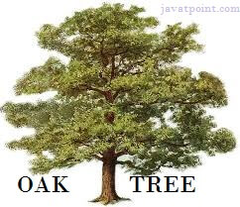

5) **Why Oak?** Oak is a symbol of strength and chosen as a national tree of many countries like the U.S.A., France, Germany, Romania, etc.

6) In 1995, Oak was renamed as **"Java"** because it was already a trademark by Oak Technologies.

## Why Java Programming named "Java"?

7) Why had they chose the name Java for Java language? The team gathered to choose a new name. The suggested words were "dynamic", "revolutionary", "Silk", "jolt", "DNA", etc. They wanted something that reflected the essence of the technology: revolutionary, dynamic, lively, cool, unique, and easy to spell, and fun to say.

According to James Gosling, "Java was one of the top choices along with **Silk**". Since Java was so unique, most of the team members preferred Java than other names.

8) Java is an island in Indonesia where the first coffee was produced (called Java coffee). It is a kind of espresso bean. Java name was chosen by James Gosling while having a cup of coffee nearby his office.

9) Notice that Java is just a name, not an acronym.

10) Initially developed by James Gosling at [Sun Microsystems](https://www.javatpoint.com/sun-microsystems) (which is now a subsidiary of Oracle Corporation) and released in 1995.

11) In 1995, Time magazine called **Java one of the Ten Best Products of 1995**.

12) JDK 1.0 was released on January 23, 1996. After the first release of Java, there have been many additional features added to the language. Now Java is being used in Windows applications, Web applications, enterprise applications, mobile applications, cards, etc. Each new version adds new features in Java.

### **Java Version History**

Many java versions have been released till now. The current stable release of Java is Java SE 10.

1. JDK Alpha and Beta (1995)
2. JDK 1.0 (23rd Jan 1996)
3. JDK 1.1 (19th Feb 1997)
4. J2SE 1.2 (8th Dec 1998)
5. J2SE 1.3 (8th May 2000)
6. J2SE 1.4 (6th Feb 2002)
7. J2SE 5.0 (30th Sep 2004)
8. Java SE 6 (11th Dec 2006)
9. Java SE 7 (28th July 2011)
10. Java SE 8 (18th Mar 2014)
11. Java SE 9 (21st Sep 2017)
12. Java SE 10 (20th Mar 2018)
13. Java SE 11 (September 2018)
14. Java SE 12 (March 2019)
15. Java SE 13 (September 2019)
16. Java SE 14 (Mar 2020)
17. Java SE 15 (September 2020)
18. Java SE 16 (Mar 2021)
19. Java SE 17 (September 2021)
20. Java SE 18 (to be released by March 2022)

Since Java SE 8 release, the Oracle corporation follows a pattern in which every even version is release in March month and an odd version released in September month.

# Features of Java

The primary objective of [Java programming](https://www.javatpoint.com/java-tutorial) language creation was to make it portable, simple and secure programming language. Apart from this, there are also some excellent features which play an important role in the popularity of this language. The features of Java are also known as Java buzzwords.

A list of the most important features of the Java language is given below.

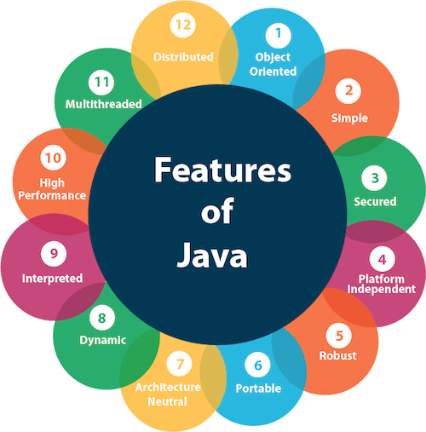

1. [Simple](https://www.javatpoint.com/features-of-java#Simple)
2. [Object-Oriented](https://www.javatpoint.com/features-of-java#Object-Oriented)
3. [Portable](https://www.javatpoint.com/features-of-java#Portable)
4. [Platform independent](https://www.javatpoint.com/features-of-java#Platform-independent)
5. [Secured](https://www.javatpoint.com/features-of-java#Secured)
6. [Robust](https://www.javatpoint.com/features-of-java#Robust)
7. [Architecture neutral](https://www.javatpoint.com/features-of-java#Architecture-neutral)
8. [Interpreted](https://www.javatpoint.com/features-of-java#Interpreted)
9. [High Performance](https://www.javatpoint.com/features-of-java#High-Performance)
10. [Multithreaded](https://www.javatpoint.com/features-of-java#Multithreaded)
11. [Distributed](https://www.javatpoint.com/features-of-java#Distributed)
12. [Dynamic](https://www.javatpoint.com/features-of-java#Dynamic)

### **Simple**

Java is very easy to learn, and its syntax is simple, clean and easy to understand. According to Sun Microsystem, Java language is a simple programming language because:

* Java syntax is based on C++ (so easier for programmers to learn it after C++).
* Java has removed many complicated and rarely-used features, for example, explicit pointers, operator overloading, etc.
* There is no need to remove unreferenced objects because there is an Automatic Garbage Collection in Java.

### **Object-oriented**

Java is an [object-oriented](https://www.javatpoint.com/java-oops-concepts) programming language. Everything in Java is an object. Object-oriented means we organize our software as a combination of different types of objects that incorporate both data and behavior.

32.4M

741

Features of Java - Javatpoint

Object-oriented programming (OOPs) is a methodology that simplifies software development and maintenance by providing some rules.

Basic concepts of OOPs are:

1. [Object](https://www.javatpoint.com/object-and-class-in-java)
2. [Class](https://www.javatpoint.com/object-and-class-in-java#class)
3. [Inheritance](https://www.javatpoint.com/inheritance-in-java)
4. [Polymorphism](https://www.javatpoint.com/runtime-polymorphism-in-java)
5. [Abstraction](https://www.javatpoint.com/abstract-class-in-java)
6. [Encapsulation](https://www.javatpoint.com/encapsulation)

### **Platform Independent**

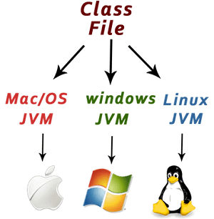

Java is platform independent because it is different from other languages like [C](https://www.javatpoint.com/c-programming-language-tutorial), [C++](https://www.javatpoint.com/cpp-tutorial), etc. which are compiled into platform specific machines while Java is a write once, run anywhere language. A platform is the hardware or software environment in which a program runs.

There are two types of platforms software-based and hardware-based. Java provides a software-based platform.

The Java platform differs from most other platforms in the sense that it is a software-based platform that runs on top of other hardware-based platforms. It has two components:

1. Runtime Environment
2. API(Application Programming Interface)

Java code can be executed on multiple platforms, for example, Windows, Linux, Sun Solaris, Mac/OS, etc. Java code is compiled by the compiler and converted into bytecode. This bytecode is a platform-independent code because it can be run on multiple platforms, i.e., Write Once and Run Anywhere (WORA).

### **Secured**

Java is best known for its security. With Java, we can develop virus-free systems. Java is secured because:

* **No explicit pointer**
* **Java Programs run inside a virtual machine sandbox**

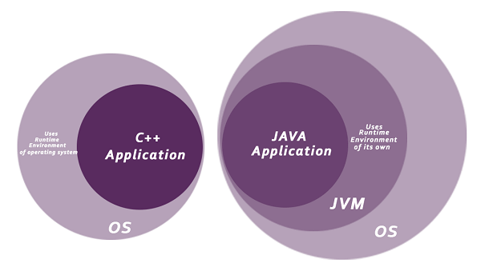

* **Classloader:** Classloader in Java is a part of the Java Runtime Environment (JRE) which is used to load Java classes into the Java Virtual Machine dynamically. It adds security by separating the package for the classes of the local file system from those that are imported from network sources.
* **Bytecode Verifier:** It checks the code fragments for illegal code that can violate access rights to objects.
* **Security Manager:** It determines what resources a class can access such as reading and writing to the local disk.

Java language provides these securities by default. Some security can also be provided by an application developer explicitly through SSL, JAAS, Cryptography, etc.

### **Robust**

The English mining of Robust is strong. Java is robust because:

* It uses strong memory management.
* There is a lack of pointers that avoids security problems.
* Java provides automatic garbage collection which runs on the Java Virtual Machine to get rid of objects which are not being used by a Java application anymore.
* There are exception handling and the type checking mechanism in Java. All these points make Java robust.

### **Architecture-neutral**

Java is architecture neutral because there are no implementation dependent features, for example, the size of primitive types is fixed.

In C programming, int data type occupies 2 bytes of memory for 32-bit architecture and 4 bytes of memory for 64-bit architecture. However, it occupies 4 bytes of memory for both 32 and 64-bit architectures in Java.

### **Portable**

Java is portable because it facilitates you to carry the Java bytecode to any platform. It doesn't require any implementation.

### **High-performance**

Java is faster than other traditional interpreted programming languages because Java bytecode is "close" to native code. It is still a little bit slower than a compiled language (e.g., C++). Java is an interpreted language that is why it is slower than compiled languages, e.g., C, C++, etc.

### **Distributed**

Java is distributed because it facilitates users to create distributed applications in Java. RMI and EJB are used for creating distributed applications. This feature of Java makes us able to access files by calling the methods from any machine on the internet.

### **Multi-threaded**

A thread is like a separate program, executing concurrently. We can write Java programs that deal with many tasks at once by defining multiple threads. The main advantage of multi-threading is that it doesn't occupy memory for each thread. It shares a common memory area. Threads are important for multi-media, Web applications, etc.

### **Dynamic**

Java is a dynamic language. It supports the dynamic loading of classes. It means classes are loaded on demand. It also supports functions from its native languages, i.e., C and C++.

Java supports dynamic compilation and automatic memory management (garbage collection).

C++ vs Java

There are many differences and similarities between the [C++ programming](https://www.javatpoint.com/cpp-tutorial) language and [Java](https://www.javatpoint.com/java-tutorial). A list of top differences between C++ and Java are given below:

|  |  |  |
| --- | --- | --- |
| **Comparison Index** | **C++** | **Java** |
| **Platform-independent** | C++ is platform-dependent. | Java is platform-independent. |
| **Mainly used for** | C++ is mainly used for system programming. | Java is mainly used for application programming. It is widely used in Windows-based, web-based, enterprise, and mobile applications. |
| **Design Goal** | C++ was designed for systems and applications programming. It was an extension of the [C programming language](https://www.javatpoint.com/c-programming-language-tutorial). | Java was designed and created as an interpreter for printing systems but later extended as a support network computing. It was designed to be easy to use and accessible to a broader audience. |
| **Goto** | C++ supports the [goto](https://www.javatpoint.com/cpp-goto-statement) statement. | Java doesn't support the goto statement. |
| **Multiple inheritance** | C++ supports multiple inheritance. | Java doesn't support multiple inheritance through class. It can be achieved by using [interfaces in java](https://www.javatpoint.com/interface-in-java). |
| **Operator Overloading** | C++ supports [operator overloading](https://www.javatpoint.com/cpp-overloading). | Java doesn't support operator overloading. |
| **Pointers** | C++ supports [pointers](https://www.javatpoint.com/cpp-pointers). You can write a pointer program in C++. | Java supports pointer internally. However, you can't write the pointer program in java. It means java has restricted pointer support in java. |
| **Compiler and Interpreter** | C++ uses compiler only. C++ is compiled and run using the compiler which converts source code into machine code so, C++ is platform dependent. | Java uses both compiler and interpreter. Java source code is converted into bytecode at compilation time. The interpreter executes this bytecode at runtime and produces output. Java is interpreted that is why it is platform-independent. |
| **Call by Value and Call by reference** | C++ supports both call by value and call by reference. | Java supports call by value only. There is no call by reference in java. |
| **Structure and Union** | C++ supports structures and unions. | Java doesn't support structures and unions. |
| **Thread Support** | C++ doesn't have built-in support for threads. It relies on third-party libraries for thread support. | Java has built-in [thread](https://www.javatpoint.com/multithreading-in-java) support. |
| **Documentation comment** | C++ doesn't support documentation comments. | Java supports documentation comment (/\*\* ... \*/) to create documentation for java source code. |
| **Virtual Keyword** | C++ supports virtual keyword so that we can decide whether or not to override a function. | Java has no virtual keyword. We can override all non-static methods by default. In other words, non-static methods are virtual by default. |
| **unsigned right shift >>>** | C++ doesn't support >>> operator. | Java supports unsigned right shift >>> operator that fills zero at the top for the negative numbers. For positive numbers, it works same like >> operator. |
| **Inheritance Tree** | C++ always creates a new inheritance tree. | Java always uses a single inheritance tree because all classes are the child of the Object class in Java. The Object class is the root of the [inheritance](https://www.javatpoint.com/inheritance-in-java) tree in java. |
| **Hardware** | C++ is nearer to hardware. | Java is not so interactive with hardware. |
| **Object-oriented** | C++ is an object-oriented language. However, in the C language, a single root hierarchy is not possible. | Java is also an [object-oriented](https://www.javatpoint.com/java-oops-concepts) language. However, everything (except fundamental types) is an object in Java. It is a single root hierarchy as everything gets derived from java.lang.Object. |

**Note**

* Java doesn't support default arguments like C++.
* Java does not support header files like C++. Java uses the import keyword to include different classes and methods.

C++ Program Example

File: main.cpp

1. #include <iostream>
2. **using** **namespace** std;
3. **int** main() {
4. cout << "Hello C++ Programming";
5. **return** 0;
6. }

**Output:**

14.3M

230

Triggers in SQL (Hindi)

Hello C++ Programming

Java Program Example

File: Simple.java

1. **class** Simple{
2. **public** **static** **void** main(String args[]){
3. System.out.println("Hello Java");
4. }
5. }

**Output:**

Hello Java

# First Java Program | Hello World Example

1. [Software Requirements](https://www.javatpoint.com/simple-program-of-java#hellojavareq)
2. [Creating Hello Java Example](https://www.javatpoint.com/simple-program-of-java#hellojavaex)
3. [Resolving javac is not recognized](https://www.javatpoint.com/simple-program-of-java#hellojavawhatjavacnot)

In this section, we will learn how to write the simple program of Java. We can write a simple hello Java program easily after installing the JDK.

To create a simple Java program, you need to create a class that contains the main method. Let's understand the requirement first.

### **The requirement for Java Hello World Example**

For executing any Java program, the following software or application must be properly installed.

* Install the JDK if you don't have installed it, [download the JDK](http://www.oracle.com/technetwork/java/javase/downloads/index.html) and install it.
* Set path of the jdk/bin directory. [http://www.javatpoint.com/how-to-set-path-in-java](https://www.javatpoint.com/how-to-set-path-in-java)
* Create the Java program
* Compile and run the Java program

### **Creating Hello World Example**

Let's create the hello java program:

30.3M

703

OOPs Concepts in Java

1. **class** Simple{
2. **public** **static** **void** main(String args[]){
3. System.out.println("Hello Java");
4. }
5. }

[**Test it Now**](https://www.javatpoint.com/opr/test.jsp?filename=Simple)

Save the above file as Simple.java.

|  |  |
| --- | --- |
| **To compile:** | javac Simple.java |
| **To execute:** | java Simple |

**Output:**

Hello Java

**Compilation Flow:**

When we compile Java program using javac tool, the Java compiler converts the source code into byte code.

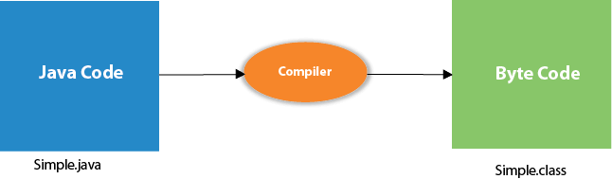

## Parameters used in First Java Program

Let's see what is the meaning of class, public, static, void, main, String[], System.out.println().

* **class** keyword is used to declare a class in Java.
* **public** keyword is an access modifier that represents visibility. It means it is visible to all.
* **static** is a keyword. If we declare any method as static, it is known as the static method. The core advantage of the static method is that there is no need to create an object to invoke the static method. The main() method is executed by the JVM, so it doesn't require creating an object to invoke the main() method. So, it saves memory.
* **void** is the return type of the method. It means it doesn't return any value.
* **main** represents the starting point of the program.
* **String[] args** or **String args[]** is used for [command line argument](https://www.javatpoint.com/command-line-argument). We will discuss it in coming section.
* **System.out.println()** is used to print statement. Here, System is a class, out is an object of the PrintStream class, println() is a method of the PrintStream class. We will discuss the internal working of [System.out.println()](https://www.javatpoint.com/system-out-println-in-java) statement in the coming section.

To write the simple program, you need to open notepad by **start menu -> All Programs -> Accessories -> Notepad** and write a simple program as we have shownbelow:

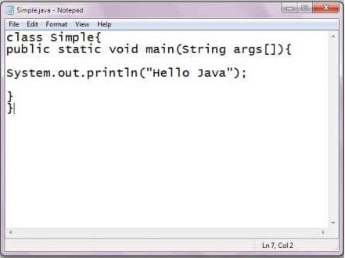

As displayed in the above diagram, write the simple program of Java in notepad and saved it as Simple.java. In order to compile and run the above program, you need to open the command prompt by **start menu -> All Programs -> Accessories -> command prompt**. When we have done with all the steps properly, it shows the following output:

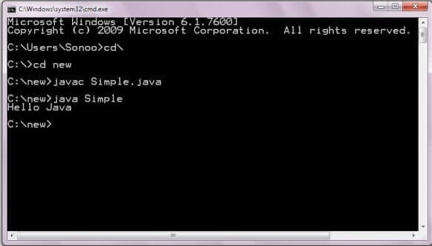

To compile and run the above program, go to your current directory first; my current directory is c:\new. Write here:

|  |  |
| --- | --- |
| **To compile:** | javac Simple.java |
| **To execute:** | java Simple |

## In how many ways we can write a Java program?

There are many ways to write a Java program. The modifications that can be done in a Java program are given below:

**1) By changing the sequence of the modifiers, method prototype is not changed in Java.**

Let's see the simple code of the main method.

1. **static** **public** **void** main(String args[])

**2) The subscript notation in the Java array can be used after type, before the variable or after the variable.**

Let's see the different codes to write the main method.

1. **public** **static** **void** main(String[] args)
2. **public** **static** **void** main(String []args)
3. **public** **static** **void** main(String args[])

**3) You can provide var-args support to the main() method by passing 3 ellipses (dots)**

Let's see the simple code of using var-args in the main() method. We will learn about var-args later in the Java New Features chapter.

1. **public** **static** **void** main(String... args)

**4) Having a semicolon at the end of class is optional in Java.**

Let's see the simple code.

1. **class** A{
2. **static** **public** **void** main(String... args){
3. System.out.println("hello java4");
4. }
5. };

## Valid Java main() method signature

1. **public** **static** **void** main(String[] args)
2. **public** **static** **void** main(String []args)
3. **public** **static** **void** main(String args[])
4. **public** **static** **void** main(String... args)
5. **static** **public** **void** main(String[] args)
6. **public** **static** **final** **void** main(String[] args)
7. **final** **public** **static** **void** main(String[] args)
8. **final** **strictfp** **public** **static** **void** main(String[] args)

## Invalid Java main() method signature

1. **public** **void** main(String[] args)
2. **static** **void** main(String[] args)
3. **public** **void** **static** main(String[] args)
4. **abstract** **public** **static** **void** main(String[] args)

### **Resolving an error "javac is not recognized as an internal or external command"?**

If there occurs a problem like displayed in the below figure, you need to set a path. Since DOS doesn't recognize javac and java as internal or external command. To overcome this problem, we need to set a path. The path is not required in a case where you save your program inside the JDK/bin directory. However, it is an excellent approach to set the path. Click here for [How to set path in java](https://www.javatpoint.com/how-to-set-path-in-java).

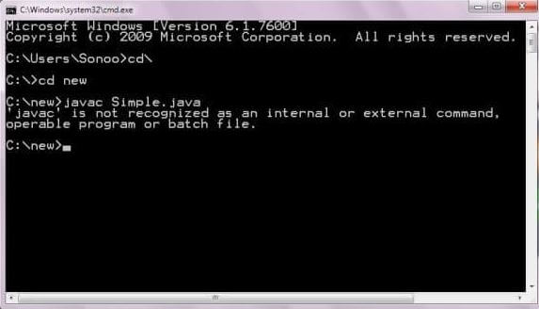

# Internal Details of Hello Java Program

In the previous section, we have created Java Hello World program and learn how to compile and run a Java program. In this section, we are going to learn, what happens while we compile and run the Java program. Moreover, we will see some questions based on the first program.

## What happens at compile time?

At compile time, the Java file is compiled by Java Compiler (It does not interact with OS) and converts the Java code into bytecode.



## What happens at runtime?

At runtime, the following steps are performed:

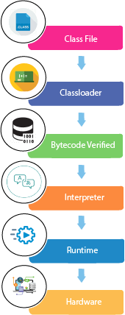

**Classloader:** It is the subsystem of JVM that is used to load class files.

26.6M

531

Java Try Catch

**Bytecode Verifier:** Checks the code fragments for illegal code that can violate access rights to objects.

**Interpreter:** Read bytecode stream then execute the instructions.

### **Q) Can you save a Java source file by another name than the class name?**

Yes, if the class is not public. It is explained in the figure given below:

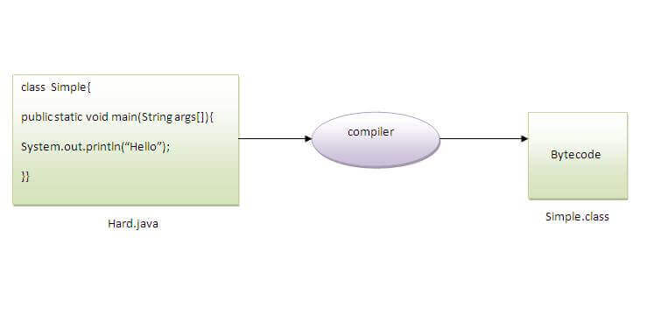

|  |  |
| --- | --- |
| **To compile:** | javac Hard.java |
| **To execute:** | java Simple |

Observe that, we have compiled the code with file name but running the program with class name. Therefore, we can save a Java program other than class name.

### **Q) Can you have multiple classes in a java source file?**

Yes, like the figure given below illustrates:

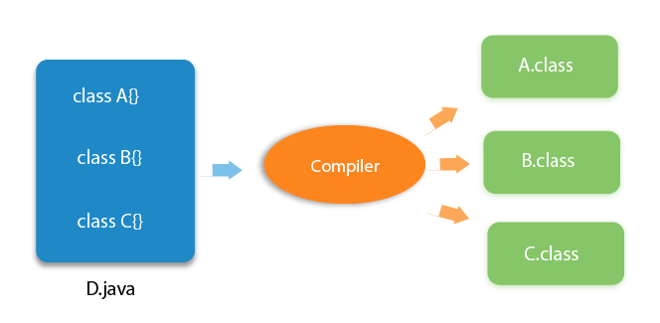

# How to set path in Java

1. [How to set the path of JDK in Windows OS](https://www.javatpoint.com/how-to-set-path-in-java)
   1. [Setting Temporary Path of JDK](https://www.javatpoint.com/how-to-set-path-in-java#pathtemporary)
   2. [Setting Permanent Path of JDK](https://www.javatpoint.com/how-to-set-path-in-java#pathpermanent)
2. [How to set the path of JDK in Linux OS](https://www.javatpoint.com/how-to-set-path-in-java#pathlinux)

The path is required to be set for using tools such as javac, java, etc.

If you are saving the Java source file inside the JDK/bin directory, the path is not required to be set because all the tools will be available in the current directory.

However, if you have your Java file outside the JDK/bin folder, it is necessary to set the path of JDK.

There are two ways to set the path in Java:

33.3M

570

Hello Java Program for Beginners

1. Temporary
2. Permanent

## 1) How to set the Temporary Path of JDK in Windows

To set the temporary path of JDK, you need to follow the following steps:

* Open the command prompt
* Copy the path of the JDK/bin directory
* Write in command prompt: set path=copied\_path

### **For Example:**

set path=C:\Program Files\Java\jdk1.6.0\_23\bin

Let's see it in the figure given below:

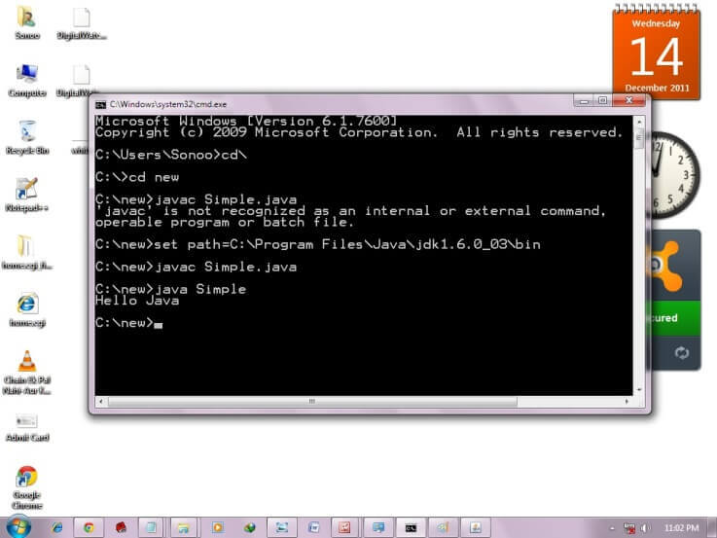

## 2) How to set Permanent Path of JDK in Windows

For setting the permanent path of JDK, you need to follow these steps:

* Go to MyComputer properties -> advanced tab -> environment variables -> new tab of user variable -> write path in variable name -> write path of bin folder in variable value -> ok -> ok -> ok

### **For Example:**

|  |
| --- |
| **1) Go to MyComputer properties** |
| how to set path in java |
| **2) Click on the advanced tab** |
| how to set path in java |
| **3) Click on environment variables** |
| how to set path in java |
| **4) Click on the new tab of user variables** |
| how to set path in java |
| **5) Write the path in the variable name** |
| how to set path in java |
| **6) Copy the path of bin folder** |
| how to set path in java |
| **7) Paste path of bin folder in the variable value** |
| how to set path in java |
| **8) Click on ok button** |
| how to set path in java |
| **9) Click on ok button** |
| how to set path in java |

Now your permanent path is set. You can now execute any program of java from any drive.

### **Setting Java Path in Linux OS**

Setting path in Linux OS is the same as setting the path in the Windows OS. But, here we use the export tool rather than set. Let's see how to set path in Linux OS:

export PATH=$PATH:/home/jdk1.6.01/bin/

Here, we have installed the JDK in the home directory under Root (/home).

You may also like:

[How to set classpath in Java](https://www.javatpoint.com/how-to-set-classpath-in-java)

# Difference between JDK, JRE, and JVM

1. [A summary of JVM](https://www.javatpoint.com/difference-between-jdk-jre-and-jvm)
2. [Java Runtime Environment (JRE)](https://www.javatpoint.com/difference-between-jdk-jre-and-jvm#jre)
3. [Java Development Kit (JDK)](https://www.javatpoint.com/difference-between-jdk-jre-and-jvm#jdk)

We must understand the differences between JDK, JRE, and JVM before proceeding further to [Java](https://www.javatpoint.com/java-tutorial). See the brief overview of JVM here.

If you want to get the detailed knowledge of Java Virtual Machine, move to the next page. Firstly, let's see the differences between the JDK, JRE, and JVM.

### **JVM**

JVM (Java Virtual Machine) is an abstract machine. It is called a virtual machine because it doesn't physically exist. It is a specification that provides a runtime environment in which Java bytecode can be executed. It can also run those programs which are written in other languages and compiled to Java bytecode.

JVMs are available for many hardware and software platforms. JVM, JRE, and JDK are platform dependent because the configuration of each [OS](https://www.javatpoint.com/os-tutorial) is different from each other. However, Java is platform independent. There are three notions of the JVM: specification, implementation, and instance.

How to find Nth Highest Salary in SQL

The JVM performs the following main tasks:

* Loads code
* Verifies code
* Executes code
* Provides runtime environment

[More Details.](https://www.javatpoint.com/internal-details-of-jvm)

### **JRE**

JRE is an acronym for Java Runtime Environment. It is also written as Java RTE. The Java Runtime Environment is a set of software tools which are used for developing Java applications. It is used to provide the runtime environment. It is the implementation of JVM. It physically exists. It contains a set of libraries + other files that JVM uses at runtime.

The implementation of JVM is also actively released by other companies besides Sun Micro Systems.

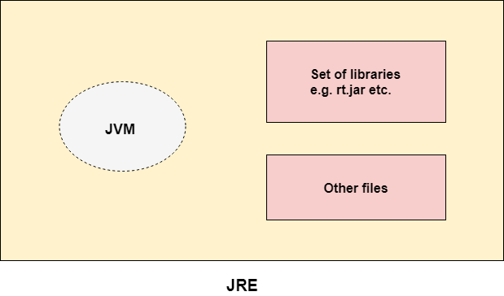

### **JDK**

JDK is an acronym for Java Development Kit. The Java Development Kit (JDK) is a software development environment which is used to develop Java applications and [applets](https://www.javatpoint.com/java-applet). It physically exists. It contains JRE + development tools.

JDK is an implementation of any one of the below given Java Platforms released by Oracle Corporation:

* Standard Edition Java Platform
* Enterprise Edition Java Platform
* Micro Edition Java Platform

The JDK contains a private Java Virtual Machine (JVM) and a few other resources such as an interpreter/loader (java), a compiler (javac), an archiver (jar), a documentation generator (Javadoc), etc. to complete the development of a Java Application.

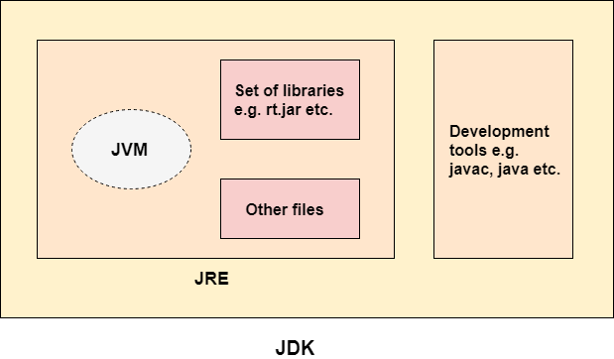

# JVM (Java Virtual Machine) Architecture

1. [Java Virtual Machine](https://www.javatpoint.com/jvm-java-virtual-machine)
2. [Internal Architecture of JVM](https://www.javatpoint.com/jvm-java-virtual-machine#jvminternalarch)

JVM (Java Virtual Machine) is an abstract machine. It is a specification that provides runtime environment in which java bytecode can be executed.

JVMs are available for many hardware and software platforms (i.e. JVM is platform dependent).

### **What is JVM**

It is:

1. **A specification** where working of Java Virtual Machine is specified. But implementation provider is independent to choose the algorithm. Its implementation has been provided by Oracle and other companies.
2. **An implementation** Its implementation is known as JRE (Java Runtime Environment).
3. **Runtime Instance** Whenever you write java command on the command prompt to run the java class, an instance of JVM is created.

### **What it does**

The JVM performs following operation:

14.3M

230

Triggers in SQL (Hindi)

* Loads code
* Verifies code
* Executes code
* Provides runtime environment

JVM provides definitions for the:

* Memory area
* Class file format
* Register set
* Garbage-collected heap
* Fatal error reporting etc.

## JVM Architecture

Let's understand the internal architecture of JVM. It contains classloader, memory area, execution engine etc.

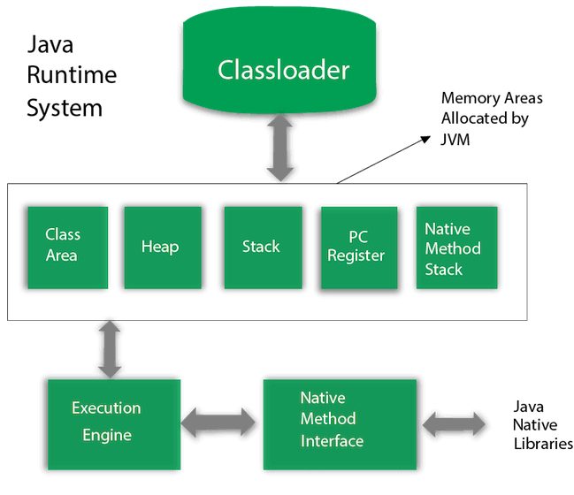

### **1) Classloader**

Classloader is a subsystem of JVM which is used to load class files. Whenever we run the java program, it is loaded first by the classloader. There are three built-in classloaders in Java.

1. **Bootstrap ClassLoader**: This is the first classloader which is the super class of Extension classloader. It loads the rt.jar file which contains all class files of Java Standard Edition like java.lang package classes, java.net package classes, java.util package classes, java.io package classes, java.sql package classes etc.
2. **Extension ClassLoader**: This is the child classloader of Bootstrap and parent classloader of System classloader. It loades the jar files located inside $JAVA\_HOME/jre/lib/ext directory.
3. **System/Application ClassLoader**: This is the child classloader of Extension classloader. It loads the classfiles from classpath. By default, classpath is set to current directory. You can change the classpath using "-cp" or "-classpath" switch. It is also known as Application classloader.
4. //Let's see an example to print the classloader name
5. **public** **class** ClassLoaderExample
6. {
7. **public** **static** **void** main(String[] args)
8. {
9. // Let's print the classloader name of current class.
10. //Application/System classloader will load this class
11. Class c=ClassLoaderExample.**class**;
12. System.out.println(c.getClassLoader());
13. //If we print the classloader name of String, it will print null because it is an
14. //in-built class which is found in rt.jar, so it is loaded by Bootstrap classloader
15. System.out.println(String.**class**.getClassLoader());
16. }
17. }

[**Test it Now**](https://compiler.javatpoint.com/opr/test.jsp?filename=ClassLoaderExample)

Output:

sun.misc.Launcher$AppClassLoader@4e0e2f2a

null

These are the internal classloaders provided by Java. If you want to create your own classloader, you need to extend the ClassLoader class.

### **2) Class(Method) Area**

Class(Method) Area stores per-class structures such as the runtime constant pool, field and method data, the code for methods.

### **3) Heap**

It is the runtime data area in which objects are allocated.

### **4) Stack**

Java Stack stores frames. It holds local variables and partial results, and plays a part in method invocation and return.

Each thread has a private JVM stack, created at the same time as thread.

A new frame is created each time a method is invoked. A frame is destroyed when its method invocation completes.

### **5) Program Counter Register**

PC (program counter) register contains the address of the Java virtual machine instruction currently being executed.

### **6) Native Method Stack**

It contains all the native methods used in the application.

### **7) Execution Engine**

It contains:

1. **A virtual processor**
2. **Interpreter:** Read bytecode stream then execute the instructions.
3. **Just-In-Time(JIT) compiler:** It is used to improve the performance. JIT compiles parts of the byte code that have similar functionality at the same time, and hence reduces the amount of time needed for compilation. Here, the term "compiler" refers to a translator from the instruction set of a Java virtual machine (JVM) to the instruction set of a specific CPU.

### **8) Java Native Interface**

Java Native Interface (JNI) is a framework which provides an interface to communicate with another application written in another language like C, C++, Assembly etc. Java uses JNI framework to send output to the Console or interact with OS libraries.

# Java Variables

A variable is a container which holds the value while the [Java program](https://www.javatpoint.com/simple-program-of-java) is executed. A variable is assigned with a data type.

Variable is a name of memory location. There are three types of variables in java: local, instance and static.

There are two types of [data types in Java](https://www.javatpoint.com/java-data-types): primitive and non-primitive.

## Variable

A variable is the name of a reserved area allocated in memory. In other words, it is a name of the memory location. It is a combination of "vary + able" which means its value can be changed.

32.4M

741

Features of Java - Javatpoint

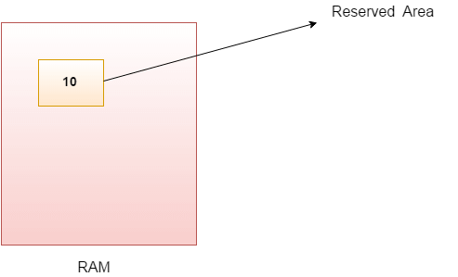

1. **int** data=50;//Here data is variable

### **Types of Variables**

There are three types of variables in [Java](https://www.javatpoint.com/java-tutorial):

* local variable
* instance variable
* static variable

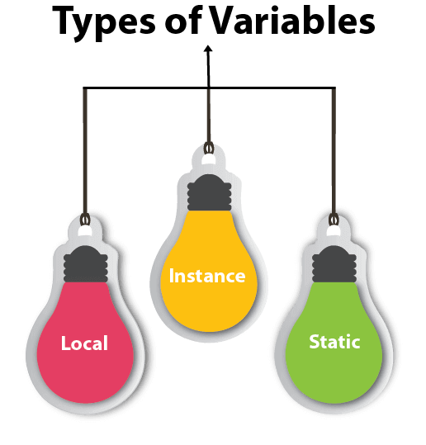

#### 1) Local Variable

A variable declared inside the body of the method is called local variable. You can use this variable only within that method and the other methods in the class aren't even aware that the variable exists.

A local variable cannot be defined with "static" keyword.

#### 2) Instance Variable

A variable declared inside the class but outside the body of the method, is called an instance variable. It is not declared as [static](https://www.javatpoint.com/static-keyword-in-java).

It is called an instance variable because its value is instance-specific and is not shared among instances.

#### 3) Static variable

A variable that is declared as static is called a static variable. It cannot be local. You can create a single copy of the static variable and share it among all the instances of the class. Memory allocation for static variables happens only once when the class is loaded in the memory.

### **Example to understand the types of variables in java**

1. **public** **class** A
2. {
3. **static** **int** m=100;//static variable
4. **void** method()
5. {
6. **int** n=90;//local variable
7. }
8. **public** **static** **void** main(String args[])
9. {
10. **int** data=50;//instance variable
11. }
12. }//end of class

### **Java Variable Example: Add Two Numbers**

1. **public** **class** Simple{
2. **public** **static** **void** main(String[] args){
3. **int** a=10;
4. **int** b=10;
5. **int** c=a+b;
6. System.out.println(c);
7. }
8. }

**Output:**

20

### **Java Variable Example: Widening**

1. **public** **class** Simple{
2. **public** **static** **void** main(String[] args){
3. **int** a=10;
4. **float** f=a;
5. System.out.println(a);
6. System.out.println(f);
7. }}

**Output:**

10

10.0

### **Java Variable Example: Narrowing (Typecasting)**

1. **public** **class** Simple{
2. **public** **static** **void** main(String[] args){
3. **float** f=10.5f;
4. //int a=f;//Compile time error
5. **int** a=(**int**)f;
6. System.out.println(f);
7. System.out.println(a);
8. }}

**Output:**

10.5

10

### **Java Variable Example: Overflow**

1. **class** Simple{
2. **public** **static** **void** main(String[] args){
3. //Overflow
4. **int** a=130;
5. **byte** b=(**byte**)a;
6. System.out.println(a);
7. System.out.println(b);
8. }}

**Output:**

130

-126

### **Java Variable Example: Adding Lower Type**

1. **class** Simple{
2. **public** **static** **void** main(String[] args){
3. **byte** a=10;
4. **byte** b=10;
5. //byte c=a+b;//Compile Time Error: because a+b=20 will be int
6. **byte** c=(**byte**)(a+b);
7. System.out.println(c);
8. }}

**Output:**

20

# Data Types in Java

Data types specify the different sizes and values that can be stored in the variable. There are two types of data types in Java:

1. **Primitive data types:** The primitive data types include boolean, char, byte, short, int, long, float and double.
2. **Non-primitive data types:** The non-primitive data types include [Classes](https://www.javatpoint.com/object-and-class-in-java), [Interfaces](https://www.javatpoint.com/interface-in-java), and [Arrays](https://www.javatpoint.com/array-in-java).

## Java Primitive Data Types

In Java language, primitive data types are the building blocks of data manipulation. These are the most basic data types available in [Java language](https://www.javatpoint.com/java-tutorial).

Java is a statically-typed programming language. It means, all [variables](https://www.javatpoint.com/java-variables) must be declared before its use. That is why we need to declare variable's type and name.

There are 8 types of primitive data types:

10 Sec

Prime Ministers of India | List of Prime Minister of India (1947-2020)

* boolean data type
* byte data type
* char data type
* short data type
* int data type
* long data type
* float data type
* double data type

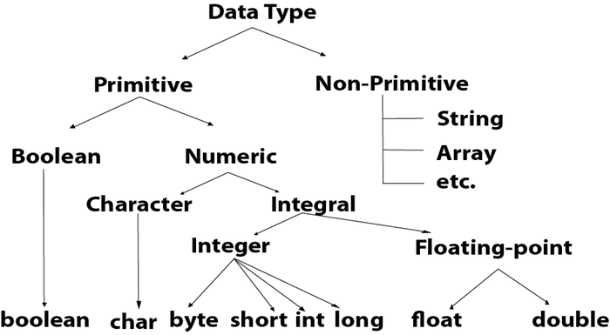

|  |  |  |
| --- | --- | --- |
| **Data Type** | **Default Value** | **Default size** |
| boolean | false | 1 bit |
| char | '\u0000' | 2 byte |
| byte | 0 | 1 byte |
| short | 0 | 2 byte |
| int | 0 | 4 byte |
| long | 0L | 8 byte |
| float | 0.0f | 4 byte |
| double | 0.0d | 8 byte |

## Boolean Data Type

The Boolean data type is used to store only two possible values: true and false. This data type is used for simple flags that track true/false conditions.

The Boolean data type specifies one bit of information, but its "size" can't be defined precisely.

**Example:**

1. Boolean one = **false**

## Byte Data Type

The byte data type is an example of primitive data type. It isan 8-bit signed two's complement integer. Its value-range lies between -128 to 127 (inclusive). Its minimum value is -128 and maximum value is 127. Its default value is 0.

The byte data type is used to save memory in large arrays where the memory savings is most required. It saves space because a byte is 4 times smaller than an integer. It can also be used in place of "int" data type.

**Example:**

1. **byte** a = 10, **byte** b = -20

## Short Data Type

The short data type is a 16-bit signed two's complement integer. Its value-range lies between -32,768 to 32,767 (inclusive). Its minimum value is -32,768 and maximum value is 32,767. Its default value is 0.

The short data type can also be used to save memory just like byte data type. A short data type is 2 times smaller than an integer.

**Example:**

1. **short** s = 10000, **short** r = -5000

## Int Data Type

The int data type is a 32-bit signed two's complement integer. Its value-range lies between - 2,147,483,648 (-2^31) to 2,147,483,647 (2^31 -1) (inclusive). Its minimum value is - 2,147,483,648and maximum value is 2,147,483,647. Its default value is 0.

The int data type is generally used as a default data type for integral values unless if there is no problem about memory.

**Example:**

1. **int** a = 100000, **int** b = -200000

## Long Data Type

The long data type is a 64-bit two's complement integer. Its value-range lies between -9,223,372,036,854,775,808(-2^63) to 9,223,372,036,854,775,807(2^63 -1)(inclusive). Its minimum value is - 9,223,372,036,854,775,808and maximum value is 9,223,372,036,854,775,807. Its default value is 0. The long data type is used when you need a range of values more than those provided by int.

**Example:**

1. **long** a = 100000L, **long** b = -200000L

## Float Data Type

The float data type is a single-precision 32-bit IEEE 754 floating point.Its value range is unlimited. It is recommended to use a float (instead of double) if you need to save memory in large arrays of floating point numbers. The float data type should never be used for precise values, such as currency. Its default value is 0.0F.

**Example:**

1. **float** f1 = 234.5f

## Double Data Type

The double data type is a double-precision 64-bit IEEE 754 floating point. Its value range is unlimited. The double data type is generally used for decimal values just like float. The double data type also should never be used for precise values, such as currency. Its default value is 0.0d.

**Example:**

1. **double** d1 = 12.3

## Char Data Type

The char data type is a single 16-bit Unicode character. Its value-range lies between '\u0000' (or 0) to '\uffff' (or 65,535 inclusive).The char data type is used to store characters.

**Example:**

1. **char** letterA = 'A'

### **Why char uses 2 byte in java and what is \u0000 ?**

It is because java uses Unicode system not ASCII code system. The \u0000 is the lowest range of Unicode system. To get detail explanation about Unicode visit next page.

# Unicode System

|  |
| --- |
| Unicode is a universal international standard character encoding that is capable of representing most of the world's written languages. |

### **Why java uses Unicode System?**

|  |
| --- |
| Before Unicode, there were many language standards: |
| * **ASCII** (American Standard Code for Information Interchange) for the United States. * **ISO 8859-1** for Western European Language. * **KOI-8** for Russian. * **GB18030 and BIG-5** for chinese, and so on. |

## Problem

|  |
| --- |
| **This caused two problems:**   1. A particular code value corresponds to different letters in the various language standards. 2. The encodings for languages with large character sets have variable length.Some common characters are encoded as single bytes, other require two or more byte. |

## Solution

|  |
| --- |
| To solve these problems, a new language standard was developed i.e. Unicode System. |
| In unicode, character holds 2 byte, so java also uses 2 byte for characters. |
| **lowest value:**\u0000 |
| **highest value:**\uFFFF |

# Operators in Java

**Operator** in [Java](https://www.javatpoint.com/java-tutorial) is a symbol that is used to perform operations. For example: +, -, \*, / etc.

There are many types of operators in Java which are given below:

* Unary Operator,
* Arithmetic Operator,
* Shift Operator,
* Relational Operator,
* Bitwise Operator,
* Logical Operator,
* Ternary Operator and
* Assignment Operator.

## Java Operator Precedence

|  |  |  |
| --- | --- | --- |
| **Operator Type** | **Category** | **Precedence** |
| Unary | postfix | expr++ expr-- |
| prefix | ++expr --expr +expr -expr ~ ! |
| Arithmetic | multiplicative | \* / % |
| additive | + - |
| Shift | shift | << >> >>> |
| Relational | comparison | < > <= >= instanceof |
| equality | == != |
| Bitwise | bitwise AND | & |
| bitwise exclusive OR | ^ |
| bitwise inclusive OR | | |
| Logical | logical AND | && |
| logical OR | || |
| Ternary | ternary | ? : |
| Assignment | assignment | = += -= \*= /= %= &= ^= |= <<= >>= >>>= |

### **Java Unary Operator**

The Java unary operators require only one operand. Unary operators are used to perform various operations i.e.:

32.7M

638

Difference between JDK, JRE, and JVM

* incrementing/decrementing a value by one
* negating an expression
* inverting the value of a boolean

### **Java Unary Operator Example: ++ and --**

1. **public** **class** OperatorExample{
2. **public** **static** **void** main(String args[]){
3. **int** x=10;
4. System.out.println(x++);//10 (11)
5. System.out.println(++x);//12
6. System.out.println(x--);//12 (11)
7. System.out.println(--x);//10
8. }}

**Output:**

10

12

12

10

### **Java Unary Operator Example 2: ++ and --**

1. **public** **class** OperatorExample{
2. **public** **static** **void** main(String args[]){
3. **int** a=10;
4. **int** b=10;
5. System.out.println(a++ + ++a);//10+12=22
6. System.out.println(b++ + b++);//10+11=21
8. }}

**Output:**

22

21

### **Java Unary Operator Example: ~ and !**

1. **public** **class** OperatorExample{
2. **public** **static** **void** main(String args[]){
3. **int** a=10;
4. **int** b=-10;
5. **boolean** c=**true**;
6. **boolean** d=**false**;
7. System.out.println(~a);//-11 (minus of total positive value which starts from 0)
8. System.out.println(~b);//9 (positive of total minus, positive starts from 0)
9. System.out.println(!c);//false (opposite of boolean value)
10. System.out.println(!d);//true
11. }}

**Output:**

-11

9

false

true

### **Java Arithmetic Operators**

Java arithmetic operators are used to perform addition, subtraction, multiplication, and division. They act as basic mathematical operations.

### **Java Arithmetic Operator Example**

1. **public** **class** OperatorExample{
2. **public** **static** **void** main(String args[]){
3. **int** a=10;
4. **int** b=5;
5. System.out.println(a+b);//15
6. System.out.println(a-b);//5
7. System.out.println(a\*b);//50
8. System.out.println(a/b);//2
9. System.out.println(a%b);//0
10. }}

**Output:**

15

5

50

2

0

### **Java Arithmetic Operator Example: Expression**

1. **public** **class** OperatorExample{
2. **public** **static** **void** main(String args[]){
3. System.out.println(10\*10/5+3-1\*4/2);
4. }}

**Output:**

21

### **Java Left Shift Operator**

The Java left shift operator << is used to shift all of the bits in a value to the left side of a specified number of times.

### **Java Left Shift Operator Example**

1. **public** **class** OperatorExample{
2. **public** **static** **void** main(String args[]){
3. System.out.println(10<<2);//10\*2^2=10\*4=40
4. System.out.println(10<<3);//10\*2^3=10\*8=80
5. System.out.println(20<<2);//20\*2^2=20\*4=80
6. System.out.println(15<<4);//15\*2^4=15\*16=240
7. }}

**Output:**

40

80

80

240

### **Java Right Shift Operator**

The Java right shift operator >> is used to move the value of the left operand to right by the number of bits specified by the right operand.

### **Java Right Shift Operator Example**

1. **public** OperatorExample{
2. **public** **static** **void** main(String args[]){
3. System.out.println(10>>2);//10/2^2=10/4=2
4. System.out.println(20>>2);//20/2^2=20/4=5
5. System.out.println(20>>3);//20/2^3=20/8=2
6. }}

**Output:**

2

5

2

### **Java Shift Operator Example: >> vs >>>**

1. **public** **class** OperatorExample{
2. **public** **static** **void** main(String args[]){
3. //For positive number, >> and >>> works same
4. System.out.println(20>>2);
5. System.out.println(20>>>2);
6. //For negative number, >>> changes parity bit (MSB) to 0
7. System.out.println(-20>>2);
8. System.out.println(-20>>>2);
9. }}

**Output:**

5

5

-5

1073741819

### **Java AND Operator Example: Logical && and Bitwise &**

The logical && operator doesn't check the second condition if the first condition is false. It checks the second condition only if the first one is true.

The bitwise & operator always checks both conditions whether first condition is true or false.

1. **public** **class** OperatorExample{
2. **public** **static** **void** main(String args[]){
3. **int** a=10;
4. **int** b=5;
5. **int** c=20;
6. System.out.println(a<b&&a<c);//false && true = false
7. System.out.println(a<b&a<c);//false & true = false
8. }}

**Output:**

false

false

### **Java AND Operator Example: Logical && vs Bitwise &**

1. **public** **class** OperatorExample{
2. **public** **static** **void** main(String args[]){
3. **int** a=10;
4. **int** b=5;
5. **int** c=20;
6. System.out.println(a<b&&a++<c);//false && true = false
7. System.out.println(a);//10 because second condition is not checked
8. System.out.println(a<b&a++<c);//false && true = false
9. System.out.println(a);//11 because second condition is checked
10. }}

**Output:**

false

10

false

11

### **Java OR Operator Example: Logical || and Bitwise |**

The logical || operator doesn't check the second condition if the first condition is true. It checks the second condition only if the first one is false.

The bitwise | operator always checks both conditions whether first condition is true or false.

1. **public** **class** OperatorExample{
2. **public** **static** **void** main(String args[]){
3. **int** a=10;
4. **int** b=5;
5. **int** c=20;
6. System.out.println(a>b||a<c);//true || true = true
7. System.out.println(a>b|a<c);//true | true = true
8. //|| vs |
9. System.out.println(a>b||a++<c);//true || true = true
10. System.out.println(a);//10 because second condition is not checked
11. System.out.println(a>b|a++<c);//true | true = true
12. System.out.println(a);//11 because second condition is checked
13. }}

**Output:**

true

true

true

10

true

11

### **Java Ternary Operator**

Java Ternary operator is used as one line replacement for if-then-else statement and used a lot in Java programming. It is the only conditional operator which takes three operands.

### **Java Ternary Operator Example**

1. **public** **class** OperatorExample{
2. **public** **static** **void** main(String args[]){
3. **int** a=2;
4. **int** b=5;
5. **int** min=(a<b)?a:b;
6. System.out.println(min);
7. }}

**Output:**

2

Another Example:

1. **public** **class** OperatorExample{
2. **public** **static** **void** main(String args[]){
3. **int** a=10;
4. **int** b=5;
5. **int** min=(a<b)?a:b;
6. System.out.println(min);
7. }}

**Output:**

5

### **Java Assignment Operator**

Java assignment operator is one of the most common operators. It is used to assign the value on its right to the operand on its left.

### **Java Assignment Operator Example**

1. **public** **class** OperatorExample{
2. **public** **static** **void** main(String args[]){
3. **int** a=10;
4. **int** b=20;
5. a+=4;//a=a+4 (a=10+4)
6. b-=4;//b=b-4 (b=20-4)
7. System.out.println(a);
8. System.out.println(b);
9. }}

**Output:**

14

16

### **Java Assignment Operator Example**

1. **public** **class** OperatorExample{
2. **public** **static** **void** main(String[] args){
3. **int** a=10;
4. a+=3;//10+3
5. System.out.println(a);
6. a-=4;//13-4
7. System.out.println(a);
8. a\*=2;//9\*2
9. System.out.println(a);
10. a/=2;//18/2
11. System.out.println(a);
12. }}

**Output:**

13

9

18

9

### **Java Assignment Operator Example: Adding short**

1. **public** **class** OperatorExample{
2. **public** **static** **void** main(String args[]){
3. **short** a=10;
4. **short** b=10;
5. //a+=b;//a=a+b internally so fine
6. a=a+b;//Compile time error because 10+10=20 now int
7. System.out.println(a);
8. }}

**Output:**

Compile time error

After type cast:

1. **public** **class** OperatorExample{
2. **public** **static** **void** main(String args[]){
3. **short** a=10;
4. **short** b=10;
5. a=(**short**)(a+b);//20 which is int now converted to short
6. System.out.println(a);
7. }}

**Output:**

20

Java Keywords

Java keywords are also known as reserved words. Keywords are particular words that act as a key to a code. These are predefined words by Java so they cannot be used as a variable or object name or class name.

List of Java Keywords

A list of Java keywords or reserved words are given below:

1. [**abstract**](https://www.javatpoint.com/abstract-keyword-in-java)**:** Java abstract keyword is used to declare an abstract class. An abstract class can provide the implementation of the interface. It can have abstract and non-abstract methods.
2. [**boolean:**](https://www.javatpoint.com/boolean-keyword-in-java) Java boolean keyword is used to declare a variable as a boolean type. It can hold True and False values only.
3. [**break**](https://www.javatpoint.com/java-break)**:** Java break keyword is used to break the loop or switch statement. It breaks the current flow of the program at specified conditions.
4. [**byte**](https://www.javatpoint.com/byte-keyword-in-java)**:** Java byte keyword is used to declare a variable that can hold 8-bit data values.
5. [**case**](https://www.javatpoint.com/case-keyword-in-java)**:** Java case keyword is used with the switch statements to mark blocks of text.
6. [**catch**](https://www.javatpoint.com/try-catch-block)**:** Java catch keyword is used to catch the exceptions generated by try statements. It must be used after the try block only.
7. [**char**](https://www.javatpoint.com/char-keyword-in-java)**:** Java char keyword is used to declare a variable that can hold unsigned 16-bit Unicode characters
8. [**class**](https://www.javatpoint.com/class-keyword-in-java)**:** Java class keyword is used to declare a class.
9. [**continue**](https://www.javatpoint.com/java-continue)**:** Java continue keyword is used to continue the loop. It continues the current flow of the program and skips the remaining code at the specified condition.
10. [**default**](https://www.javatpoint.com/default-keyword-in-java)**:** Java default keyword is used to specify the default block of code in a switch statement.
11. [**do**](https://www.javatpoint.com/java-do-while-loop)**:** Java do keyword is used in the control statement to declare a loop. It can iterate a part of the program several times.
12. [**double**](https://www.javatpoint.com/double-keyword-in-java)**:** Java double keyword is used to declare a variable that can hold 64-bit floating-point number.
13. [**else**](https://www.javatpoint.com/java-if-else)**:** Java else keyword is used to indicate the alternative branches in an if statement.
14. [**enum**](https://www.javatpoint.com/enum-in-java)**:** Java enum keyword is used to define a fixed set of constants. Enum constructors are always private or default.
15. [**extends**](https://www.javatpoint.com/inheritance-in-java)**:** Java extends keyword is used to indicate that a class is derived from another class or interface.
16. [**final**](https://www.javatpoint.com/final-keyword)**:** Java final keyword is used to indicate that a variable holds a constant value. It is used with a variable. It is used to restrict the user from updating the value of the variable.
17. [**finally**](https://www.javatpoint.com/finally-block-in-exception-handling)**:** Java finally keyword indicates a block of code in a try-catch structure. This block is always executed whether an exception is handled or not.
18. [**float**](https://www.javatpoint.com/float-keyword-in-java)**:** Java float keyword is used to declare a variable that can hold a 32-bit floating-point number.
19. [**for**](https://www.javatpoint.com/java-for-loop)**:** Java for keyword is used to start a for loop. It is used to execute a set of instructions/functions repeatedly when some condition becomes true. If the number of iteration is fixed, it is recommended to use for loop.
20. [**if**](https://www.javatpoint.com/java-if-else)**:** Java if keyword tests the condition. It executes the if block if the condition is true.
21. [**implements**](https://www.javatpoint.com/interface-in-java)**:** Java implements keyword is used to implement an interface.
22. [**import**](https://www.javatpoint.com/package)**:** Java import keyword makes classes and interfaces available and accessible to the current source code.
23. [**instanceof**](https://www.javatpoint.com/downcasting-with-instanceof-operator)**:** Java instanceof keyword is used to test whether the object is an instance of the specified class or implements an interface.
24. [**int**](https://www.javatpoint.com/int-keyword-in-java)**:** Java int keyword is used to declare a variable that can hold a 32-bit signed integer.
25. [**interface**](https://www.javatpoint.com/interface-in-java)**:** Java interface keyword is used to declare an interface. It can have only abstract methods.
26. [**long**](https://www.javatpoint.com/long-keyword-in-java)**:** Java long keyword is used to declare a variable that can hold a 64-bit integer.
27. **native:** Java native keyword is used to specify that a method is implemented in native code using JNI (Java Native Interface).
28. [**new**](https://www.javatpoint.com/new-keyword-in-java)**:** Java new keyword is used to create new objects.
29. [**null**](https://www.javatpoint.com/null-keyword-in-java)**:** Java null keyword is used to indicate that a reference does not refer to anything. It removes the garbage value.
30. [**package**](https://www.javatpoint.com/package)**:** Java package keyword is used to declare a Java package that includes the classes.
31. [**private**](https://www.javatpoint.com/private-keyword-in-java)**:** Java private keyword is an access modifier. It is used to indicate that a method or variable may be accessed only in the class in which it is declared.
32. [**protected**](https://www.javatpoint.com/protected-keyword-in-java)**:** Java protected keyword is an access modifier. It can be accessible within the package and outside the package but through inheritance only. It can't be applied with the class.
33. [**public**](https://www.javatpoint.com/public-keyword-in-java)**:** Java public keyword is an access modifier. It is used to indicate that an item is accessible anywhere. It has the widest scope among all other modifiers.
34. [**return**](https://www.javatpoint.com/return-keyword-in-java)**:** Java return keyword is used to return from a method when its execution is complete.
35. [**short**](https://www.javatpoint.com/short-keyword-in-java)**:** Java short keyword is used to declare a variable that can hold a 16-bit integer.
36. [**static**](https://www.javatpoint.com/static-keyword-in-java)**:** Java static keyword is used to indicate that a variable or method is a class method. The static keyword in Java is mainly used for memory management.
37. [**strictfp**](https://www.javatpoint.com/strictfp-keyword)**:** Java strictfp is used to restrict the floating-point calculations to ensure portability.
38. [**super**](https://www.javatpoint.com/super-keyword)**:** Java super keyword is a reference variable that is used to refer to parent class objects. It can be used to invoke the immediate parent class method.
39. [**switch**](https://www.javatpoint.com/java-switch)**:** The Java switch keyword contains a switch statement that executes code based on test value. The switch statement tests the equality of a variable against multiple values.
40. [**synchronized**](https://www.javatpoint.com/synchronization-in-java)**:** Java synchronized keyword is used to specify the critical sections or methods in multithreaded code.
41. [**this**](https://www.javatpoint.com/this-keyword)**:** Java this keyword can be used to refer the current object in a method or constructor.
42. [**throw**](https://www.javatpoint.com/throw-keyword)**:** The Java throw keyword is used to explicitly throw an exception. The throw keyword is mainly used to throw custom exceptions. It is followed by an instance.
43. [**throws**](https://www.javatpoint.com/throws-keyword-and-difference-between-throw-and-throws)**:** The Java throws keyword is used to declare an exception. Checked exceptions can be propagated with throws.
44. [**transient**](https://www.javatpoint.com/transient-keyword)**:** Java transient keyword is used in serialization. If you define any data member as transient, it will not be serialized.
45. [**try**](https://www.javatpoint.com/try-catch-block)**:** Java try keyword is used to start a block of code that will be tested for exceptions. The try block must be followed by either catch or finally block.
46. **void:** Java void keyword is used to specify that a method does not have a return value.
47. [**volatile**](https://www.javatpoint.com/volatile-keyword-in-java)**:** Java volatile keyword is used to indicate that a variable may change asynchronously.
48. [**while**](https://www.javatpoint.com/java-while-loop)**:** Java while keyword is used to start a while loop. This loop iterates a part of the program several times. If the number of iteration is not fixed, it is recommended to use the while loop.

# Java Control Statements | Control Flow in Java

Java compiler executes the code from top to bottom. The statements in the code are executed according to the order in which they appear. However, [Java](https://www.javatpoint.com/java-tutorial)

provides statements that can be used to control the flow of Java code. Such statements are called control flow statements. It is one of the fundamental features of Java, which provides a smooth flow of program.

Java provides three types of control flow statements.

1. Decision Making statements
   * if statements
   * switch statement
2. Loop statements
   * do while loop
   * while loop
   * for loop
   * for-each loop
3. Jump statements
   * break statement
   * continue statement

### **Decision-Making statements:**

As the name suggests, decision-making statements decide which statement to execute and when. Decision-making statements evaluate the Boolean expression and control the program flow depending upon the result of the condition provided. There are two types of decision-making statements in Java, i.e., If statement and switch statement.

### **1) If Statement:**

In Java, the "if" statement is used to evaluate a condition. The control of the program is diverted depending upon the specific condition. The condition of the If statement gives a Boolean value, either true or false. In Java, there are four types of if-statements given below.

2.9M

Competitive questions on Structures

1. Simple if statement
2. if-else statement
3. if-else-if ladder
4. Nested if-statement

Let's understand the if-statements one by one.

### **1) Simple if statement:**

It is the most basic statement among all control flow statements in Java. It evaluates a Boolean expression and enables the program to enter a block of code if the expression evaluates to true.

Syntax of if statement is given below.

1. **if**(condition) {
2. statement 1; //executes when condition is true
3. }

Consider the following example in which we have used the **if** statement in the java code.

Student.java

**Student.java**

1. **public** **class** Student {
2. **public** **static** **void** main(String[] args) {
3. **int** x = 10;
4. **int** y = 12;
5. **if**(x+y > 20) {
6. System.out.println("x + y is greater than 20");
7. }
8. }
9. }

**Output:**

x + y is greater than 20

### **2) if-else statement**

The [if-else statement](https://www.javatpoint.com/java-if-else)

is an extension to the if-statement, which uses another block of code, i.e., else block. The else block is executed if the condition of the if-block is evaluated as false.

**Syntax:**

1. **if**(condition) {
2. statement 1; //executes when condition is true
3. }
4. **else**{
5. statement 2; //executes when condition is false
6. }

Consider the following example.

**Student.java**

1. **public** **class** Student {
2. **public** **static** **void** main(String[] args) {
3. **int** x = 10;
4. **int** y = 12;
5. **if**(x+y < 10) {
6. System.out.println("x + y is less than      10");
7. }   **else** {
8. System.out.println("x + y is greater than 20");
9. }
10. }
11. }

**Output:**

x + y is greater than 20

### **3) if-else-if ladder:**

The if-else-if statement contains the if-statement followed by multiple else-if statements. In other words, we can say that it is the chain of if-else statements that create a decision tree where the program may enter in the block of code where the condition is true. We can also define an else statement at the end of the chain.

Syntax of if-else-if statement is given below.

1. **if**(condition 1) {
2. statement 1; //executes when condition 1 is true
3. }
4. **else** **if**(condition 2) {
5. statement 2; //executes when condition 2 is true
6. }
7. **else** {
8. statement 2; //executes when all the conditions are false
9. }

Consider the following example.

**Student.java**

1. **public** **class** Student {
2. **public** **static** **void** main(String[] args) {
3. String city = "Delhi";
4. **if**(city == "Meerut") {
5. System.out.println("city is meerut");
6. }**else** **if** (city == "Noida") {
7. System.out.println("city is noida");
8. }**else** **if**(city == "Agra") {
9. System.out.println("city is agra");
10. }**else** {
11. System.out.println(city);
12. }
13. }
14. }

**Output:**

Delhi

### **4. Nested if-statement**

In nested if-statements, the if statement can contain a **if** or **if-else** statement inside another if or else-if statement.

Syntax of Nested if-statement is given below.

1. **if**(condition 1) {
2. statement 1; //executes when condition 1 is true
3. **if**(condition 2) {
4. statement 2; //executes when condition 2 is true
5. }
6. **else**{
7. statement 2; //executes when condition 2 is false
8. }
9. }

Consider the following example.

**Student.java**

1. **public** **class** Student {
2. **public** **static** **void** main(String[] args) {
3. String address = "Delhi, India";
5. **if**(address.endsWith("India")) {
6. **if**(address.contains("Meerut")) {
7. System.out.println("Your city is Meerut");
8. }**else** **if**(address.contains("Noida")) {
9. System.out.println("Your city is Noida");
10. }**else** {
11. System.out.println(address.split(",")[0]);
12. }
13. }**else** {
14. System.out.println("You are not living in India");
15. }
16. }
17. }

**Output:**

Delhi

### **Switch Statement:**

In Java, [Switch statements](https://www.javatpoint.com/java-switch)

are similar to if-else-if statements. The switch statement contains multiple blocks of code called cases and a single case is executed based on the variable which is being switched. The switch statement is easier to use instead of if-else-if statements. It also enhances the readability of the program.

Points to be noted about switch statement:

* The case variables can be int, short, byte, char, or enumeration. String type is also supported since version 7 of Java
* Cases cannot be duplicate
* Default statement is executed when any of the case doesn't match the value of expression. It is optional.
* Break statement terminates the switch block when the condition is satisfied.  
  It is optional, if not used, next case is executed.
* While using switch statements, we must notice that the case expression will be of the same type as the variable. However, it will also be a constant value.

The syntax to use the switch statement is given below.

1. **switch** (expression){
2. **case** value1:
3. statement1;
4. **break**;
5. .
6. .
7. .
8. **case** valueN:
9. statementN;
10. **break**;
11. **default**:
12. **default** statement;
13. }

Consider the following example to understand the flow of the switch statement.

**Student.java**

1. **public** **class** Student **implements** Cloneable {
2. **public** **static** **void** main(String[] args) {
3. **int** num = 2;
4. **switch** (num){
5. **case** 0:
6. System.out.println("number is 0");
7. **break**;
8. **case** 1:
9. System.out.println("number is 1");
10. **break**;
11. **default**:
12. System.out.println(num);
13. }
14. }
15. }

**Output:**

2

While using switch statements, we must notice that the case expression will be of the same type as the variable. However, it will also be a constant value. The switch permits only int, string, and Enum type variables to be used.

### **Loop Statements**

In programming, sometimes we need to execute the block of code repeatedly while some condition evaluates to true. However, loop statements are used to execute the set of instructions in a repeated order. The execution of the set of instructions depends upon a particular condition.

In Java, we have three types of loops that execute similarly. However, there are differences in their syntax and condition checking time.

1. for loop
2. while loop
3. do-while loop

Let's understand the loop statements one by one.

### **Java for loop**

In Java, [for loop](https://www.javatpoint.com/java-for-loop)

is similar to [C](https://www.javatpoint.com/c-programming-language-tutorial)

and [C++](https://www.javatpoint.com/cpp-tutorial)

. It enables us to initialize the loop variable, check the condition, and increment/decrement in a single line of code. We use the for loop only when we exactly know the number of times, we want to execute the block of code.

1. **for**(initialization, condition, increment/decrement) {
2. //block of statements
3. }

The flow chart for the for-loop is given below.

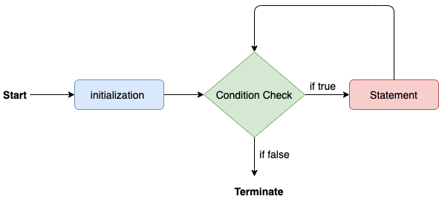

Consider the following example to understand the proper functioning of the for loop in java.

**Calculation.java**

1. **public** **class** Calculattion {
2. **public** **static** **void** main(String[] args) {
3. // TODO Auto-generated method stub
4. **int** sum = 0;
5. **for**(**int** j = 1; j<=10; j++) {
6. sum = sum + j;
7. }
8. System.out.println("The sum of first 10 natural numbers is " + sum);
9. }
10. }

**Output:**

The sum of first 10 natural numbers is 55

### **Java for-each loop**

Java provides an enhanced for loop to traverse the data structures like array or collection. In the for-each loop, we don't need to update the loop variable. The syntax to use the for-each loop in java is given below.

1. **for**(data\_type var : array\_name/collection\_name){
2. //statements
3. }

Consider the following example to understand the functioning of the for-each loop in Java.

**Calculation.java**

1. **public** **class** Calculation {
2. **public** **static** **void** main(String[] args) {
3. // TODO Auto-generated method stub
4. String[] names = {"Java","C","C++","Python","JavaScript"};
5. System.out.println("Printing the content of the array names:\n");
6. **for**(String name:names) {
7. System.out.println(name);
8. }
9. }
10. }

**Output:**

Printing the content of the array names:

Java

C

C++

Python

JavaScript

### **Java while loop**

The [while loop](https://www.javatpoint.com/java-while-loop)

is also used to iterate over the number of statements multiple times. However, if we don't know the number of iterations in advance, it is recommended to use a while loop. Unlike for loop, the initialization and increment/decrement doesn't take place inside the loop statement in while loop.

It is also known as the entry-controlled loop since the condition is checked at the start of the loop. If the condition is true, then the loop body will be executed; otherwise, the statements after the loop will be executed.

The syntax of the while loop is given below.

1. **while**(condition){
2. //looping statements
3. }

The flow chart for the while loop is given in the following image.

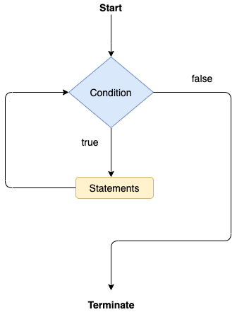

Consider the following example.

**Calculation .java**

1. **public** **class** Calculation {
2. **public** **static** **void** main(String[] args) {
3. // TODO Auto-generated method stub
4. **int** i = 0;
5. System.out.println("Printing the list of first 10 even numbers \n");
6. **while**(i<=10) {
7. System.out.println(i);
8. i = i + 2;
9. }
10. }
11. }

**Output:**

Printing the list of first 10 even numbers

0

2

4

6

8

10

### **Java do-while loop**

The [do-while loop](https://www.javatpoint.com/java-do-while-loop)

checks the condition at the end of the loop after executing the loop statements. When the number of iteration is not known and we have to execute the loop at least once, we can use do-while loop.

It is also known as the exit-controlled loop since the condition is not checked in advance. The syntax of the do-while loop is given below.

1. **do**
2. {
3. //statements
4. } **while** (condition);

The flow chart of the do-while loop is given in the following image.

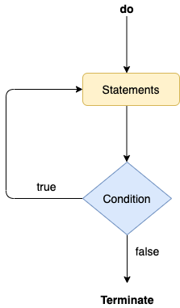

Consider the following example to understand the functioning of the do-while loop in Java.

**Calculation.java**

1. **public** **class** Calculation {
2. **public** **static** **void** main(String[] args) {
3. // TODO Auto-generated method stub
4. **int** i = 0;
5. System.out.println("Printing the list of first 10 even numbers \n");
6. **do** {
7. System.out.println(i);
8. i = i + 2;
9. }**while**(i<=10);
10. }
11. }

**Output:**

Printing the list of first 10 even numbers

0

2

4

6

8

10

### **Jump Statements**

Jump statements are used to transfer the control of the program to the specific statements. In other words, jump statements transfer the execution control to the other part of the program. There are two types of jump statements in Java, i.e., break and continue.

### **Java break statement**

As the name suggests, the [break statement](https://www.javatpoint.com/java-break)

is used to break the current flow of the program and transfer the control to the next statement outside a loop or switch statement. However, it breaks only the inner loop in the case of the nested loop.

The break statement cannot be used independently in the Java program, i.e., it can only be written inside the loop or switch statement.

**The break statement example with for loop**

Consider the following example in which we have used the break statement with the for loop.

**BreakExample.java**

1. **public** **class** BreakExample {
3. **public** **static** **void** main(String[] args) {
4. // TODO Auto-generated method stub
5. **for**(**int** i = 0; i<= 10; i++) {
6. System.out.println(i);
7. **if**(i==6) {
8. **break**;
9. }
10. }
11. }
12. }

**Output:**

0

1

2

3

4

5

6

**break statement example with labeled for loop**

**Calculation.java**

1. **public** **class** Calculation {
3. **public** **static** **void** main(String[] args) {
4. // TODO Auto-generated method stub
5. a:
6. **for**(**int** i = 0; i<= 10; i++) {
7. b:
8. **for**(**int** j = 0; j<=15;j++) {
9. c:
10. **for** (**int** k = 0; k<=20; k++) {
11. System.out.println(k);
12. **if**(k==5) {
13. **break** a;
14. }
15. }
16. }
18. }
19. }

22. }

**Output:**

0

1

2

3

4

5

### **Java continue statement**

Unlike break statement, the [continue statement](https://www.javatpoint.com/java-continue)

doesn't break the loop, whereas, it skips the specific part of the loop and jumps to the next iteration of the loop immediately.

Consider the following example to understand the functioning of the continue statement in Java.

1. **public** **class** ContinueExample {
3. **public** **static** **void** main(String[] args) {
4. // TODO Auto-generated method stub
6. **for**(**int** i = 0; i<= 2; i++) {
8. **for** (**int** j = i; j<=5; j++) {
10. **if**(j == 4) {
11. **continue**;
12. }
13. System.out.println(j);
14. }
15. }
16. }
18. }

**Output:**

0

1

2

3

5

1

2

3

5

2

3

5

Java If-else Statement

The [Java](https://www.javatpoint.com/java-tutorial)

*if statement* is used to test the condition. It checks [boolean](https://www.javatpoint.com/boolean-keyword-in-java)

condition: *true* or *false*. There are various types of if statement in Java.

* if statement
* if-else statement
* if-else-if ladder
* nested if statement

Java if Statement

The Java if statement tests the condition. It executes the *if block* if condition is true.

**Syntax:**

1. **if**(condition){
2. //code to be executed
3. }

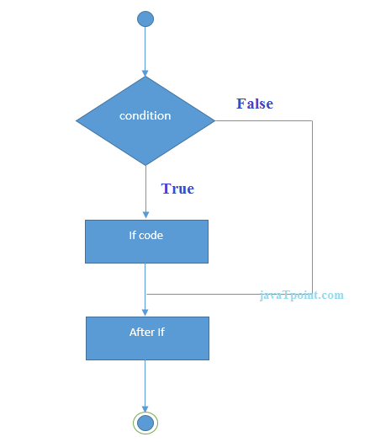

**Example:**

32.7M

638

Difference between JDK, JRE, and JVM

1. //Java Program to demonstate the use of if statement.
2. **public** **class** IfExample {
3. **public** **static** **void** main(String[] args) {
4. //defining an 'age' variable
5. **int** age=20;
6. //checking the age
7. **if**(age>18){
8. System.out.print("Age is greater than 18");
9. }
10. }
11. }

**[Test it Now](https://compiler.javatpoint.com/opr/test.jsp?filename=IfExample" \t "_blank)**

Output:

Age is greater than 18

Java if-else Statement

The Java if-else statement also tests the condition. It executes the *if block* if condition is true otherwise *else block* is executed.

**Syntax:**

1. **if**(condition){
2. //code if condition is true
3. }**else**{
4. //code if condition is false
5. }

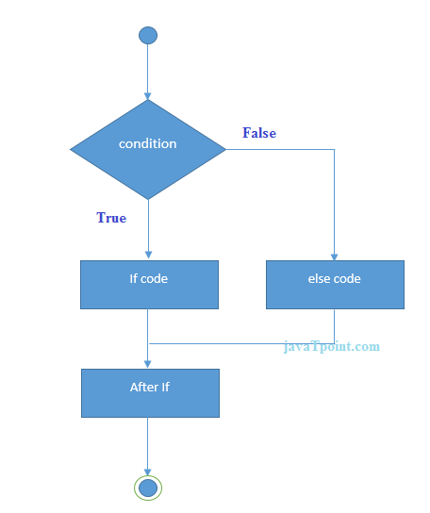

**Example:**

1. //A Java Program to demonstrate the use of if-else statement.
2. //It is a program of odd and even number.
3. **public** **class** IfElseExample {
4. **public** **static** **void** main(String[] args) {
5. //defining a variable
6. **int** number=13;
7. //Check if the number is divisible by 2 or not
8. **if**(number%2==0){
9. System.out.println("even number");
10. }**else**{
11. System.out.println("odd number");
12. }
13. }
14. }

**[Test it Now](https://compiler.javatpoint.com/opr/test.jsp?filename=IfElseExample" \t "_blank)**

Output:

odd number

**Leap Year Example:**

A year is leap, if it is divisible by 4 and 400. But, not by 100.

1. **public** **class** LeapYearExample {
2. **public** **static** **void** main(String[] args) {
3. **int** year=2020;
4. **if**(((year % 4 ==0) && (year % 100 !=0)) || (year % 400==0)){
5. System.out.println("LEAP YEAR");
6. }
7. **else**{
8. System.out.println("COMMON YEAR");
9. }
10. }
11. }

Output:

LEAP YEAR

Using Ternary Operator

We can also use ternary operator (? :) to perform the task of if...else statement. It is a shorthand way to check the condition. If the condition is true, the result of ? is returned. But, if the condition is false, the result of : is returned.

**Example:**

1. **public** **class** IfElseTernaryExample {
2. **public** **static** **void** main(String[] args) {
3. **int** number=13;
4. //Using ternary operator
5. String output=(number%2==0)?"even number":"odd number";
6. System.out.println(output);
7. }
8. }

Output:

odd number

Java if-else-if ladder Statement

The if-else-if ladder statement executes one condition from multiple statements.

**Syntax:**

1. **if**(condition1){
2. //code to be executed if condition1 is true
3. }**else** **if**(condition2){
4. //code to be executed if condition2 is true
5. }
6. **else** **if**(condition3){
7. //code to be executed if condition3 is true
8. }
9. ...
10. **else**{
11. //code to be executed if all the conditions are false
12. }

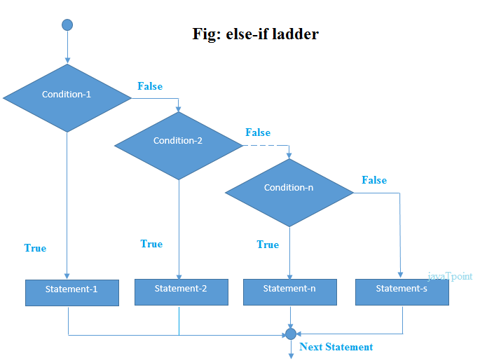

**Example:**

1. //Java Program to demonstrate the use of If else-if ladder.
2. //It is a program of grading system for fail, D grade, C grade, B grade, A grade and A+.
3. **public** **class** IfElseIfExample {
4. **public** **static** **void** main(String[] args) {
5. **int** marks=65;
7. **if**(marks<50){
8. System.out.println("fail");
9. }
10. **else** **if**(marks>=50 && marks<60){
11. System.out.println("D grade");
12. }
13. **else** **if**(marks>=60 && marks<70){
14. System.out.println("C grade");
15. }
16. **else** **if**(marks>=70 && marks<80){
17. System.out.println("B grade");
18. }
19. **else** **if**(marks>=80 && marks<90){
20. System.out.println("A grade");
21. }**else** **if**(marks>=90 && marks<100){
22. System.out.println("A+ grade");
23. }**else**{
24. System.out.println("Invalid!");
25. }
26. }
27. }

Output:

C grade

**Program to check POSITIVE, NEGATIVE or ZERO:**

1. **public** **class** PositiveNegativeExample {
2. **public** **static** **void** main(String[] args) {
3. **int** number=-13;
4. **if**(number>0){
5. System.out.println("POSITIVE");
6. }**else** **if**(number<0){
7. System.out.println("NEGATIVE");
8. }**else**{
9. System.out.println("ZERO");
10. }
11. }
12. }

Output:

NEGATIVE

Java Nested if statement

The nested if statement represents the *if block within another if block*. Here, the inner if block condition executes only when outer if block condition is true.

**Syntax:**

1. **if**(condition){
2. //code to be executed
3. **if**(condition){
4. //code to be executed
5. }
6. }

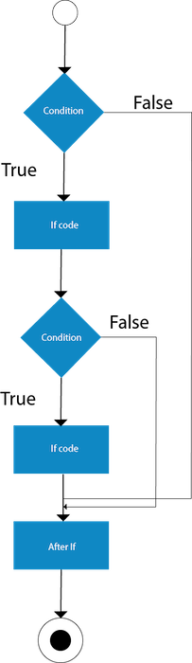

**Example:**

1. //Java Program to demonstrate the use of Nested If Statement.
2. **public** **class** JavaNestedIfExample {
3. **public** **static** **void** main(String[] args) {
4. //Creating two variables for age and weight
5. **int** age=20;
6. **int** weight=80;
7. //applying condition on age and weight
8. **if**(age>=18){
9. **if**(weight>50){
10. System.out.println("You are eligible to donate blood");
11. }
12. }
13. }}

**[Test it Now](https://compiler.javatpoint.com/opr/test.jsp?filename=JavaNestedIfExample" \t "_blank)**

Output:

You are eligible to donate blood

**Example 2:**

1. //Java Program to demonstrate the use of Nested If Statement.
2. **public** **class** JavaNestedIfExample2 {
3. **public** **static** **void** main(String[] args) {
4. //Creating two variables for age and weight
5. **int** age=25;
6. **int** weight=48;
7. //applying condition on age and weight
8. **if**(age>=18){
9. **if**(weight>50){
10. System.out.println("You are eligible to donate blood");
11. } **else**{
12. System.out.println("You are not eligible to donate blood");
13. }
14. } **else**{
15. System.out.println("Age must be greater than 18");
16. }
17. }  }

**[Test it Now](https://compiler.javatpoint.com/opr/test.jsp?filename=JavaNestedIfExample2" \t "_blank)**

Output:

You are not eligible to donate blood

# Java Switch Statement

The Java switch statement executes one statement from multiple conditions. It is like [if-else-if](https://www.javatpoint.com/java-if-else) ladder statement. The switch statement works with byte, short, int, long, enum types, String and some wrapper types like Byte, Short, Int, and Long. Since Java 7, you can use [strings](https://www.javatpoint.com/java-string) in the switch statement.

In other words, the switch statement tests the equality of a variable against multiple values.

### **Points to Remember**

* There can be one or N number of case values for a switch expression.
* The case value must be of switch expression type only. The case value must be literal or constant. It doesn't allow [variables](https://www.javatpoint.com/java-variables).
* The case values must be unique. In case of duplicate value, it renders compile-time error.
* The Java switch expression must be of byte, short, int, long (with its Wrapper type), *[enums](https://www.javatpoint.com/java-switch)* and string.
* Each case statement can have a break statement which is optional. When control reaches to the [break statement](https://www.javatpoint.com/java-break), it jumps the control after the switch expression. If a break statement is not found, it executes the next case.
* The case value can have a default label which is optional.

**Syntax:**

1. **switch**(expression){
2. **case** value1:
3. //code to be executed;
4. **break**;  //optional
5. **case** value2:
6. //code to be executed;
7. **break**;  //optional
8. ......
10. **default**:
11. code to be executed **if** all cases are not matched;
12. }

**Flowchart of Switch Statement**

26.6M

531

Java Try Catch

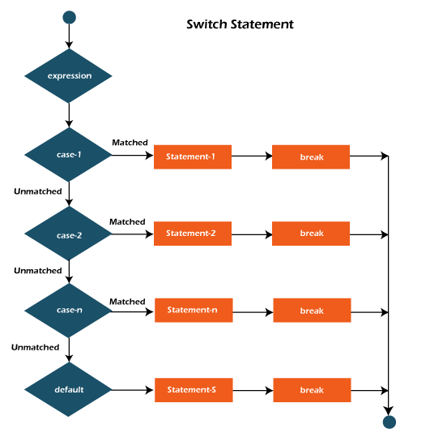

**Example:**

**SwitchExample.java**

1. **public** **class** SwitchExample {
2. **public** **static** **void** main(String[] args) {
3. //Declaring a variable for switch expression
4. **int** number=20;
5. //Switch expression
6. **switch**(number){
7. //Case statements
8. **case** 10: System.out.println("10");
9. **break**;
10. **case** 20: System.out.println("20");
11. **break**;
12. **case** 30: System.out.println("30");
13. **break**;
14. //Default case statement
15. **default**:System.out.println("Not in 10, 20 or 30");
16. }
17. }
18. }

[**Test it Now**](https://compiler.javatpoint.com/opr/test.jsp?filename=SwitchExample)

**Output:**

20

**Finding Month Example:**

**SwitchMonthExample.javaHTML**

1. //Java Program to demonstrate the example of Switch statement
2. //where we are printing month name for the given number
3. **public** **class** SwitchMonthExample {
4. **public** **static** **void** main(String[] args) {
5. //Specifying month number
6. **int** month=7;
7. String monthString="";
8. //Switch statement
9. **switch**(month){
10. //case statements within the switch block
11. **case** 1: monthString="1 - January";
12. **break**;
13. **case** 2: monthString="2 - February";
14. **break**;
15. **case** 3: monthString="3 - March";
16. **break**;
17. **case** 4: monthString="4 - April";
18. **break**;
19. **case** 5: monthString="5 - May";
20. **break**;
21. **case** 6: monthString="6 - June";
22. **break**;
23. **case** 7: monthString="7 - July";
24. **break**;
25. **case** 8: monthString="8 - August";
26. **break**;
27. **case** 9: monthString="9 - September";
28. **break**;
29. **case** 10: monthString="10 - October";
30. **break**;
31. **case** 11: monthString="11 - November";
32. **break**;
33. **case** 12: monthString="12 - December";
34. **break**;
35. **default**:System.out.println("Invalid Month!");
36. }
37. //Printing month of the given number
38. System.out.println(monthString);
39. }
40. }

[**Test it Now**](https://compiler.javatpoint.com/opr/test.jsp?filename=SwitchMonthExample)

**Output:**

7 - July

**Program to check Vowel or Consonant:**

If the character is A, E, I, O, or U, it is vowel otherwise consonant. It is not case-sensitive.

**SwitchVowelExample.java**

1. **public** **class** SwitchVowelExample {
2. **public** **static** **void** main(String[] args) {
3. **char** ch='O';
4. **switch**(ch)
5. {
6. **case** 'a':
7. System.out.println("Vowel");
8. **break**;
9. **case** 'e':
10. System.out.println("Vowel");
11. **break**;
12. **case** 'i':
13. System.out.println("Vowel");
14. **break**;
15. **case** 'o':
16. System.out.println("Vowel");
17. **break**;
18. **case** 'u':
19. System.out.println("Vowel");
20. **break**;
21. **case** 'A':
22. System.out.println("Vowel");
23. **break**;
24. **case** 'E':
25. System.out.println("Vowel");
26. **break**;
27. **case** 'I':
28. System.out.println("Vowel");
29. **break**;
30. **case** 'O':
31. System.out.println("Vowel");
32. **break**;
33. **case** 'U':
34. System.out.println("Vowel");
35. **break**;
36. **default**:
37. System.out.println("Consonant");
38. }
39. }
40. }

**Output:**

Vowel

## Java Switch Statement is fall-through

The Java switch statement is fall-through. It means it executes all statements after the first match if a break statement is not present.

**Example:**

**SwitchExample2.java**

1. //Java Switch Example where we are omitting the
2. //break statement
3. **public** **class** SwitchExample2 {
4. **public** **static** **void** main(String[] args) {
5. **int** number=20;
6. //switch expression with int value
7. **switch**(number){
8. //switch cases without break statements
9. **case** 10: System.out.println("10");
10. **case** 20: System.out.println("20");
11. **case** 30: System.out.println("30");
12. **default**:System.out.println("Not in 10, 20 or 30");
13. }
14. }
15. }

[**Test it Now**](https://compiler.javatpoint.com/opr/test.jsp?filename=SwitchExample2)

**Output:**

20

30

Not in 10, 20 or 30

## Java Switch Statement with String

Java allows us to use strings in switch expression since Java SE 7. The case statement should be string literal.

**Example:**

**SwitchStringExample.java**

1. //Java Program to demonstrate the use of Java Switch
2. //statement with String
3. **public** **class** SwitchStringExample {
4. **public** **static** **void** main(String[] args) {
5. //Declaring String variable
6. String levelString="Expert";
7. **int** level=0;
8. //Using String in Switch expression
9. **switch**(levelString){
10. //Using String Literal in Switch case
11. **case** "Beginner": level=1;
12. **break**;
13. **case** "Intermediate": level=2;
14. **break**;
15. **case** "Expert": level=3;
16. **break**;
17. **default**: level=0;
18. **break**;
19. }
20. System.out.println("Your Level is: "+level);
21. }
22. }

[**Test it Now**](https://compiler.javatpoint.com/opr/test.jsp?filename=SwitchStringExample)

**Output:**

Your Level is: 3

## Java Nested Switch Statement

We can use switch statement inside other switch statement in Java. It is known as nested switch statement.

**Example:**

**NestedSwitchExample.java**

1. //Java Program to demonstrate the use of Java Nested Switch
2. **public** **class** NestedSwitchExample {
3. **public** **static** **void** main(String args[])
4. {
5. //C - CSE, E - ECE, M - Mechanical
6. **char** branch = 'C';
7. **int** collegeYear = 4;
8. **switch**( collegeYear )
9. {
10. **case** 1:
11. System.out.println("English, Maths, Science");
12. **break**;
13. **case** 2:
14. **switch**( branch )
15. {
16. **case** 'C':
17. System.out.println("Operating System, Java, Data Structure");
18. **break**;
19. **case** 'E':
20. System.out.println("Micro processors, Logic switching theory");
21. **break**;
22. **case** 'M':
23. System.out.println("Drawing, Manufacturing Machines");
24. **break**;
25. }
26. **break**;
27. **case** 3:
28. **switch**( branch )
29. {
30. **case** 'C':
31. System.out.println("Computer Organization, MultiMedia");
32. **break**;
33. **case** 'E':
34. System.out.println("Fundamentals of Logic Design, Microelectronics");
35. **break**;
36. **case** 'M':
37. System.out.println("Internal Combustion Engines, Mechanical Vibration");
38. **break**;
39. }
40. **break**;
41. **case** 4:
42. **switch**( branch )
43. {
44. **case** 'C':
45. System.out.println("Data Communication and Networks, MultiMedia");
46. **break**;
47. **case** 'E':
48. System.out.println("Embedded System, Image Processing");
49. **break**;
50. **case** 'M':
51. System.out.println("Production Technology, Thermal Engineering");
52. **break**;
53. }
54. **break**;
55. }
56. }
57. }

[**Test it Now**](https://compiler.javatpoint.com/opr/test.jsp?filename=NestedSwitchExample)

**Output:**

Data Communication and Networks, MultiMedia

## Java Enum in Switch Statement

Java allows us to use enum in switch statement. Java enum is a class that represent the group of constants. (immutable such as final variables). We use the keyword enum and put the constants in curly braces separated by comma.

**Example:**

**JavaSwitchEnumExample.java**

1. //Java Program to demonstrate the use of Enum
2. //in switch statement
3. **public** **class** JavaSwitchEnumExample {
4. **public** **enum** Day {  Sun, Mon, Tue, Wed, Thu, Fri, Sat  }
5. **public** **static** **void** main(String args[])
6. {
7. Day[] DayNow = Day.values();
8. **for** (Day Now : DayNow)
9. {
10. **switch** (Now)
11. {
12. **case** Sun:
13. System.out.println("Sunday");
14. **break**;
15. **case** Mon:
16. System.out.println("Monday");
17. **break**;
18. **case** Tue:
19. System.out.println("Tuesday");
20. **break**;
21. **case** Wed:
22. System.out.println("Wednesday");
23. **break**;
24. **case** Thu:
25. System.out.println("Thursday");
26. **break**;
27. **case** Fri:
28. System.out.println("Friday");
29. **break**;
30. **case** Sat:
31. System.out.println("Saturday");
32. **break**;
33. }
34. }
35. }
36. }

[**Test it Now**](https://compiler.javatpoint.com/opr/test.jsp?filename=JavaSwitchEnumExample)

**Output:**

Sunday

Monday

Twesday

Wednesday

Thursday

Friday

Saturday

## Java Wrapper in Switch Statement

Java allows us to use four [wrapper classes](https://www.javatpoint.com/wrapper-class-in-java): Byte, Short, Integer and Long in switch statement.

**Example:**

**WrapperInSwitchCaseExample.java**

1. //Java Program to demonstrate the use of Wrapper class
2. //in switch statement
3. **public** **class** WrapperInSwitchCaseExample {
4. **public** **static** **void** main(String args[])
5. {
6. Integer age = 18;
7. **switch** (age)
8. {
9. **case** (16):
10. System.out.println("You are under 18.");
11. **break**;
12. **case** (18):
13. System.out.println("You are eligible for vote.");
14. **break**;
15. **case** (65):
16. System.out.println("You are senior citizen.");
17. **break**;
18. **default**:
19. System.out.println("Please give the valid age.");
20. **break**;
21. }
22. }
23. }

[**Test it Now**](https://compiler.javatpoint.com/opr/test.jsp?filename=WrapperInSwitchCaseExample)

**Output:**

You are eligible for vote.

Loops in Java

The Java *for loop* is used to iterate a part of the program several times. If the number of iteration is **fixed**, it is recommended to use for loop.

There are three types of for loops in Java.

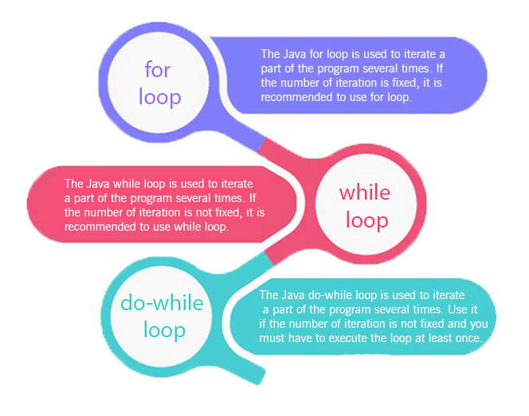

* Simple for Loop
* [For-each](https://www.javatpoint.com/for-each-loop) or Enhanced for Loop
* Labeled for Loop

Java Simple for Loop

A simple for loop is the same as [C](https://www.javatpoint.com/c-programming-language-tutorial)/[C++](https://www.javatpoint.com/cpp-tutorial). We can initialize the [variable](https://www.javatpoint.com/java-variables), check condition and increment/decrement value. It consists of four parts:

1. **Initialization**: It is the initial condition which is executed once when the loop starts. Here, we can initialize the variable, or we can use an already initialized variable. It is an optional condition.
2. **Condition**: It is the second condition which is executed each time to test the condition of the loop. It continues execution until the condition is false. It must return boolean value either true or false. It is an optional condition.
3. **Increment/Decrement**: It increments or decrements the variable value. It is an optional condition.
4. **Statement**: The statement of the loop is executed each time until the second condition is false.

**Syntax:**

30.3M

703

OOPs Concepts in Java

1. **for**(initialization; condition; increment/decrement){
2. //statement or code to be executed
3. }

**Flowchart:**

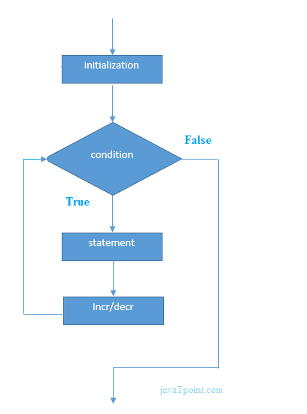

**Example:**

**ForExample.java**

1. //Java Program to demonstrate the example of for loop
2. //which prints table of 1
3. **public** **class** ForExample {
4. **public** **static** **void** main(String[] args) {
5. //Code of Java for loop
6. **for**(**int** i=1;i<=10;i++){
7. System.out.println(i);
8. }
9. }
10. }

[**Test it Now**](https://compiler.javatpoint.com/opr/test.jsp?filename=ForExample)

**Output:**

1

2

3

4

5

6

7

8

9

10

Java Nested for Loop

If we have a for loop inside the another loop, it is known as nested for loop. The inner loop executes completely whenever outer loop executes.

**Example:**

**NestedForExample.java**

1. **public** **class** NestedForExample {
2. **public** **static** **void** main(String[] args) {
3. //loop of i
4. **for**(**int** i=1;i<=3;i++){
5. //loop of j
6. **for**(**int** j=1;j<=3;j++){
7. System.out.println(i+" "+j);
8. }//end of i
9. }//end of j
10. }
11. }

**Output:**

1 1

1 2

1 3

2 1

2 2

2 3

3 1

3 2

3 3

**Pyramid Example 1:**

**PyramidExample.java**

1. **public** **class** PyramidExample {
2. **public** **static** **void** main(String[] args) {
3. **for**(**int** i=1;i<=5;i++){
4. **for**(**int** j=1;j<=i;j++){
5. System.out.print("\* ");
6. }
7. System.out.println();//new line
8. }
9. }
10. }

**Output:**

\*

\* \*

\* \* \*

\* \* \* \*

\* \* \* \* \*

**Pyramid Example 2:**

**PyramidExample2.java**

1. **public** **class** PyramidExample2 {
2. **public** **static** **void** main(String[] args) {
3. **int** term=6;
4. **for**(**int** i=1;i<=term;i++){
5. **for**(**int** j=term;j>=i;j--){
6. System.out.print("\* ");
7. }
8. System.out.println();//new line
9. }
10. }
11. }

**Output:**

\* \* \* \* \* \*

\* \* \* \* \*

\* \* \* \*

\* \* \*

\* \*

\*

Java for-each Loop

The for-each loop is used to traverse array or collection in Java. It is easier to use than simple for loop because we don't need to increment value and use subscript notation.

It works on the basis of elements and not the index. It returns element one by one in the defined variable.

**Syntax:**

1. **for**(data\_type variable : array\_name){
2. //code to be executed
3. }

**Example:**

**ForEachExample.java**

1. //Java For-each loop example which prints the
2. //elements of the array
3. **public** **class** ForEachExample {
4. **public** **static** **void** main(String[] args) {
5. //Declaring an array
6. **int** arr[]={12,23,44,56,78};
7. //Printing array using for-each loop
8. **for**(**int** i:arr){
9. System.out.println(i);
10. }
11. }
12. }

[**Test it Now**](https://compiler.javatpoint.com/opr/test.jsp?filename=ForEachExample)

**Output:**

12

23

44

56

78

Java Labeled For Loop

We can have a name of each Java for loop. To do so, we use label before the for loop. It is useful while using the nested for loop as we can break/continue specific for loop.

Note: The break and continue keywords breaks or continues the innermost for loop respectively.

**Syntax:**

1. labelname:
2. **for**(initialization; condition; increment/decrement){
3. //code to be executed
4. }

**Example:**

**LabeledForExample.java**

1. //A Java program to demonstrate the use of labeled for loop
2. **public** **class** LabeledForExample {
3. **public** **static** **void** main(String[] args) {
4. //Using Label for outer and for loop
5. aa:
6. **for**(**int** i=1;i<=3;i++){
7. bb:
8. **for**(**int** j=1;j<=3;j++){
9. **if**(i==2&&j==2){
10. **break** aa;
11. }
12. System.out.println(i+" "+j);
13. }
14. }
15. }
16. }

**Output:**

1 1

1 2

1 3

2 1

If you use **break bb;**, it will break inner loop only which is the default behaviour of any loop.

**LabeledForExample2.java**

1. **public** **class** LabeledForExample2 {
2. **public** **static** **void** main(String[] args) {
3. aa:
4. **for**(**int** i=1;i<=3;i++){
5. bb:
6. **for**(**int** j=1;j<=3;j++){
7. **if**(i==2&&j==2){
8. **break** bb;
9. }
10. System.out.println(i+" "+j);
11. }
12. }
13. }
14. }

**Output:**

1 1

1 2

1 3

2 1

3 1

3 2

3 3

Java Infinitive for Loop

If you use two semicolons ;; in the for loop, it will be infinitive for loop.

**Syntax:**

1. **for**(;;){
2. //code to be executed
3. }

**Example:**

**ForExample.java**

1. //Java program to demonstrate the use of infinite for loop
2. //which prints an statement
3. **public** **class** ForExample {
4. **public** **static** **void** main(String[] args) {
5. //Using no condition in for loop
6. **for**(;;){
7. System.out.println("infinitive loop");
8. }
9. }
10. }

**Output:**

infinitive loop

infinitive loop

infinitive loop

infinitive loop

infinitive loop

ctrl+c

Now, you need to press ctrl+c to exit from the program.

Java for Loop vs while Loop vs do-while Loop

|  |  |  |  |
| --- | --- | --- | --- |
| **Comparison** | **for loop** | **while loop** | **do-while loop** |
| Introduction | The Java for loop is a control flow statement that iterates a part of the [programs](https://www.javatpoint.com/java-programs) multiple times. | The Java while loop is a control flow statement that executes a part of the programs repeatedly on the basis of given boolean condition. | The Java do while loop is a control flow statement that executes a part of the programs at least once and the further execution depends upon the given boolean condition. |
| When to use | If the number of iteration is fixed, it is recommended to use for loop. | If the number of iteration is not fixed, it is recommended to use while loop. | If the number of iteration is not fixed and you must have to execute the loop at least once, it is recommended to use the do-while loop. |
| Syntax | for(init;condition;incr/decr){ // code to be executed } | while(condition){ //code to be executed } | do{ //code to be executed }while(condition); |
| Example | //for loop for(int i=1;i<=10;i++){ System.out.println(i); } | //while loop int i=1; while(i<=10){ System.out.println(i); i++; } | //do-while loop int i=1; do{ System.out.println(i); i++; }while(i<=10); |
| Syntax for infinitive loop | for(;;){ //code to be executed } | while(true){ //code to be executed } | do{ //code to be executed }while(true); |

# Java While Loop

The [Java](https://www.javatpoint.com/java-tutorial) *while loop* is used to iterate a part of the [program](https://www.javatpoint.com/programs-list) repeatedly until the specified Boolean condition is true. As soon as the Boolean condition becomes false, the loop automatically stops.

The while loop is considered as a repeating if statement. If the number of iteration is not fixed, it is recommended to use the while [loop](https://www.javatpoint.com/java-for-loop).

**Syntax:**

1. **while** (condition){
2. //code to be executed
3. I ncrement / decrement statement
4. }

**The different parts of do-while loop:**

26.6M

531

Java Try Catch

1. Condition: It is an expression which is tested. If the condition is true, the loop body is executed and control goes to update expression. When the condition becomes false, we exit the while loop.

**Example**:

i <=100

2. Update expression: Every time the loop body is executed, this expression increments or decrements loop variable.

**Example:**

**i++;**

**Flowchart of Java While Loop**

Here, the important thing about while loop is that, sometimes it may not even execute. If the condition to be tested results into false, the loop body is skipped and first statement after the while loop will be executed.

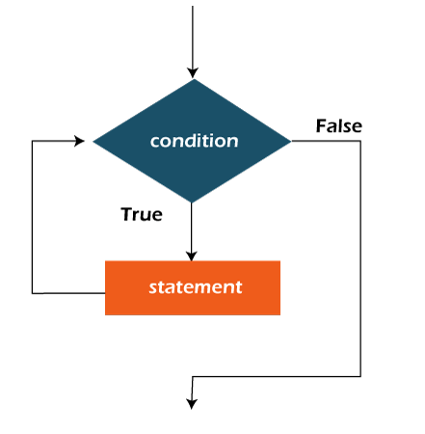

**Example:**

In the below example, we print integer values from 1 to 10. Unlike the for loop, we separately need to initialize and increment the variable used in the condition (here, i). Otherwise, the loop will execute infinitely.

**WhileExample.java**

1. **public** **class** WhileExample {
2. **public** **static** **void** main(String[] args) {
3. **int** i=1;
4. **while**(i<=10){
5. System.out.println(i);
6. i++;
7. }
8. }
9. }

[**Test it Now**](https://compiler.javatpoint.com/opr/test.jsp?filename=WhileExample)

**Output:**

1

2

3

4

5

6

7

8

9

10

Java Infinitive While Loop

If you pass **true** in the while loop, it will be infinitive while loop.

**Syntax:**

1. **while**(**true**){
2. //code to be executed
3. }

**Example:**

**WhileExample2.java**

1. **public** **class** WhileExample2 {
2. **public** **static** **void** main(String[] args) {
3. // setting the infinite while loop by passing true to the condition
4. **while**(**true**){
5. System.out.println("infinitive while loop");
6. }
7. }
8. }

**Output:**

infinitive while loop

infinitive while loop

infinitive while loop

infinitive while loop

infinitive while loop

ctrl+c

In the above code, we need to enter Ctrl + C command to terminate the infinite loop.

Java do-while Loop

The Java *do-while loop* is used to iterate a part of the program repeatedly, until the specified condition is true. If the number of iteration is not fixed and you must have to execute the loop at least once, it is recommended to use a do-while loop.

Java do-while loop is called an **exit control loop**. Therefore, unlike while loop and for loop, the do-while check the condition at the end of loop body. The Java *do-while loop* is executed at least once because condition is checked after loop body.

**Syntax:**

1. **do**{
2. //code to be executed / loop body
3. //update statement
4. }**while** (condition);

**The different parts of do-while loop:**

10 Sec

Java Try Catch

1. Condition: It is an expression which is tested. If the condition is true, the loop body is executed and control goes to update expression. As soon as the condition becomes false, loop breaks automatically.

**Example:**

**i <=100**

2. Update expression: Every time the loop body is executed, the this expression increments or decrements loop variable.

**Example:**

**i++;**

Note: The do block is executed at least once, even if the condition is false.

**Flowchart of do-while loop:**

**Example:**

In the below example, we print integer values from 1 to 10. Unlike the for loop, we separately need to initialize and increment the variable used in the condition (here, i). Otherwise, the loop will execute infinitely.

**DoWhileExample.java**

1. **public** **class** DoWhileExample {
2. **public** **static** **void** main(String[] args) {
3. **int** i=1;
4. **do**{
5. System.out.println(i);
6. i++;
7. }**while**(i<=10);
8. }
9. }

[**Test it Now**](https://compiler.javatpoint.com/opr/test.jsp?filename=DoWhileExample)

**Output:**

1

2

3

4

5

6

7

8

9

10

Java Infinitive do-while Loop

If you pass **true** in the do-while loop, it will be infinitive do-while loop.

**Syntax:**

1. **do**{
2. //code to be executed
3. }**while**(**true**);

**Example:**

**DoWhileExample2.java**

1. **public** **class** DoWhileExample2 {
2. **public** **static** **void** main(String[] args) {
3. **do**{
4. System.out.println("infinitive do while loop");
5. }**while**(**true**);
6. }
7. }

**Output:**

infinitive do while loop

infinitive do while loop

infinitive do while loop

ctrl+c

In the above code, we need to enter Ctrl + C command to terminate the infinite loop.

Java Break Statement

When a break statement is encountered inside a loop, the loop is immediately terminated and the program control resumes at the next statement following the loop.

The Java *break* statement is used to break loop or [switch](https://www.javatpoint.com/java-switch) statement. It breaks the current flow of the program at specified condition. In case of inner loop, it breaks only inner loop.

We can use Java break statement in all types of loops such as [for loop](https://www.javatpoint.com/java-for-loop), [while loop](https://www.javatpoint.com/java-while-loop) and [do-while loop](https://www.javatpoint.com/java-do-while-loop).

**Syntax:**

10 Sec

OOPs Concepts in Java

1. jump-statement;
2. **break**;

**Flowchart of Break Statement**

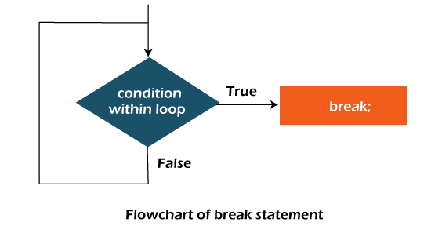

Java Break Statement with Loop

**Example:**

**BreakExample.java**

1. //Java Program to demonstrate the use of break statement
2. //inside the for loop.
3. **public** **class** BreakExample {
4. **public** **static** **void** main(String[] args) {
5. //using for loop
6. **for**(**int** i=1;i<=10;i++){
7. **if**(i==5){
8. //breaking the loop
9. **break**;
10. }
11. System.out.println(i);
12. }
13. }
14. }

**Output:**

1

2

3

4

Java Break Statement with Inner Loop

It breaks inner loop only if you use break statement inside the inner loop.

**Example:**

**BreakExample2.java**

1. //Java Program to illustrate the use of break statement
2. //inside an inner loop
3. **public** **class** BreakExample2 {
4. **public** **static** **void** main(String[] args) {
5. //outer loop
6. **for**(**int** i=1;i<=3;i++){
7. //inner loop
8. **for**(**int** j=1;j<=3;j++){
9. **if**(i==2&&j==2){
10. //using break statement inside the inner loop
11. **break**;
12. }
13. System.out.println(i+" "+j);
14. }
15. }
16. }
17. }

**Output:**

1 1

1 2

1 3

2 1

3 1

3 2

3 3

Java Break Statement with Labeled For Loop

We can use break statement with a label. The feature is introduced since JDK 1.5. So, we can break any loop in Java now whether it is outer or inner loop.

**Example:**

**BreakExample3.java**

1. //Java Program to illustrate the use of continue statement
2. //with label inside an inner loop to break outer loop
3. **public** **class** BreakExample3 {
4. **public** **static** **void** main(String[] args) {
5. aa:
6. **for**(**int** i=1;i<=3;i++){
7. bb:
8. **for**(**int** j=1;j<=3;j++){
9. **if**(i==2&&j==2){
10. //using break statement with label
11. **break** aa;
12. }
13. System.out.println(i+" "+j);
14. }
15. }
16. }
17. }

**Output:**

1 1

1 2

1 3

2 1

Java Break Statement in while loop

**Example:**

**BreakWhileExample.java**

1. //Java Program to demonstrate the use of break statement
2. //inside the while loop.
3. **public** **class** BreakWhileExample {
4. **public** **static** **void** main(String[] args) {
5. //while loop
6. **int** i=1;
7. **while**(i<=10){
8. **if**(i==5){
9. //using break statement
10. i++;
11. **break**;//it will break the loop
12. }
13. System.out.println(i);
14. i++;
15. }
16. }
17. }

**Output:**

1

2

3

4

Java Break Statement in do-while loop

**Example:**

**BreakDoWhileExample.java**

1. //Java Program to demonstrate the use of break statement
2. //inside the Java do-while loop.
3. **public** **class** BreakDoWhileExample {
4. **public** **static** **void** main(String[] args) {
5. //declaring variable
6. **int** i=1;
7. //do-while loop
8. **do**{
9. **if**(i==5){
10. //using break statement
11. i++;
12. **break**;//it will break the loop
13. }
14. System.out.println(i);
15. i++;
16. }**while**(i<=10);
17. }
18. }

**Output:**

1

2

3

4

Java Break Statement with Switch

To understand the example of break with switch statement, please visit here: [Java Switch Statement](https://www.javatpoint.com/java-switch).

Java Continue Statement

The continue statement is used in loop control structure when you need to jump to the next iteration of the loop immediately. It can be used with for loop or while loop.

The Java *continue statement* is used to continue the loop. It continues the current flow of the program and skips the remaining code at the specified condition. In case of an inner loop, it continues the inner loop only.

We can use Java continue statement in all types of loops such as for loop, while loop and do-while loop.

**Syntax:**

C++ vs Java

1. jump-statement;
2. **continue**;

Java Continue Statement Example

**ContinueExample.java**

1. //Java Program to demonstrate the use of continue statement
2. //inside the for loop.
3. **public** **class** ContinueExample {
4. **public** **static** **void** main(String[] args) {
5. //for loop
6. **for**(**int** i=1;i<=10;i++){
7. **if**(i==5){
8. //using continue statement
9. **continue**;//it will skip the rest statement
10. }
11. System.out.println(i);
12. }
13. }
14. }

[**Test it Now**](https://compiler.javatpoint.com/opr/test.jsp?filename=ContinueExample)

**Output:**

1

2

3

4

6

7

8

9

10

As you can see in the above output, 5 is not printed on the console. It is because the loop is continued when it reaches to 5.

Java Continue Statement with Inner Loop

It continues inner loop only if you use the continue statement inside the inner loop.

**ContinueExample2.java**

1. //Java Program to illustrate the use of continue statement
2. //inside an inner loop
3. **public** **class** ContinueExample2 {
4. **public** **static** **void** main(String[] args) {
5. //outer loop
6. **for**(**int** i=1;i<=3;i++){
7. //inner loop
8. **for**(**int** j=1;j<=3;j++){
9. **if**(i==2&&j==2){
10. //using continue statement inside inner loop
11. **continue**;
12. }
13. System.out.println(i+" "+j);
14. }
15. }
16. }
17. }

**Output:**

1 1

1 2

1 3

2 1

2 3

3 1

3 2

3 3

Java Continue Statement with Labelled For Loop

We can use continue statement with a label. This feature is introduced since JDK 1.5. So, we can continue any loop in Java now whether it is outer loop or inner.

**Example:**

**ContinueExample3.java**

1. //Java Program to illustrate the use of continue statement
2. //with label inside an inner loop to continue outer loop
3. **public** **class** ContinueExample3 {
4. **public** **static** **void** main(String[] args) {
5. aa:
6. **for**(**int** i=1;i<=3;i++){
7. bb:
8. **for**(**int** j=1;j<=3;j++){
9. **if**(i==2&&j==2){
10. //using continue statement with label
11. **continue** aa;
12. }
13. System.out.println(i+" "+j);
14. }
15. }
16. }
17. }

**Output:**

1 1

1 2

1 3

2 1

3 1

3 2

3 3

Java Continue Statement in while loop

**ContinueWhileExample.java**

1. //Java Program to demonstrate the use of continue statement
2. //inside the while loop.
3. **public** **class** ContinueWhileExample {
4. **public** **static** **void** main(String[] args) {
5. //while loop
6. **int** i=1;
7. **while**(i<=10){
8. **if**(i==5){
9. //using continue statement
10. i++;
11. **continue**;//it will skip the rest statement
12. }
13. System.out.println(i);
14. i++;
15. }
16. }
17. }

[**Test it Now**](https://compiler.javatpoint.com/opr/test.jsp?filename=ContinueWhileExample)

**Output:**

1

2

3

4

6

7

8

9

10

Java Continue Statement in do-while Loop

**ContinueDoWhileExample.java**

1. //Java Program to demonstrate the use of continue statement
2. //inside the Java do-while loop.
3. **public** **class** ContinueDoWhileExample {
4. **public** **static** **void** main(String[] args) {
5. //declaring variable
6. **int** i=1;
7. //do-while loop
8. **do**{
9. **if**(i==5){
10. //using continue statement
11. i++;
12. **continue**;//it will skip the rest statement
13. }
14. System.out.println(i);
15. i++;
16. }**while**(i<=10);
17. }
18. }

[**Test it Now**](https://compiler.javatpoint.com/opr/test.jsp?filename=ContinueDoWhileExample)

**Output:**

1

2

3

4

6

7

8

9

10

# ava Comments

The [Java](https://www.javatpoint.com/java-tutorial) comments are the statements in a program that are not executed by the compiler and interpreter.

## Why do we use comments in a code?

* Comments are used to make the program more readable by adding the details of the code.
* It makes easy to maintain the code and to find the errors easily.
* The comments can be used to provide information or explanation about the [variable](https://www.javatpoint.com/java-variables), method, [class](https://www.javatpoint.com/object-and-class-in-java), or any statement.
* It can also be used to prevent the execution of program code while testing the alternative code.

## Types of Java Comments

There are three types of comments in Java.

1. Single Line Comment
2. Multi Line Comment
3. Documentation Comment

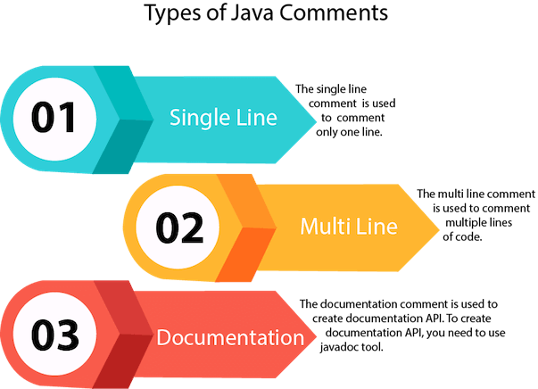

### **1) Java Single Line Comment**

The single-line comment is used to comment only one line of the code. It is the widely used and easiest way of commenting the statements.

Single line comments starts with two forward slashes **(//)**. Any text in front of // is not executed by Java.

10 Sec

33.3M

572

Hello Java Program for Beginners

**Syntax:**

1. //This is single line comment

Let's use single line comment in a Java program.

**CommentExample1.java**

1. **public** **class** CommentExample1 {
2. **public** **static** **void** main(String[] args) {
3. **int** i=10; // i is a variable with value 10
4. System.out.println(i);  //printing the variable i
5. }
6. }

**Output:**

10

### **2) Java Multi Line Comment**

The multi-line comment is used to comment multiple lines of code. It can be used to explain a complex code snippet or to comment multiple lines of code at a time (as it will be difficult to use single-line comments there).

Multi-line comments are placed between /\* and \*/. Any text between /\* and \*/ is not executed by Java.

**Syntax:**

1. /\*
2. This
3. is
4. multi line
5. comment
6. \*/

Let's use multi-line comment in a Java program.

**CommentExample2.java**

1. **public** **class** CommentExample2 {
2. **public** **static** **void** main(String[] args) {
3. /\* Let's declare and
4. print variable in java. \*/
5. **int** i=10;
6. System.out.println(i);
7. /\* float j = 5.9;
8. float k = 4.4;
9. System.out.println( j + k ); \*/
10. }
11. }

**Output:**

10

#### Note: Usually // is used for short comments and /\* \*/ is used for longer comments.

### **3) Java Documentation Comment**

Documentation comments are usually used to write large programs for a project or software application as it helps to create documentation API. These APIs are needed for reference, i.e., which classes, methods, arguments, etc., are used in the code.

To create documentation API, we need to use the **[javadoc tool](https://www.javatpoint.com/creating-api-document)**. The documentation comments are placed between /\*\* and \*/.

**Syntax:**

1. /\*\*
2. \*
3. \*We can use various tags to depict the parameter
4. \*or heading or author name
5. \*We can also use HTML tags
6. \*
7. \*/

## javadoc tags

Some of the commonly used tags in documentation comments:

|  |  |  |
| --- | --- | --- |
| **Tag** | **Syntax** | **Description** |
| {@docRoot} | {@docRoot} | to depict relative path to root directory of generated document from any page. |
| @author | @author name - text | To add the author of the class. |
| @code | {@code text} | To show the text in code font without interpreting it as html markup or nested javadoc tag. |
| @version | @version version-text | To specify "Version" subheading and version-text when -version option is used. |
| @since | @since release | To add "Since" heading with since text to generated documentation. |
| @param | @param parameter-name description | To add a parameter with given name and description to 'Parameters' section. |
| @return | @return description | Required for every method that returns something (except void) |

Let's use the Javadoc tag in a Java program.

**Calculate.java**

1. **import** java.io.\*;
3. /\*\*
4. \* <h2> Calculation of numbers </h2>
5. \* This program implements an application
6. \* to perform operation such as addition of numbers
7. \* and print the result
8. \* <p>
9. \* <b>Note:</b> Comments make the code readable and
10. \* easy to understand.
11. \*
12. \* @author Anurati
13. \* @version 16.0
14. \* @since 2021-07-06
15. \*/
17. **public** **class** Calculate{
18. /\*\*
19. \* This method calculates the summation of two integers.
20. \* @param input1 This is the first parameter to sum() method
21. \* @param input2 This is the second parameter to the sum() method.
22. \* @return int This returns the addition of input1 and input2
23. \*/
24. **public** **int** sum(**int** input1, **int** input2){
25. **return** input1 + input2;
26. }
27. /\*\*
28. \* This is the main method uses of sum() method.
29. \* @param args Unused
30. \* @see IOException
31. \*/
32. **public** **static** **void** main(String[] args) {
33. Calculate obj = **new** Calculate();
34. **int** result = obj.sum(40, 20);
36. System.out.println("Addition of numbers: " + result);
37. }
38. }

Compile it by javac tool:

Create Document

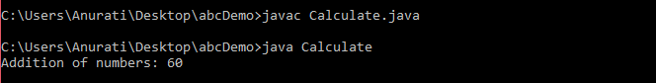

Create documentation API by **javadoc** tool:

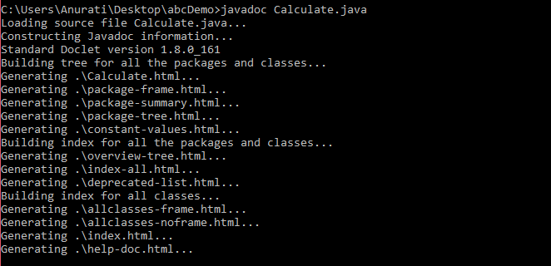

Now, the [HTML](https://www.javatpoint.com/html-tutorial) files are created for the **Calculate** class in the current directory, i.e., **abcDemo**. Open the HTML files, and we can see the explanation of Calculate class provided through the documentation comment.

## Are Java comments executable?

**Ans:** As we know, Java comments are not executed by the compiler or interpreter, however, before the lexical transformation of code in compiler, contents of the code are encoded into ASCII in order to make the processing easy.

**Test.java**

1. **public** **class** Test{
2. **public** **static** **void** main(String[] args) {
3. //the below comment will be executed
4. // \u000d System.out.println("Java comment is executed!!");
5. }
6. }

**Output:**

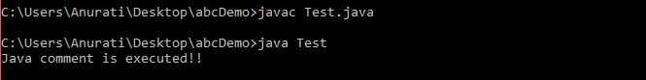

The above code generate the output because the compiler parses the Unicode character \**u000d** as a **new line** before the lexical transformation, and thus the code is transformed as shown below:

**Test.java**

1. **public** **class** Test{
2. **public** **static** **void** main(String[] args) {
3. //the below comment will be executed
4. //
5. System.out.println("Java comment is executed!!");
6. }
7. }

Thus, the Unicode character shifts the print statement to next line and it is executed as a normal Java code.

# Java OOPs Concepts

1. [Object-Oriented Programming](https://www.javatpoint.com/java-oops-concepts" \l "oops)
2. [Advantage of OOPs over Procedure-oriented programming language](https://www.javatpoint.com/java-oops-concepts" \l "oopsadvantage)
3. [Difference between Object-oriented and Object-based programming language.](https://www.javatpoint.com/java-oops-concepts" \l "oopsdifference)

In this page, we will learn about the basics of OOPs. Object-Oriented Programming is a paradigm that provides many concepts, such as **inheritance**, **data binding**, **polymorphism**, etc.

**Simula** is considered the first object-oriented programming language. The programming paradigm where everything is represented as an object is known as a truly object-oriented programming language.

**Smalltalk** is considered the first truly object-oriented programming language.

The popular object-oriented languages are [Java](https://www.javatpoint.com/java-tutorial)

, [C#](https://www.javatpoint.com/c-sharp-tutorial)

, [PHP](https://www.javatpoint.com/php-tutorial)

, [Python](https://www.javatpoint.com/python-tutorial)

, [C++](https://www.javatpoint.com/cpp-tutorial)

, etc.

31.8M

686

C++ vs Java

The main aim of object-oriented programming is to implement real-world entities, for example, object, classes, abstraction, inheritance, polymorphism, etc.

## OOPs (Object-Oriented Programming System)

**Object** means a real-world entity such as a pen, chair, table, computer, watch, etc. **Object-Oriented Programming** is a methodology or paradigm to design a program using classes and objects. It simplifies software development and maintenance by providing some concepts:

* [Object](https://www.javatpoint.com/object-and-class-in-java)
* Class
* [Inheritance](https://www.javatpoint.com/inheritance-in-java)
* [Polymorphism](https://www.javatpoint.com/runtime-polymorphism-in-java)
* [Abstraction](https://www.javatpoint.com/abstract-class-in-java)
* [Encapsulation](https://www.javatpoint.com/encapsulation)

Apart from these concepts, there are some other terms which are used in Object-Oriented design:

* Coupling
* Cohesion
* Association
* Aggregation
* Composition

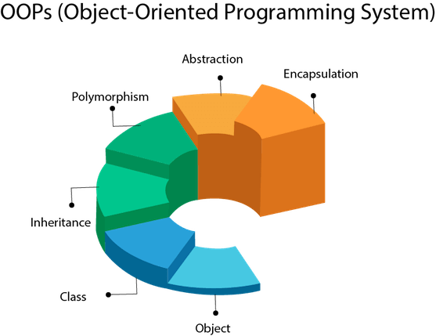

## Object

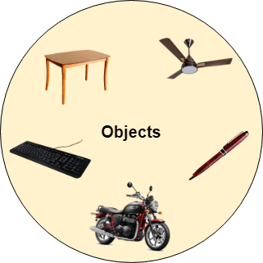

Any entity that has state and behavior is known as an object. For example, a chair, pen, table, keyboard, bike, etc. It can be physical or logical.

An Object can be defined as an instance of a class. An object contains an address and takes up some space in memory. Objects can communicate without knowing the details of each other's data or code. The only necessary thing is the type of message accepted and the type of response returned by the objects.

**Example:** A dog is an object because it has states like color, name, breed, etc. as well as behaviors like wagging the tail, barking, eating, etc.

## Class

Collection of objects is called class. It is a logical entity.

A class can also be defined as a blueprint from which you can create an individual object. Class doesn't consume any space.

### **Inheritance**

When one object acquires all the properties and behaviors of a parent object, it is known as inheritance. It provides code reusability. It is used to achieve runtime polymorphism.

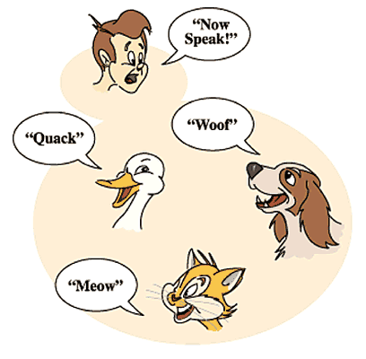

### **Polymorphism**

If one task is performed in different ways, it is known as polymorphism. For example: to convince the customer differently, to draw something, for example, shape, triangle, rectangle, etc.

In Java, we use method overloading and method overriding to achieve polymorphism.

Another example can be to speak something; for example, a cat speaks meow, dog barks woof, etc.

#### Abstraction

Hiding internal details and showing functionality is known as abstraction. For example phone call, we don't know the internal processing.

In Java, we use abstract class and interface to achieve abstraction.



### **Encapsulation**

Binding (or wrapping) code and data together into a single unit are known as encapsulation. For example, a capsule, it is wrapped with different medicines.

A java class is the example of encapsulation. Java bean is the fully encapsulated class because all the data members are private here.

### **Coupling**

Coupling refers to the knowledge or information or dependency of another class. It arises when classes are aware of each other. If a class has the details information of another class, there is strong coupling. In Java, we use private, protected, and public modifiers to display the visibility level of a class, method, and field. You can use interfaces for the weaker coupling because there is no concrete implementation.

### **Cohesion**

Cohesion refers to the level of a component which performs a single well-defined task. A single well-defined task is done by a highly cohesive method. The weakly cohesive method will split the task into separate parts. The java.io package is a highly cohesive package because it has I/O related classes and interface. However, the java.util package is a weakly cohesive package because it has unrelated classes and interfaces.

### **Association**

Association represents the relationship between the objects. Here, one object can be associated with one object or many objects. There can be four types of association between the objects:

* One to One
* One to Many
* Many to One, and
* Many to Many

Let's understand the relationship with real-time examples. For example, One country can have one prime minister (one to one), and a prime minister can have many ministers (one to many). Also, many MP's can have one prime minister (many to one), and many ministers can have many departments (many to many).

Association can be undirectional or bidirectional.

### **Aggregation**

Aggregation is a way to achieve Association. Aggregation represents the relationship where one object contains other objects as a part of its state. It represents the weak relationship between objects. It is also termed as a has-a relationship in Java. Like, inheritance represents the is-a relationship. It is another way to reuse objects.

### **Composition**

The composition is also a way to achieve Association. The composition represents the relationship where one object contains other objects as a part of its state. There is a strong relationship between the containing object and the dependent object. It is the state where containing objects do not have an independent existence. If you delete the parent object, all the child objects will be deleted automatically.

## Advantage of OOPs over Procedure-oriented programming language

1) OOPs makes development and maintenance easier, whereas, in a procedure-oriented programming language, it is not easy to manage if code grows as project size increases.

2) OOPs provides data hiding, whereas, in a procedure-oriented programming language, global data can be accessed from anywhere.

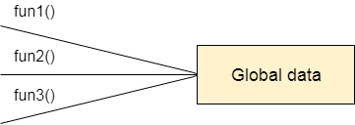

Figure: Data Representation in Procedure-Oriented Programming

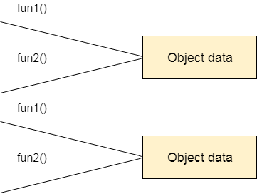

Figure: Data Representation in Object-Oriented Programming

3) OOPs provides the ability to simulate real-world event much more effectively. We can provide the solution of real word problem if we are using the Object-Oriented Programming language.

## What is the difference between an object-oriented programming language and object-based programming language?

Object-based programming language follows all the features of OOPs except Inheritance. JavaScript and VBScript are examples of object-based programming languages.

Do You Know?

* Can we overload the main method?
* A Java Constructor returns a value but, what?
* Can we create a program without main method?
* What are the six ways to use this keyword?
* Why is multiple inheritance not supported in Java?
* Why use aggregation?
* Can we override the static method?
* What is the covariant return type?
* What are the three usages of Java super keyword?
* Why use instance initializer block?
* What is the usage of a blank final variable?
* What is a marker or tagged interface?
* What is runtime polymorphism or dynamic method dispatch?
* What is the difference between static and dynamic binding?
* How downcasting is possible in Java?
* What is the purpose of a private constructor?
* What is object cloning?

What will we learn in OOPs Concepts?

* Advantage of OOPs
* Naming Convention
* Object and class
* Method overloading
* Constructor
* static keyword
* this keyword with six usage
* Inheritance
* Aggregation
* Method Overriding
* Covariant Return Type
* super keyword
* Instance Initializer block
* final keyword
* Abstract class
* Interface
* Runtime Polymorphism
* Static and Dynamic Binding
* Downcasting with instanceof operator
* Package
* Access Modifiers
* Encapsulation
* Object Cloning

# Java Naming Convention

Java naming convention is a rule to follow as you decide what to name your identifiers such as class, package, variable, constant, method, etc.

But, it is not forced to follow. So, it is known as convention not rule. These conventions are suggested by several Java communities such as Sun Microsystems and Netscape.

All the classes, interfaces, packages, methods and fields of Java programming language are given according to the Java naming convention. If you fail to follow these conventions, it may generate confusion or erroneous code.

## Advantage of Naming Conventions in Java

By using standard Java naming conventions, you make your code easier to read for yourself and other programmers. Readability of Java program is very important. It indicates that less time is spent to figure out what the code does.

10 Sec

Exception Handling in Java - Javatpoint

## Naming Conventions of the Different Identifiers

The following table shows the popular conventions used for the different identifiers.

|  |  |  |
| --- | --- | --- |
| **Identifiers Type** | **Naming Rules** | **Examples** |
| Class | It should start with the uppercase letter. It should be a noun such as Color, Button, System, Thread, etc. Use appropriate words, instead of acronyms. | public class **Employee** { //code snippet } |
| Interface | It should start with the uppercase letter. It should be an adjective such as Runnable, Remote, ActionListener. Use appropriate words, instead of acronyms. | interface **Printable** { //code snippet } |
| Method | It should start with lowercase letter. It should be a verb such as main(), print(), println(). If the name contains multiple words, start it with a lowercase letter followed by an uppercase letter such as actionPerformed(). | class Employee { // method void **draw()** { //code snippet } } |
| Variable | It should start with a lowercase letter such as id, name. It should not start with the special characters like & (ampersand), $ (dollar), \_ (underscore). If the name contains multiple words, start it with the lowercase letter followed by an uppercase letter such as firstName, lastName. Avoid using one-character variables such as x, y, z. | class Employee { // variable int **id**; //code snippet } |
| Package | It should be a lowercase letter such as java, lang. If the name contains multiple words, it should be separated by dots (.) such as java.util, java.lang. | //package package **com.javatpoint;** class Employee { //code snippet } |
| Constant | It should be in uppercase letters such as RED, YELLOW. If the name contains multiple words, it should be separated by an underscore(\_) such as MAX\_PRIORITY. It may contain digits but not as the first letter. | class Employee { //constant static final int **MIN\_AGE** = 18; //code snippet } |

## CamelCase in Java naming conventions

Java follows camel-case syntax for naming the class, interface, method, and variable.

If the name is combined with two words, the second word will start with uppercase letter always such as actionPerformed(), firstName, ActionEvent, ActionListener, etc.

# Objects and Classes in Java

1. [Object in Java](https://www.javatpoint.com/object-and-class-in-java#object)
2. [Class in Java](https://www.javatpoint.com/object-and-class-in-java#class)
3. [Instance Variable in Java](https://www.javatpoint.com/object-and-class-in-java#objectinstancevariable)
4. [Method in Java](https://www.javatpoint.com/object-and-class-in-java#objectmethod)
5. [Example of Object and class that maintains the records of student](https://www.javatpoint.com/object-and-class-in-java#objectex2)
6. [Anonymous Object](https://www.javatpoint.com/object-and-class-in-java#objectannonymous)

In this page, we will learn about Java objects and classes. In object-oriented programming technique, we design a program using objects and classes.

An object in Java is the physical as well as a logical entity, whereas, a class in Java is a logical entity only.

### **What is an object in Java**

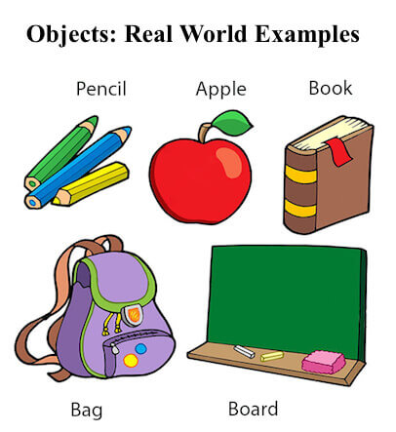

An entity that has state and behavior is known as an object e.g., chair, bike, marker, pen, table, car, etc. It can be physical or logical (tangible and intangible). The example of an intangible object is the banking system.

An object has three characteristics:

2.9M

Competitive questions on Structures

* **State:** represents the data (value) of an object.
* **Behavior:** represents the behavior (functionality) of an object such as deposit, withdraw, etc.
* **Identity:** An object identity is typically implemented via a unique ID. The value of the ID is not visible to the external user. However, it is used internally by the JVM to identify each object uniquely.

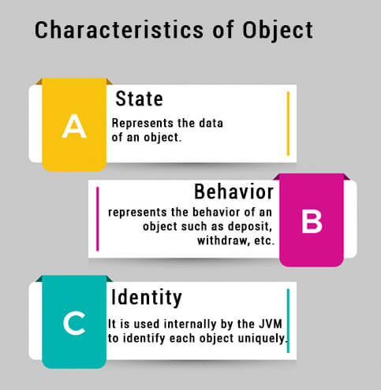

For Example, Pen is an object. Its name is Reynolds; color is white, known as its state. It is used to write, so writing is its behavior.

**An object is an instance of a class.** A class is a template or blueprint from which objects are created. So, an object is the instance(result) of a class.

**Object Definitions:**

* An object is a real-world entity.
* An object is a runtime entity.
* The object is an entity which has state and behavior.
* The object is an instance of a class.

## What is a class in Java

A class is a group of objects which have common properties. It is a template or blueprint from which objects are created. It is a logical entity. It can't be physical.

A class in Java can contain:

* **Fields**
* **Methods**
* **Constructors**
* **Blocks**
* **Nested class and interface**

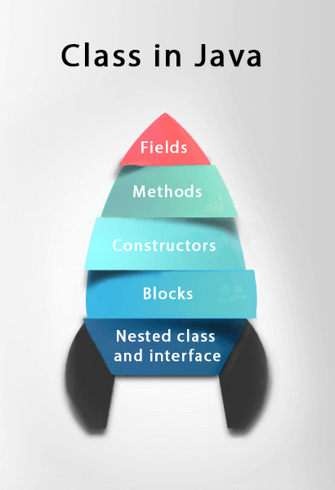

### **Syntax to declare a class:**

1. **class** <class\_name>{
2. field;
3. method;
4. }

### **Instance variable in Java**

A variable which is created inside the class but outside the method is known as an instance variable. Instance variable doesn't get memory at compile time. It gets memory at runtime when an object or instance is created. That is why it is known as an instance variable.

### **Method in Java**

In Java, a method is like a function which is used to expose the behavior of an object.

#### Advantage of Method

* Code Reusability
* Code Optimization

### **new keyword in Java**

The new keyword is used to allocate memory at runtime. All objects get memory in Heap memory area.

### **Object and Class Example: main within the class**

In this example, we have created a Student class which has two data members id and name. We are creating the object of the Student class by new keyword and printing the object's value.

Here, we are creating a main() method inside the class.

*File: Student.java*

1. //Java Program to illustrate how to define a class and fields
2. //Defining a Student class.
3. **class** Student{
4. //defining fields
5. **int** id;//field or data member or instance variable
6. String name;
7. //creating main method inside the Student class
8. **public** **static** **void** main(String args[]){
9. //Creating an object or instance
10. Student s1=**new** Student();//creating an object of Student
11. //Printing values of the object
12. System.out.println(s1.id);//accessing member through reference variable
13. System.out.println(s1.name);
14. }
15. }

[**Test it Now**](https://www.javatpoint.com/opr/test.jsp?filename=Student)

Output:

0

null

### **Object and Class Example: main outside the class**

In real time development, we create classes and use it from another class. It is a better approach than previous one. Let's see a simple example, where we are having main() method in another class.

We can have multiple classes in different Java files or single Java file. If you define multiple classes in a single Java source file, it is a good idea to save the file name with the class name which has main() method.

*File: TestStudent1.java*

1. //Java Program to demonstrate having the main method in
2. //another class
3. //Creating Student class.
4. **class** Student{
5. **int** id;
6. String name;
7. }
8. //Creating another class TestStudent1 which contains the main method
9. **class** TestStudent1{
10. **public** **static** **void** main(String args[]){
11. Student s1=**new** Student();
12. System.out.println(s1.id);
13. System.out.println(s1.name);
14. }
15. }

[**Test it Now**](https://www.javatpoint.com/opr/test.jsp?filename=TestStudent1)

Output:

0

null

## 3 Ways to initialize object

There are 3 ways to initialize object in Java.

1. By reference variable
2. By method
3. By constructor

### **1) Object and Class Example: Initialization through reference**

Initializing an object means storing data into the object. Let's see a simple example where we are going to initialize the object through a reference variable.

*File: TestStudent2.java*

1. **class** Student{
2. **int** id;
3. String name;
4. }
5. **class** TestStudent2{
6. **public** **static** **void** main(String args[]){
7. Student s1=**new** Student();
8. s1.id=101;
9. s1.name="Sonoo";
10. System.out.println(s1.id+" "+s1.name);//printing members with a white space
11. }
12. }

[**Test it Now**](https://www.javatpoint.com/opr/test.jsp?filename=TestStudent2)

Output:

101 Sonoo

We can also create multiple objects and store information in it through reference variable.

*File: TestStudent3.java*

1. **class** Student{
2. **int** id;
3. String name;
4. }
5. **class** TestStudent3{
6. **public** **static** **void** main(String args[]){
7. //Creating objects
8. Student s1=**new** Student();
9. Student s2=**new** Student();
10. //Initializing objects
11. s1.id=101;
12. s1.name="Sonoo";
13. s2.id=102;
14. s2.name="Amit";
15. //Printing data
16. System.out.println(s1.id+" "+s1.name);
17. System.out.println(s2.id+" "+s2.name);
18. }
19. }

[**Test it Now**](https://www.javatpoint.com/opr/test.jsp?filename=TestStudent3)

Output:

101 Sonoo

102 Amit

### **2) Object and Class Example: Initialization through method**

In this example, we are creating the two objects of Student class and initializing the value to these objects by invoking the insertRecord method. Here, we are displaying the state (data) of the objects by invoking the displayInformation() method.

*File: TestStudent4.java*

1. **class** Student{
2. **int** rollno;
3. String name;
4. **void** insertRecord(**int** r, String n){
5. rollno=r;
6. name=n;
7. }
8. **void** displayInformation(){System.out.println(rollno+" "+name);}
9. }
10. **class** TestStudent4{
11. **public** **static** **void** main(String args[]){
12. Student s1=**new** Student();
13. Student s2=**new** Student();
14. s1.insertRecord(111,"Karan");
15. s2.insertRecord(222,"Aryan");
16. s1.displayInformation();
17. s2.displayInformation();
18. }
19. }

[**Test it Now**](https://www.javatpoint.com/opr/test.jsp?filename=TestStudent4)

Output:

111 Karan

222 Aryan

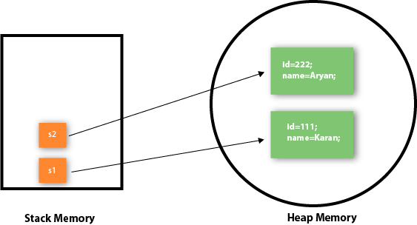

As you can see in the above figure, object gets the memory in heap memory area. The reference variable refers to the object allocated in the heap memory area. Here, s1 and s2 both are reference variables that refer to the objects allocated in memory.

### **3) Object and Class Example: Initialization through a constructor**

We will learn about constructors in Java later.

### **Object and Class Example: Employee**

Let's see an example where we are maintaining records of employees.

*File: TestEmployee.java*

1. **class** Employee{
2. **int** id;
3. String name;
4. **float** salary;
5. **void** insert(**int** i, String n, **float** s) {
6. id=i;
7. name=n;
8. salary=s;
9. }
10. **void** display(){System.out.println(id+" "+name+" "+salary);}
11. }
12. **public** **class** TestEmployee {
13. **public** **static** **void** main(String[] args) {
14. Employee e1=**new** Employee();
15. Employee e2=**new** Employee();
16. Employee e3=**new** Employee();
17. e1.insert(101,"ajeet",45000);
18. e2.insert(102,"irfan",25000);
19. e3.insert(103,"nakul",55000);
20. e1.display();
21. e2.display();
22. e3.display();
23. }
24. }

[**Test it Now**](https://www.javatpoint.com/opr/test.jsp?filename=TestEmployee)

Output:

101 ajeet 45000.0

102 irfan 25000.0

103 nakul 55000.0

### **Object and Class Example: Rectangle**

There is given another example that maintains the records of Rectangle class.

*File: TestRectangle1.java*

1. **class** Rectangle{
2. **int** length;
3. **int** width;
4. **void** insert(**int** l, **int** w){
5. length=l;
6. width=w;
7. }
8. **void** calculateArea(){System.out.println(length\*width);}
9. }
10. **class** TestRectangle1{
11. **public** **static** **void** main(String args[]){
12. Rectangle r1=**new** Rectangle();
13. Rectangle r2=**new** Rectangle();
14. r1.insert(11,5);
15. r2.insert(3,15);
16. r1.calculateArea();
17. r2.calculateArea();
18. }
19. }

[**Test it Now**](https://www.javatpoint.com/opr/test.jsp?filename=TestRectangle1)

Output:

55

45

## What are the different ways to create an object in Java?

There are many ways to create an object in java. They are:

* By new keyword
* By newInstance() method
* By clone() method
* By deserialization
* By factory method etc.

We will learn these ways to create object later.

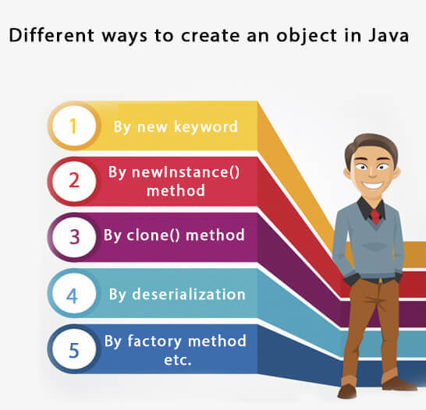

## Anonymous object

Anonymous simply means nameless. An object which has no reference is known as an anonymous object. It can be used at the time of object creation only.

If you have to use an object only once, an anonymous object is a good approach. For example:

1. **new** Calculation();//anonymous object

Calling method through a reference:

1. Calculation c=**new** Calculation();
2. c.fact(5);

Calling method through an anonymous object

1. **new** Calculation().fact(5);

Let's see the full example of an anonymous object in Java.

1. **class** Calculation{
2. **void** fact(**int**  n){
3. **int** fact=1;
4. **for**(**int** i=1;i<=n;i++){
5. fact=fact\*i;
6. }
7. System.out.println("factorial is "+fact);
8. }
9. **public** **static** **void** main(String args[]){
10. **new** Calculation().fact(5);//calling method with anonymous object
11. }
12. }

Output:

Factorial is 120

### **Creating multiple objects by one type only**

We can create multiple objects by one type only as we do in case of primitives.

Initialization of primitive variables:

1. **int** a=10, b=20;

Initialization of refernce variables:

1. Rectangle r1=**new** Rectangle(), r2=**new** Rectangle();//creating two objects

Let's see the example:

1. //Java Program to illustrate the use of Rectangle class which
2. //has length and width data members
3. **class** Rectangle{
4. **int** length;
5. **int** width;
6. **void** insert(**int** l,**int** w){
7. length=l;
8. width=w;
9. }
10. **void** calculateArea(){System.out.println(length\*width);}
11. }
12. **class** TestRectangle2{
13. **public** **static** **void** main(String args[]){
14. Rectangle r1=**new** Rectangle(),r2=**new** Rectangle();//creating two objects
15. r1.insert(11,5);
16. r2.insert(3,15);
17. r1.calculateArea();
18. r2.calculateArea();
19. }
20. }

[**Test it Now**](https://www.javatpoint.com/opr/test.jsp?filename=TestRectangle2)

Output:

55

45

### **Real World Example: Account**

*File: TestAccount.java*

1. //Java Program to demonstrate the working of a banking-system
2. //where we deposit and withdraw amount from our account.
3. //Creating an Account class which has deposit() and withdraw() methods
4. **class** Account{
5. **int** acc\_no;
6. String name;
7. **float** amount;
8. //Method to initialize object
9. **void** insert(**int** a,String n,**float** amt){
10. acc\_no=a;
11. name=n;
12. amount=amt;
13. }
14. //deposit method
15. **void** deposit(**float** amt){
16. amount=amount+amt;
17. System.out.println(amt+" deposited");
18. }
19. //withdraw method
20. **void** withdraw(**float** amt){
21. **if**(amount<amt){
22. System.out.println("Insufficient Balance");
23. }**else**{
24. amount=amount-amt;
25. System.out.println(amt+" withdrawn");
26. }
27. }
28. //method to check the balance of the account
29. **void** checkBalance(){System.out.println("Balance is: "+amount);}
30. //method to display the values of an object
31. **void** display(){System.out.println(acc\_no+" "+name+" "+amount);}
32. }
33. //Creating a test class to deposit and withdraw amount
34. **class** TestAccount{
35. **public** **static** **void** main(String[] args){
36. Account a1=**new** Account();
37. a1.insert(832345,"Ankit",1000);
38. a1.display();
39. a1.checkBalance();
40. a1.deposit(40000);
41. a1.checkBalance();
42. a1.withdraw(15000);
43. a1.checkBalance();
44. }}

[**Test it Now**](https://www.javatpoint.com/opr/test.jsp?filename=TestAccount)

Output:

832345 Ankit 1000.0

Balance is: 1000.0

40000.0 deposited

Balance is: 41000.0

15000.0 withdrawn

Balance is: 26000.0

# Constructors in Java

1. [Types of constructors](https://www.javatpoint.com/java-constructor#constypes)
   1. [Default Constructor](https://www.javatpoint.com/java-constructor#consdef)
   2. [Parameterized Constructor](https://www.javatpoint.com/java-constructor#conspara)
2. [Constructor Overloading](https://www.javatpoint.com/java-constructor#consoverloading)
3. [Does constructor return any value?](https://www.javatpoint.com/java-constructor#consdoesreturn)
4. [Copying the values of one object into another](https://www.javatpoint.com/java-constructor#conscopy)
5. [Does constructor perform other tasks instead of the initialization](https://www.javatpoint.com/java-constructor#consothertask)

In [Java](https://www.javatpoint.com/java-tutorial), a constructor is a block of codes similar to the method. It is called when an instance of the [class](https://www.javatpoint.com/object-and-class-in-java) is created. At the time of calling constructor, memory for the object is allocated in the memory.

It is a special type of method which is used to initialize the object.

Every time an object is created using the new() keyword, at least one constructor is called.

It calls a default constructor if there is no constructor available in the class. In such case, Java compiler provides a default constructor by default.

Nested Structure in C

Keep Watching

There are two types of constructors in Java: no-arg constructor, and parameterized constructor.

**Note:** It is called constructor because it constructs the values at the time of object creation. It is not necessary to write a constructor for a class. It is because java compiler creates a default constructor if your class doesn't have any.

### **Rules for creating Java constructor**

There are two rules defined for the constructor.

1. Constructor name must be the same as its class name
2. A Constructor must have no explicit return type
3. A Java constructor cannot be abstract, static, final, and synchronized

#### Note: We can use [access modifiers](https://www.javatpoint.com/access-modifiers) while declaring a constructor. It controls the object creation. In other words, we can have private, protected, public or default constructor in Java.

## Types of Java constructors

There are two types of constructors in Java:

1. Default constructor (no-arg constructor)
2. Parameterized constructor

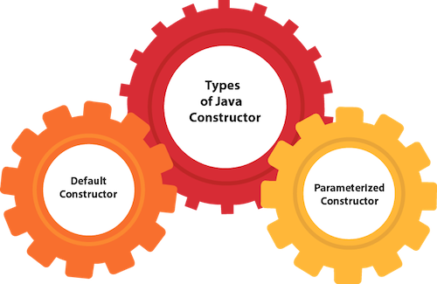

## Java Default Constructor

A constructor is called "Default Constructor" when it doesn't have any parameter.

### **Syntax of default constructor:**

1. <class\_name>(){}

## Example of default constructor

|  |
| --- |
| In this example, we are creating the no-arg constructor in the Bike class. It will be invoked at the time of object creation. |

1. //Java Program to create and call a default constructor
2. **class** Bike1{
3. //creating a default constructor
4. Bike1(){System.out.println("Bike is created");}
5. //main method
6. **public** **static** **void** main(String args[]){
7. //calling a default constructor
8. Bike1 b=**new** Bike1();
9. }
10. }

[**Test it Now**](https://www.javatpoint.com/opr/test.jsp?filename=Bike1)

Output:

Bike is created

#### Rule: If there is no constructor in a class, compiler automatically creates a default constructor.

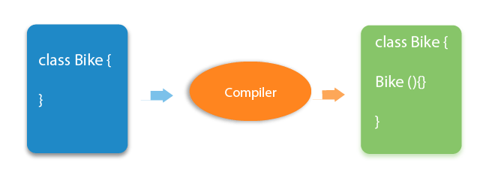

### **Q) What is the purpose of a default constructor?**

The default constructor is used to provide the default values to the object like 0, null, etc., depending on the type.

### **Example of default constructor that displays the default values**

1. //Let us see another example of default constructor
2. //which displays the default values
3. **class** Student3{
4. **int** id;
5. String name;
6. //method to display the value of id and name
7. **void** display(){System.out.println(id+" "+name);}
9. **public** **static** **void** main(String args[]){
10. //creating objects
11. Student3 s1=**new** Student3();
12. Student3 s2=**new** Student3();
13. //displaying values of the object
14. s1.display();
15. s2.display();
16. }
17. }

[**Test it Now**](https://www.javatpoint.com/opr/test.jsp?filename=Student3)

Output:

0 null

0 null

**Explanation:**In the above class,you are not creating any constructor so compiler provides you a default constructor. Here 0 and null values are provided by default constructor.

### **Java Parameterized Constructor**

A constructor which has a specific number of parameters is called a parameterized constructor.

### **Why use the parameterized constructor?**

The parameterized constructor is used to provide different values to distinct objects. However, you can provide the same values also.

### **Example of parameterized constructor**

In this example, we have created the constructor of Student class that have two parameters. We can have any number of parameters in the constructor.

1. //Java Program to demonstrate the use of the parameterized constructor.
2. **class** Student4{
3. **int** id;
4. String name;
5. //creating a parameterized constructor
6. Student4(**int** i,String n){
7. id = i;
8. name = n;
9. }
10. //method to display the values
11. **void** display(){System.out.println(id+" "+name);}
13. **public** **static** **void** main(String args[]){
14. //creating objects and passing values
15. Student4 s1 = **new** Student4(111,"Karan");
16. Student4 s2 = **new** Student4(222,"Aryan");
17. //calling method to display the values of object
18. s1.display();
19. s2.display();
20. }
21. }

[**Test it Now**](https://www.javatpoint.com/opr/test.jsp?filename=Student4)

Output:

111 Karan

222 Aryan

## Constructor Overloading in Java

In Java, a constructor is just like a method but without return type. It can also be overloaded like Java methods.

Constructor [overloading in Java](https://www.javatpoint.com/method-overloading-in-java) is a technique of having more than one constructor with different parameter lists. They are arranged in a way that each constructor performs a different task. They are differentiated by the compiler by the number of parameters in the list and their types.

### **Example of Constructor Overloading**

1. //Java program to overload constructors
2. **class** Student5{
3. **int** id;
4. String name;
5. **int** age;
6. //creating two arg constructor
7. Student5(**int** i,String n){
8. id = i;
9. name = n;
10. }
11. //creating three arg constructor
12. Student5(**int** i,String n,**int** a){
13. id = i;
14. name = n;
15. age=a;
16. }
17. **void** display(){System.out.println(id+" "+name+" "+age);}
19. **public** **static** **void** main(String args[]){
20. Student5 s1 = **new** Student5(111,"Karan");
21. Student5 s2 = **new** Student5(222,"Aryan",25);
22. s1.display();
23. s2.display();
24. }
25. }

[**Test it Now**](https://www.javatpoint.com/opr/test.jsp?filename=Student5)

Output:

111 Karan 0

222 Aryan 25

## Difference between constructor and method in Java

There are many differences between constructors and methods. They are given below.

|  |  |
| --- | --- |
| **Java Constructor** | **Java Method** |
| A constructor is used to initialize the state of an object. | A method is used to expose the behavior of an object. |
| A constructor must not have a return type. | A method must have a return type. |
| The constructor is invoked implicitly. | The method is invoked explicitly. |
| The Java compiler provides a default constructor if you don't have any constructor in a class. | The method is not provided by the compiler in any case. |
| The constructor name must be same as the class name. | The method name may or may not be same as the class name. |

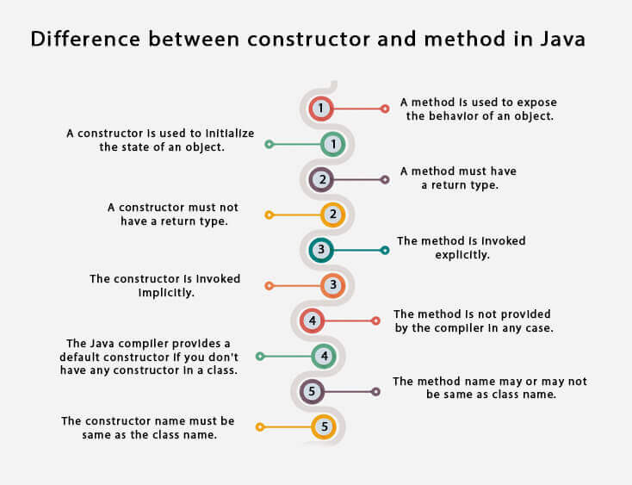

## Java Copy Constructor

There is no copy constructor in Java. However, we can copy the values from one object to another like copy constructor in C++.

There are many ways to copy the values of one object into another in Java. They are:

* By constructor
* By assigning the values of one object into another
* By clone() method of Object class

In this example, we are going to copy the values of one object into another using Java constructor.

1. //Java program to initialize the values from one object to another object.
2. **class** Student6{
3. **int** id;
4. String name;
5. //constructor to initialize integer and string
6. Student6(**int** i,String n){
7. id = i;
8. name = n;
9. }
10. //constructor to initialize another object
11. Student6(Student6 s){
12. id = s.id;
13. name =s.name;
14. }
15. **void** display(){System.out.println(id+" "+name);}
17. **public** **static** **void** main(String args[]){
18. Student6 s1 = **new** Student6(111,"Karan");
19. Student6 s2 = **new** Student6(s1);
20. s1.display();
21. s2.display();
22. }
23. }

[**Test it Now**](https://www.javatpoint.com/opr/test.jsp?filename=Student6)

Output:

111 Karan

111 Karan

## Copying values without constructor

We can copy the values of one object into another by assigning the objects values to another object. In this case, there is no need to create the constructor.

1. **class** Student7{
2. **int** id;
3. String name;
4. Student7(**int** i,String n){
5. id = i;
6. name = n;
7. }
8. Student7(){}
9. **void** display(){System.out.println(id+" "+name);}
11. **public** **static** **void** main(String args[]){
12. Student7 s1 = **new** Student7(111,"Karan");
13. Student7 s2 = **new** Student7();
14. s2.id=s1.id;
15. s2.name=s1.name;
16. s1.display();
17. s2.display();
18. }
19. }

[**Test it Now**](https://www.javatpoint.com/opr/test.jsp?filename=Student7)

Output:

111 Karan

111 Karan

### **Q) Does constructor return any value?**

Yes, it is the current class instance (You cannot use return type yet it returns a value).

### **Can constructor perform other tasks instead of initialization?**

Yes, like object creation, starting a thread, calling a method, etc. You can perform any operation in the constructor as you perform in the method.

### **Is there Constructor class in Java?**

Yes.

### **What is the purpose of Constructor class?**

Java provides a Constructor class which can be used to get the internal information of a constructor in the class. It is found in the java.lang.reflect package.

# Java static keyword

1. [Static variable](https://www.javatpoint.com/static-keyword-in-java#staticv)
2. [Program of the counter without static variable](https://www.javatpoint.com/static-keyword-in-java#staticvcounter1)
3. [Program of the counter with static variable](https://www.javatpoint.com/static-keyword-in-java#staticvcounter2)
4. [Static method](https://www.javatpoint.com/static-keyword-in-java#staticm)
5. [Restrictions for the static method](https://www.javatpoint.com/static-keyword-in-java#staticmr)
6. [Why is the main method static?](https://www.javatpoint.com/static-keyword-in-java#staticwhymain)
7. [Static block](https://www.javatpoint.com/static-keyword-in-java#staticblock)
8. [Can we execute a program without main method?](https://www.javatpoint.com/static-keyword-in-java#staticwithoutmain)

The **static keyword** in [Java](https://www.javatpoint.com/java-tutorial) is used for memory management mainly. We can apply static keyword with [variables](https://www.javatpoint.com/java-variables), methods, blocks and [nested classes](https://www.javatpoint.com/java-inner-class). The static keyword belongs to the class than an instance of the class.

The static can be:

1. Variable (also known as a class variable)
2. Method (also known as a class method)
3. Block
4. Nested class

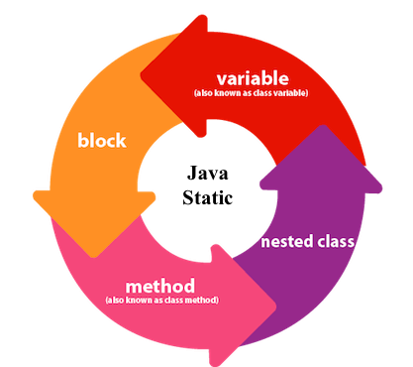

## 1) Java static variable

If you declare any variable as static, it is known as a static variable.

* The static variable can be used to refer to the common property of all objects (which is not unique for each object), for example, the company name of employees, college name of students, etc.
* The static variable gets memory only once in the class area at the time of class loading.

### **Advantages of static variable**

It makes your program **memory efficient** (i.e., it saves memory).

14.4M

230

Triggers in SQL (Hindi)

#### Understanding the problem without static variable

1. **class** Student{
2. **int** rollno;
3. String name;
4. String college="ITS";
5. }

Suppose there are 500 students in my college, now all instance data members will get memory each time when the object is created. All students have its unique rollno and name, so instance data member is good in such case. Here, "college" refers to the common property of all [objects](https://www.javatpoint.com/object-and-class-in-java). If we make it static, this field will get the memory only once.

#### Java static property is shared to all objects.

### **Example of static variable**

1. //Java Program to demonstrate the use of static variable
2. **class** Student{
3. **int** rollno;//instance variable
4. String name;
5. **static** String college ="ITS";//static variable
6. //constructor
7. Student(**int** r, String n){
8. rollno = r;
9. name = n;
10. }
11. //method to display the values
12. **void** display (){System.out.println(rollno+" "+name+" "+college);}
13. }
14. //Test class to show the values of objects
15. **public** **class** TestStaticVariable1{
16. **public** **static** **void** main(String args[]){
17. Student s1 = **new** Student(111,"Karan");
18. Student s2 = **new** Student(222,"Aryan");
19. //we can change the college of all objects by the single line of code
20. //Student.college="BBDIT";
21. s1.display();
22. s2.display();
23. }
24. }

[**Test it Now**](https://www.javatpoint.com/opr/test.jsp?filename=TestStaticVariable1)

Output:

111 Karan ITS

222 Aryan ITS

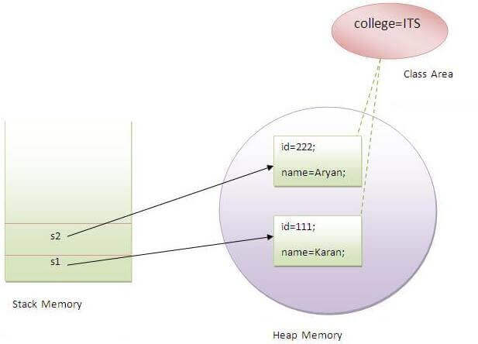

### **Program of the counter without static variable**

In this example, we have created an instance variable named count which is incremented in the constructor. Since instance variable gets the memory at the time of object creation, each object will have the copy of the instance variable. If it is incremented, it won't reflect other objects. So each object will have the value 1 in the count variable.

1. //Java Program to demonstrate the use of an instance variable
2. //which get memory each time when we create an object of the class.
3. **class** Counter{
4. **int** count=0;//will get memory each time when the instance is created
6. Counter(){
7. count++;//incrementing value
8. System.out.println(count);
9. }
11. **public** **static** **void** main(String args[]){
12. //Creating objects
13. Counter c1=**new** Counter();
14. Counter c2=**new** Counter();
15. Counter c3=**new** Counter();
16. }
17. }

[**Test it Now**](https://www.javatpoint.com/opr/test.jsp?filename=Counter)

Output:

1

1

1

### **Program of counter by static variable**

As we have mentioned above, static variable will get the memory only once, if any object changes the value of the static variable, it will retain its value.

1. //Java Program to illustrate the use of static variable which
2. //is shared with all objects.
3. **class** Counter2{
4. **static** **int** count=0;//will get memory only once and retain its value
6. Counter2(){
7. count++;//incrementing the value of static variable
8. System.out.println(count);
9. }
11. **public** **static** **void** main(String args[]){
12. //creating objects
13. Counter2 c1=**new** Counter2();
14. Counter2 c2=**new** Counter2();
15. Counter2 c3=**new** Counter2();
16. }
17. }

[**Test it Now**](https://www.javatpoint.com/opr/test.jsp?filename=Counter2)

Output:

1

2

3

## 2) Java static method

If you apply static keyword with any method, it is known as static method.

* A static method belongs to the class rather than the object of a class.
* A static method can be invoked without the need for creating an instance of a class.
* A static method can access static data member and can change the value of it.

### **Example of static method**

1. //Java Program to demonstrate the use of a static method.
2. **class** Student{
3. **int** rollno;
4. String name;
5. **static** String college = "ITS";
6. //static method to change the value of static variable
7. **static** **void** change(){
8. college = "BBDIT";
9. }
10. //constructor to initialize the variable
11. Student(**int** r, String n){
12. rollno = r;
13. name = n;
14. }
15. //method to display values
16. **void** display(){System.out.println(rollno+" "+name+" "+college);}
17. }
18. //Test class to create and display the values of object
19. **public** **class** TestStaticMethod{
20. **public** **static** **void** main(String args[]){
21. Student.change();//calling change method
22. //creating objects
23. Student s1 = **new** Student(111,"Karan");
24. Student s2 = **new** Student(222,"Aryan");
25. Student s3 = **new** Student(333,"Sonoo");
26. //calling display method
27. s1.display();
28. s2.display();
29. s3.display();
30. }
31. }

[**Test it Now**](https://www.javatpoint.com/opr/test.jsp?filename=TestStaticMethod)

Output:111 Karan BBDIT

222 Aryan BBDIT

333 Sonoo BBDIT

### **Another example of a static method that performs a normal calculation**

1. //Java Program to get the cube of a given number using the static method
3. **class** Calculate{
4. **static** **int** cube(**int** x){
5. **return** x\*x\*x;
6. }
8. **public** **static** **void** main(String args[]){
9. **int** result=Calculate.cube(5);
10. System.out.println(result);
11. }
12. }

[**Test it Now**](https://www.javatpoint.com/opr/test.jsp?filename=Calculate)

Output:125

### **Restrictions for the static method**

There are two main restrictions for the static method. They are:

1. The static method can not use non static data member or call non-static method directly.
2. this and super cannot be used in static context.
3. **class** A{
4. **int** a=40;//non static
6. **public** **static** **void** main(String args[]){
7. System.out.println(a);
8. }
9. }

[**Test it Now**](https://www.javatpoint.com/opr/test.jsp?filename=A)

Output:Compile Time Error

### **Q) Why is the Java main method static?**

Ans) It is because the object is not required to call a static method. If it were a non-static method, [JVM](https://www.javatpoint.com/jvm-java-virtual-machine) creates an object first then call main() method that will lead the problem of extra memory allocation.

## 3) Java static block

* Is used to initialize the static data member.
* It is executed before the main method at the time of classloading.

### **Example of static block**

1. **class** A2{
2. **static**{System.out.println("static block is invoked");}
3. **public** **static** **void** main(String args[]){
4. System.out.println("Hello main");
5. }
6. }

[**Test it Now**](https://www.javatpoint.com/opr/test.jsp?filename=A2)

Output:static block is invoked

Hello main

### **Q) Can we execute a program without main() method?**

Ans) No, one of the ways was the static block, but it was possible till JDK 1.6. Since JDK 1.7, it is not possible to execute a Java class without the [main method](https://www.javatpoint.com/java-main-method).

1. **class** A3{
2. **static**{
3. System.out.println("static block is invoked");
4. System.exit(0);
5. }
6. }

[**Test it Now**](https://www.javatpoint.com/opr/test.jsp?filename=A3)

Output:

static block is invoked

Since JDK 1.7 and above, output would be:

Error: Main method not found in class A3, please define the main method as:

public static void main(String[] args)

or a JavaFX application class must extend javafx.application.Application

# this keyword in Java

There can be a lot of usage of **Java this keyword**. In Java, this is a **reference variable** that refers to the current object.

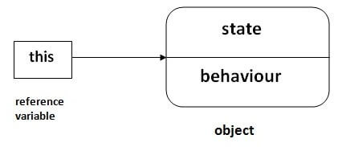

## Usage of Java this keyword

Here is given the 6 usage of java this keyword.

1. [this can be used to refer current class instance variable.](https://www.javatpoint.com/this1)
2. [this can be used to invoke current class method (implicitly)](https://www.javatpoint.com/this2)
3. [this() can be used to invoke current class constructor.](https://www.javatpoint.com/this3)
4. [this can be passed as an argument in the method call.](https://www.javatpoint.com/this4)
5. [this can be passed as argument in the constructor call.](https://www.javatpoint.com/this5)
6. [this can be used to return the current class instance from the method.](https://www.javatpoint.com/this6)

**Suggestion:** If you are beginner to java, lookup only three usages of this keyword.

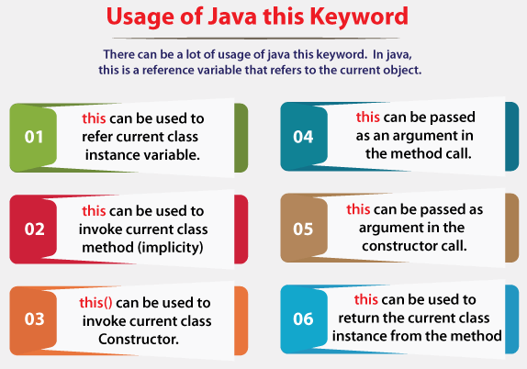

### **1) this: to refer current class instance variable**

The this keyword can be used to refer current class instance variable. If there is ambiguity between the instance variables and parameters, this keyword resolves the problem of ambiguity.

Competitive questions on Structures in Hindi

Keep Watching

#### Understanding the problem without this keyword

Let's understand the problem if we don't use this keyword by the example given below:

1. **class** Student{
2. **int** rollno;
3. String name;
4. **float** fee;
5. Student(**int** rollno,String name,**float** fee){
6. rollno=rollno;
7. name=name;
8. fee=fee;
9. }
10. **void** display(){System.out.println(rollno+" "+name+" "+fee);}
11. }
12. **class** TestThis1{
13. **public** **static** **void** main(String args[]){
14. Student s1=**new** Student(111,"ankit",5000f);
15. Student s2=**new** Student(112,"sumit",6000f);
16. s1.display();
17. s2.display();
18. }}

[**Test it Now**](https://www.javatpoint.com/opr/test.jsp?filename=TestThis1)

**Output:**

0 null 0.0

0 null 0.0

In the above example, parameters (formal arguments) and instance variables are same. So, we are using this keyword to distinguish local variable and instance variable.

#### Solution of the above problem by this keyword

1. **class** Student{
2. **int** rollno;
3. String name;
4. **float** fee;
5. Student(**int** rollno,String name,**float** fee){
6. **this**.rollno=rollno;
7. **this**.name=name;
8. **this**.fee=fee;
9. }
10. **void** display(){System.out.println(rollno+" "+name+" "+fee);}
11. }
13. **class** TestThis2{
14. **public** **static** **void** main(String args[]){
15. Student s1=**new** Student(111,"ankit",5000f);
16. Student s2=**new** Student(112,"sumit",6000f);
17. s1.display();
18. s2.display();
19. }}

[**Test it Now**](https://www.javatpoint.com/opr/test.jsp?filename=TestThis2)

**Output:**

111 ankit 5000.0

112 sumit 6000.0

If local variables(formal arguments) and instance variables are different, there is no need to use this keyword like in the following program:

#### Program where this keyword is not required

1. **class** Student{
2. **int** rollno;
3. String name;
4. **float** fee;
5. Student(**int** r,String n,**float** f){
6. rollno=r;
7. name=n;
8. fee=f;
9. }
10. **void** display(){System.out.println(rollno+" "+name+" "+fee);}
11. }
13. **class** TestThis3{
14. **public** **static** **void** main(String args[]){
15. Student s1=**new** Student(111,"ankit",5000f);
16. Student s2=**new** Student(112,"sumit",6000f);
17. s1.display();
18. s2.display();
19. }}

[**Test it Now**](https://www.javatpoint.com/opr/test.jsp?filename=TestThis3)

**Output:**

111 ankit 5000.0

112 sumit 6000.0

#### It is better approach to use meaningful names for variables. So we use same name for instance variables and parameters in real time, and always use this keyword.

### **2) this: to invoke current class method**

You may invoke the method of the current class by using the this keyword. If you don't use the this keyword, compiler automatically adds this keyword while invoking the method. Let's see the example

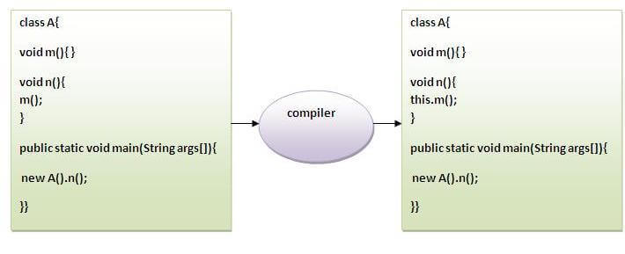

1. **class** A{
2. **void** m(){System.out.println("hello m");}
3. **void** n(){
4. System.out.println("hello n");
5. //m();//same as this.m()
6. **this**.m();
7. }
8. }
9. **class** TestThis4{
10. **public** **static** **void** main(String args[]){
11. A a=**new** A();
12. a.n();
13. }}

[**Test it Now**](https://www.javatpoint.com/opr/test.jsp?filename=TestThis4)

**Output:**

hello n

hello m

### **3) this() : to invoke current class constructor**

The this() constructor call can be used to invoke the current class constructor. It is used to reuse the constructor. In other words, it is used for constructor chaining.

**Calling default constructor from parameterized constructor:**

1. **class** A{
2. A(){System.out.println("hello a");}
3. A(**int** x){
4. **this**();
5. System.out.println(x);
6. }
7. }
8. **class** TestThis5{
9. **public** **static** **void** main(String args[]){
10. A a=**new** A(10);
11. }}

[**Test it Now**](https://www.javatpoint.com/opr/test.jsp?filename=TestThis5)

**Output:**

hello a

10

**Calling parameterized constructor from default constructor:**

1. **class** A{
2. A(){
3. **this**(5);
4. System.out.println("hello a");
5. }
6. A(**int** x){
7. System.out.println(x);
8. }
9. }
10. **class** TestThis6{
11. **public** **static** **void** main(String args[]){
12. A a=**new** A();
13. }}

[**Test it Now**](https://www.javatpoint.com/opr/test.jsp?filename=TestThis6)

**Output:**

5

hello a

### **Real usage of this() constructor call**

The this() constructor call should be used to reuse the constructor from the constructor. It maintains the chain between the constructors i.e. it is used for constructor chaining. Let's see the example given below that displays the actual use of this keyword.

1. **class** Student{
2. **int** rollno;
3. String name,course;
4. **float** fee;
5. Student(**int** rollno,String name,String course){
6. **this**.rollno=rollno;
7. **this**.name=name;
8. **this**.course=course;
9. }
10. Student(**int** rollno,String name,String course,**float** fee){
11. **this**(rollno,name,course);//reusing constructor
12. **this**.fee=fee;
13. }
14. **void** display(){System.out.println(rollno+" "+name+" "+course+" "+fee);}
15. }
16. **class** TestThis7{
17. **public** **static** **void** main(String args[]){
18. Student s1=**new** Student(111,"ankit","java");
19. Student s2=**new** Student(112,"sumit","java",6000f);
20. s1.display();
21. s2.display();
22. }}

[**Test it Now**](https://www.javatpoint.com/opr/test.jsp?filename=TestThis7)

**Output:**

111 ankit java 0.0

112 sumit java 6000.0

#### Rule: Call to this() must be the first statement in constructor.

1. **class** Student{
2. **int** rollno;
3. String name,course;
4. **float** fee;
5. Student(**int** rollno,String name,String course){
6. **this**.rollno=rollno;
7. **this**.name=name;
8. **this**.course=course;
9. }
10. Student(**int** rollno,String name,String course,**float** fee){
11. **this**.fee=fee;
12. **this**(rollno,name,course);//C.T.Error
13. }
14. **void** display(){System.out.println(rollno+" "+name+" "+course+" "+fee);}
15. }
16. **class** TestThis8{
17. **public** **static** **void** main(String args[]){
18. Student s1=**new** Student(111,"ankit","java");
19. Student s2=**new** Student(112,"sumit","java",6000f);
20. s1.display();
21. s2.display();
22. }}

[**Test it Now**](https://www.javatpoint.com/opr/test.jsp?filename=TestThis8)

**Output:**

Compile Time Error: Call to this must be first statement in constructor

### **4) this: to pass as an argument in the method**

The this keyword can also be passed as an argument in the method. It is mainly used in the event handling. Let's see the example:

1. **class** S2{
2. **void** m(S2 obj){
3. System.out.println("method is invoked");
4. }
5. **void** p(){
6. m(**this**);
7. }
8. **public** **static** **void** main(String args[]){
9. S2 s1 = **new** S2();
10. s1.p();
11. }
12. }

[**Test it Now**](https://www.javatpoint.com/opr/test.jsp?filename=S2)

**Output:**

method is invoked

### **Application of this that can be passed as an argument:**

In event handling (or) in a situation where we have to provide reference of a class to another one. It is used to reuse one object in many methods.

### **5) this: to pass as argument in the constructor call**

We can pass the this keyword in the constructor also. It is useful if we have to use one object in multiple classes. Let's see the example:

1. **class** B{
2. A4 obj;
3. B(A4 obj){
4. **this**.obj=obj;
5. }
6. **void** display(){
7. System.out.println(obj.data);//using data member of A4 class
8. }
9. }
11. **class** A4{
12. **int** data=10;
13. A4(){
14. B b=**new** B(**this**);
15. b.display();
16. }
17. **public** **static** **void** main(String args[]){
18. A4 a=**new** A4();
19. }
20. }

[**Test it Now**](https://www.javatpoint.com/opr/test.jsp?filename=A4)

Output:10

### **6) this keyword can be used to return current class instance**

We can return this keyword as an statement from the method. In such case, return type of the method must be the class type (non-primitive). Let's see the example:

### **Syntax of this that can be returned as a statement**

1. return\_type method\_name(){
2. **return** **this**;
3. }

### **Example of this keyword that you return as a statement from the method**

1. **class** A{
2. A getA(){
3. **return** **this**;
4. }
5. **void** msg(){System.out.println("Hello java");}
6. }
7. **class** Test1{
8. **public** **static** **void** main(String args[]){
9. **new** A().getA().msg();
10. }
11. }

[**Test it Now**](https://www.javatpoint.com/opr/test.jsp?filename=Test1)

**Output:**

Hello java

### **Proving this keyword**

Let's prove that this keyword refers to the current class instance variable. In this program, we are printing the reference variable and this, output of both variables are same.

1. **class** A5{
2. **void** m(){
3. System.out.println(**this**);//prints same reference ID
4. }
5. **public** **static** **void** main(String args[]){
6. A5 obj=**new** A5();
7. System.out.println(obj);//prints the reference ID
8. obj.m();
9. }
10. }

[**Test it Now**](https://www.javatpoint.com/opr/test.jsp?filename=A5)

**Output:**

A5@22b3ea59

A5@22b3ea59

# this keyword in Java

There can be a lot of usage of **Java this keyword**. In Java, this is a **reference variable** that refers to the current object.



## Usage of Java this keyword

Here is given the 6 usage of java this keyword.

1. [this can be used to refer current class instance variable.](https://www.javatpoint.com/this1)
2. [this can be used to invoke current class method (implicitly)](https://www.javatpoint.com/this2)
3. [this() can be used to invoke current class constructor.](https://www.javatpoint.com/this3)
4. [this can be passed as an argument in the method call.](https://www.javatpoint.com/this4)
5. [this can be passed as argument in the constructor call.](https://www.javatpoint.com/this5)
6. [this can be used to return the current class instance from the method.](https://www.javatpoint.com/this6)

**Suggestion:** If you are beginner to java, lookup only three usages of this keyword.



### **1) this: to refer current class instance variable**

The this keyword can be used to refer current class instance variable. If there is ambiguity between the instance variables and parameters, this keyword resolves the problem of ambiguity.

Competitive questions on Structures in Hindi

Keep Watching

#### Understanding the problem without this keyword

Let's understand the problem if we don't use this keyword by the example given below:

1. **class** Student{
2. **int** rollno;
3. String name;
4. **float** fee;
5. Student(**int** rollno,String name,**float** fee){
6. rollno=rollno;
7. name=name;
8. fee=fee;
9. }
10. **void** display(){System.out.println(rollno+" "+name+" "+fee);}
11. }
12. **class** TestThis1{
13. **public** **static** **void** main(String args[]){
14. Student s1=**new** Student(111,"ankit",5000f);
15. Student s2=**new** Student(112,"sumit",6000f);
16. s1.display();
17. s2.display();
18. }}

[**Test it Now**](https://www.javatpoint.com/opr/test.jsp?filename=TestThis1)

**Output:**

0 null 0.0

0 null 0.0

In the above example, parameters (formal arguments) and instance variables are same. So, we are using this keyword to distinguish local variable and instance variable.

#### Solution of the above problem by this keyword

1. **class** Student{
2. **int** rollno;
3. String name;
4. **float** fee;
5. Student(**int** rollno,String name,**float** fee){
6. **this**.rollno=rollno;
7. **this**.name=name;
8. **this**.fee=fee;
9. }
10. **void** display(){System.out.println(rollno+" "+name+" "+fee);}
11. }
13. **class** TestThis2{
14. **public** **static** **void** main(String args[]){
15. Student s1=**new** Student(111,"ankit",5000f);
16. Student s2=**new** Student(112,"sumit",6000f);
17. s1.display();
18. s2.display();
19. }}

[**Test it Now**](https://www.javatpoint.com/opr/test.jsp?filename=TestThis2)

**Output:**

111 ankit 5000.0

112 sumit 6000.0

If local variables(formal arguments) and instance variables are different, there is no need to use this keyword like in the following program:

#### Program where this keyword is not required

1. **class** Student{
2. **int** rollno;
3. String name;
4. **float** fee;
5. Student(**int** r,String n,**float** f){
6. rollno=r;
7. name=n;
8. fee=f;
9. }
10. **void** display(){System.out.println(rollno+" "+name+" "+fee);}
11. }
13. **class** TestThis3{
14. **public** **static** **void** main(String args[]){
15. Student s1=**new** Student(111,"ankit",5000f);
16. Student s2=**new** Student(112,"sumit",6000f);
17. s1.display();
18. s2.display();
19. }}

[**Test it Now**](https://www.javatpoint.com/opr/test.jsp?filename=TestThis3)

**Output:**

111 ankit 5000.0

112 sumit 6000.0

#### It is better approach to use meaningful names for variables. So we use same name for instance variables and parameters in real time, and always use this keyword.

### **2) this: to invoke current class method**

You may invoke the method of the current class by using the this keyword. If you don't use the this keyword, compiler automatically adds this keyword while invoking the method. Let's see the example



1. **class** A{
2. **void** m(){System.out.println("hello m");}
3. **void** n(){
4. System.out.println("hello n");
5. //m();//same as this.m()
6. **this**.m();
7. }
8. }
9. **class** TestThis4{
10. **public** **static** **void** main(String args[]){
11. A a=**new** A();
12. a.n();
13. }}

[**Test it Now**](https://www.javatpoint.com/opr/test.jsp?filename=TestThis4)

**Output:**

hello n

hello m

### **3) this() : to invoke current class constructor**

The this() constructor call can be used to invoke the current class constructor. It is used to reuse the constructor. In other words, it is used for constructor chaining.

**Calling default constructor from parameterized constructor:**

1. **class** A{
2. A(){System.out.println("hello a");}
3. A(**int** x){
4. **this**();
5. System.out.println(x);
6. }
7. }
8. **class** TestThis5{
9. **public** **static** **void** main(String args[]){
10. A a=**new** A(10);
11. }}

[**Test it Now**](https://www.javatpoint.com/opr/test.jsp?filename=TestThis5)

**Output:**

hello a

10

**Calling parameterized constructor from default constructor:**

1. **class** A{
2. A(){
3. **this**(5);
4. System.out.println("hello a");
5. }
6. A(**int** x){
7. System.out.println(x);
8. }
9. }
10. **class** TestThis6{
11. **public** **static** **void** main(String args[]){
12. A a=**new** A();
13. }}

[**Test it Now**](https://www.javatpoint.com/opr/test.jsp?filename=TestThis6)

**Output:**

5

hello a

### **Real usage of this() constructor call**

The this() constructor call should be used to reuse the constructor from the constructor. It maintains the chain between the constructors i.e. it is used for constructor chaining. Let's see the example given below that displays the actual use of this keyword.

1. **class** Student{
2. **int** rollno;
3. String name,course;
4. **float** fee;
5. Student(**int** rollno,String name,String course){
6. **this**.rollno=rollno;
7. **this**.name=name;
8. **this**.course=course;
9. }
10. Student(**int** rollno,String name,String course,**float** fee){
11. **this**(rollno,name,course);//reusing constructor
12. **this**.fee=fee;
13. }
14. **void** display(){System.out.println(rollno+" "+name+" "+course+" "+fee);}
15. }
16. **class** TestThis7{
17. **public** **static** **void** main(String args[]){
18. Student s1=**new** Student(111,"ankit","java");
19. Student s2=**new** Student(112,"sumit","java",6000f);
20. s1.display();
21. s2.display();
22. }}

[**Test it Now**](https://www.javatpoint.com/opr/test.jsp?filename=TestThis7)

**Output:**

111 ankit java 0.0

112 sumit java 6000.0

#### Rule: Call to this() must be the first statement in constructor.

1. **class** Student{
2. **int** rollno;
3. String name,course;
4. **float** fee;
5. Student(**int** rollno,String name,String course){
6. **this**.rollno=rollno;
7. **this**.name=name;
8. **this**.course=course;
9. }
10. Student(**int** rollno,String name,String course,**float** fee){
11. **this**.fee=fee;
12. **this**(rollno,name,course);//C.T.Error
13. }
14. **void** display(){System.out.println(rollno+" "+name+" "+course+" "+fee);}
15. }
16. **class** TestThis8{
17. **public** **static** **void** main(String args[]){
18. Student s1=**new** Student(111,"ankit","java");
19. Student s2=**new** Student(112,"sumit","java",6000f);
20. s1.display();
21. s2.display();
22. }}

[**Test it Now**](https://www.javatpoint.com/opr/test.jsp?filename=TestThis8)

**Output:**

Compile Time Error: Call to this must be first statement in constructor

### **4) this: to pass as an argument in the method**

The this keyword can also be passed as an argument in the method. It is mainly used in the event handling. Let's see the example:

1. **class** S2{
2. **void** m(S2 obj){
3. System.out.println("method is invoked");
4. }
5. **void** p(){
6. m(**this**);
7. }
8. **public** **static** **void** main(String args[]){
9. S2 s1 = **new** S2();
10. s1.p();
11. }
12. }

[**Test it Now**](https://www.javatpoint.com/opr/test.jsp?filename=S2)

**Output:**

method is invoked

### **Application of this that can be passed as an argument:**

In event handling (or) in a situation where we have to provide reference of a class to another one. It is used to reuse one object in many methods.

### **5) this: to pass as argument in the constructor call**

We can pass the this keyword in the constructor also. It is useful if we have to use one object in multiple classes. Let's see the example:

1. **class** B{
2. A4 obj;
3. B(A4 obj){
4. **this**.obj=obj;
5. }
6. **void** display(){
7. System.out.println(obj.data);//using data member of A4 class
8. }
9. }
11. **class** A4{
12. **int** data=10;
13. A4(){
14. B b=**new** B(**this**);
15. b.display();
16. }
17. **public** **static** **void** main(String args[]){
18. A4 a=**new** A4();
19. }
20. }

[**Test it Now**](https://www.javatpoint.com/opr/test.jsp?filename=A4)

Output:10

### **6) this keyword can be used to return current class instance**

We can return this keyword as an statement from the method. In such case, return type of the method must be the class type (non-primitive). Let's see the example:

### **Syntax of this that can be returned as a statement**

1. return\_type method\_name(){
2. **return** **this**;
3. }

### **Example of this keyword that you return as a statement from the method**

1. **class** A{
2. A getA(){
3. **return** **this**;
4. }
5. **void** msg(){System.out.println("Hello java");}
6. }
7. **class** Test1{
8. **public** **static** **void** main(String args[]){
9. **new** A().getA().msg();
10. }
11. }

[**Test it Now**](https://www.javatpoint.com/opr/test.jsp?filename=Test1)

**Output:**

Hello java

### **Proving this keyword**

Let's prove that this keyword refers to the current class instance variable. In this program, we are printing the reference variable and this, output of both variables are same.

1. **class** A5{
2. **void** m(){
3. System.out.println(**this**);//prints same reference ID
4. }
5. **public** **static** **void** main(String args[]){
6. A5 obj=**new** A5();
7. System.out.println(obj);//prints the reference ID
8. obj.m();
9. }
10. }

[**Test it Now**](https://www.javatpoint.com/opr/test.jsp?filename=A5)

**Output:**

A5@22b3ea59

A5@22b3ea59

Inheritance represents the **IS-A relationship** which is also known as a parent-child relationship.

### **Why use inheritance in java**

* For [Method Overriding](https://www.javatpoint.com/method-overriding-in-java)

(so [runtime polymorphism](https://www.javatpoint.com/runtime-polymorphism-in-java)

can be achieved).

* For Code Reusability.

### **Terms used in Inheritance**

* **Class:** A class is a group of objects which have common properties. It is a template or blueprint from which objects are created.
* **Sub Class/Child Class:** Subclass is a class which inherits the other class. It is also called a derived class, extended class, or child class.
* **Super Class/Parent Class:** Superclass is the class from where a subclass inherits the features. It is also called a base class or a parent class.
* **Reusability:** As the name specifies, reusability is a mechanism which facilitates you to reuse the fields and methods of the existing class when you create a new class. You can use the same fields and methods already defined in the previous class.

### **The syntax of Java Inheritance**

1. **class** Subclass-name **extends** Superclass-name
2. {
3. //methods and fields
4. }

The **extends keyword** indicates that you are making a new class that derives from an existing class. The meaning of "extends" is to increase the functionality.

26.6M

531

Java Try Catch

In the terminology of Java, a class which is inherited is called a parent or superclass, and the new class is called child or subclass.

### **Java Inheritance Example**

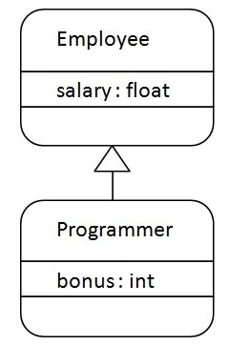

As displayed in the above figure, Programmer is the subclass and Employee is the superclass. The relationship between the two classes is **Programmer IS-A Employee**. It means that Programmer is a type of Employee.

1. **class** Employee{
2. **float** salary=40000;
3. }
4. **class** Programmer **extends** Employee{
5. **int** bonus=10000;
6. **public** **static** **void** main(String args[]){
7. Programmer p=**new** Programmer();
8. System.out.println("Programmer salary is:"+p.salary);
9. System.out.println("Bonus of Programmer is:"+p.bonus);
10. }
11. }

**[Test it Now](https://www.javatpoint.com/opr/test.jsp?filename=Programmer" \t "_blank)**

Programmer salary is:40000.0

Bonus of programmer is:10000

In the above example, Programmer object can access the field of own class as well as of Employee class i.e. code reusability.

## Types of inheritance in java

On the basis of class, there can be three types of inheritance in java: single, multilevel and hierarchical.

In java programming, multiple and hybrid inheritance is supported through interface only. We will learn about interfaces later.

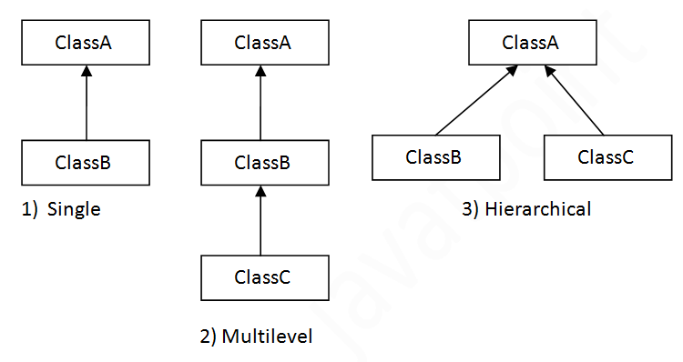

#### Note: Multiple inheritance is not supported in Java through class.

When one class inherits multiple classes, it is known as multiple inheritance. For Example:

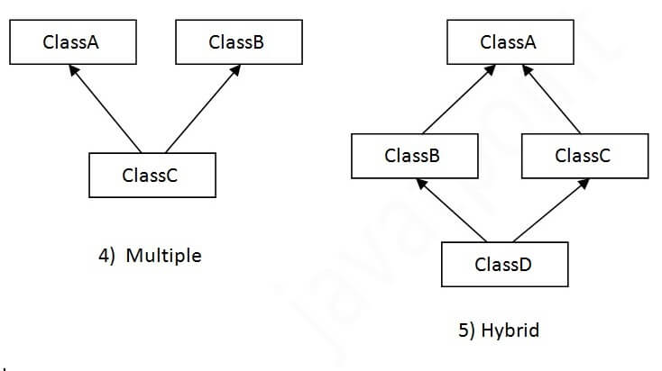

## Single Inheritance Example

When a class inherits another class, it is known as a single inheritance. In the example given below, Dog class inherits the Animal class, so there is the single inheritance.

*File: TestInheritance.java*

1. **class** Animal{
2. **void** eat(){System.out.println("eating...");}
3. }
4. **class** Dog **extends** Animal{
5. **void** bark(){System.out.println("barking...");}
6. }
7. **class** TestInheritance{
8. **public** **static** **void** main(String args[]){
9. Dog d=**new** Dog();
10. d.bark();
11. d.eat();
12. }}

Output:

barking...

eating...

## Multilevel Inheritance Example

When there is a chain of inheritance, it is known as multilevel inheritance. As you can see in the example given below, BabyDog class inherits the Dog class which again inherits the Animal class, so there is a multilevel inheritance.

*File: TestInheritance2.java*

1. **class** Animal{
2. **void** eat(){System.out.println("eating...");}
3. }
4. **class** Dog **extends** Animal{
5. **void** bark(){System.out.println("barking...");}
6. }
7. **class** BabyDog **extends** Dog{
8. **void** weep(){System.out.println("weeping...");}
9. }
10. **class** TestInheritance2{
11. **public** **static** **void** main(String args[]){
12. BabyDog d=**new** BabyDog();
13. d.weep();
14. d.bark();
15. d.eat();
16. }}

Output:

weeping...

barking...

eating...

## Hierarchical Inheritance Example

When two or more classes inherits a single class, it is known as hierarchical inheritance. In the example given below, Dog and Cat classes inherits the Animal class, so there is hierarchical inheritance.

*File: TestInheritance3.java*

1. **class** Animal{
2. **void** eat(){System.out.println("eating...");}
3. }
4. **class** Dog **extends** Animal{
5. **void** bark(){System.out.println("barking...");}
6. }
7. **class** Cat **extends** Animal{
8. **void** meow(){System.out.println("meowing...");}
9. }
10. **class** TestInheritance3{
11. **public** **static** **void** main(String args[]){
12. Cat c=**new** Cat();
13. c.meow();
14. c.eat();
15. //c.bark();//C.T.Error
16. }}

Output:

meowing...

eating...

## Q) Why multiple inheritance is not supported in java?

To reduce the complexity and simplify the language, multiple inheritance is not supported in java.

Consider a scenario where A, B, and C are three classes. The C class inherits A and B classes. If A and B classes have the same method and you call it from child class object, there will be ambiguity to call the method of A or B class.

Since compile-time errors are better than runtime errors, Java renders compile-time error if you inherit 2 classes. So whether you have same method or different, there will be compile time error.

1. **class** A{
2. **void** msg(){System.out.println("Hello");}
3. }
4. **class** B{
5. **void** msg(){System.out.println("Welcome");}
6. }
7. **class** C **extends** A,B{//suppose if it were
9. **public** **static** **void** main(String args[]){
10. C obj=**new** C();
11. obj.msg();//Now which msg() method would be invoked?
12. }
13. }

**[Test it Now](https://www.javatpoint.com/opr/test.jsp?filename=C" \t "_blank)**

Compile Time Error

# Aggregation in Java

If a class have an entity reference, it is known as Aggregation. Aggregation represents HAS-A relationship.

Consider a situation, Employee object contains many informations such as id, name, emailId etc. It contains one more object named address, which contains its own informations such as city, state, country, zipcode etc. as given below.

1. **class** Employee{
2. **int** id;
3. String name;
4. Address address;//Address is a class
5. ...
6. }

In such case, Employee has an entity reference address, so relationship is Employee HAS-A address.

### **Why use Aggregation?**

* For Code Reusability.

### **Simple Example of Aggregation**

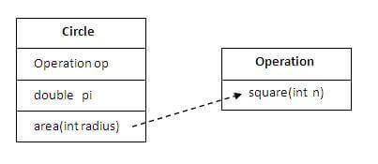

In this example, we have created the reference of Operation class in the Circle class.

25.6M

529

HTML Tutorial

1. **class** Operation{
2. **int** square(**int** n){
3. **return** n\*n;
4. }
5. }
7. **class** Circle{
8. Operation op;//aggregation
9. **double** pi=3.14;
11. **double** area(**int** radius){
12. op=**new** Operation();
13. **int** rsquare=op.square(radius);//code reusability (i.e. delegates the method call).
14. **return** pi\*rsquare;
15. }


19. **public** **static** **void** main(String args[]){
20. Circle c=**new** Circle();
21. **double** result=c.area(5);
22. System.out.println(result);
23. }
24. }

[**Test it Now**](https://www.javatpoint.com/opr/test.jsp?filename=Circle)

Output:78.5

### **When use Aggregation?**

* Code reuse is also best achieved by aggregation when there is no is-a relationship.
* Inheritance should be used only if the relationship is-a is maintained throughout the lifetime of the objects involved; otherwise, aggregation is the best choice.

### **Understanding meaningful example of Aggregation**

In this example, Employee has an object of Address, address object contains its own informations such as city, state, country etc. In such case relationship is Employee HAS-A address.

#### Address.java

1. **public** **class** Address {
2. String city,state,country;
4. **public** Address(String city, String state, String country) {
5. **this**.city = city;
6. **this**.state = state;
7. **this**.country = country;
8. }
10. }

#### Emp.java

1. **public** **class** Emp {
2. **int** id;
3. String name;
4. Address address;
6. **public** Emp(**int** id, String name,Address address) {
7. **this**.id = id;
8. **this**.name = name;
9. **this**.address=address;
10. }
12. **void** display(){
13. System.out.println(id+" "+name);
14. System.out.println(address.city+" "+address.state+" "+address.country);
15. }
17. **public** **static** **void** main(String[] args) {
18. Address address1=**new** Address("gzb","UP","india");
19. Address address2=**new** Address("gno","UP","india");
21. Emp e=**new** Emp(111,"varun",address1);
22. Emp e2=**new** Emp(112,"arun",address2);
24. e.display();
25. e2.display();
27. }
28. }

[**Test it Now**](https://www.javatpoint.com/opr/test.jsp?filename=Emp)

Output:111 varun

gzb UP india

112 arun

gno UP india

# Method Overloading in Java

1. [Different ways to overload the method](https://www.javatpoint.com/method-overloading-in-java#monumberofways)
2. [By changing the no. of arguments](https://www.javatpoint.com/method-overloading-in-java#mobynumber)
3. [By changing the datatype](https://www.javatpoint.com/method-overloading-in-java#mobydatatype)
4. [Why method overloading is not possible by changing the return type](https://www.javatpoint.com/method-overloading-in-java#moreturntype)
5. [Can we overload the main method](https://www.javatpoint.com/method-overloading-in-java#momainmethod)
6. [method overloading with Type Promotion](https://www.javatpoint.com/method-overloading-in-java#motypepromotion)

If a [class](https://www.javatpoint.com/object-and-class-in-java) has multiple methods having same name but different in parameters, it is known as **Method Overloading**.

If we have to perform only one operation, having same name of the methods increases the readability of the [program](https://www.javatpoint.com/java-programs).

Suppose you have to perform addition of the given numbers but there can be any number of arguments, if you write the method such as a(int,int) for two parameters, and b(int,int,int) for three parameters then it may be difficult for you as well as other programmers to understand the behavior of the method because its name differs.

So, we perform method overloading to figure out the program quickly.

33.1M

719

Exception Handling in Java - Javatpoint



## Advantage of method overloading

Method overloading increases the readability of the program.

### **Different ways to overload the method**

There are two ways to overload the method in java

1. By changing number of arguments
2. By changing the data type

#### In Java, Method Overloading is not possible by changing the return type of the method only.

### **1) Method Overloading: changing no. of arguments**

In this example, we have created two methods, first add() method performs addition of two numbers and second add method performs addition of three numbers.

In this example, we are creating [static methods](https://www.javatpoint.com/static-keyword-in-java) so that we don't need to create instance for calling methods.

1. **class** Adder{
2. **static** **int** add(**int** a,**int** b){**return** a+b;}
3. **static** **int** add(**int** a,**int** b,**int** c){**return** a+b+c;}
4. }
5. **class** TestOverloading1{
6. **public** **static** **void** main(String[] args){
7. System.out.println(Adder.add(11,11));
8. System.out.println(Adder.add(11,11,11));
9. }}

[**Test it Now**](https://www.javatpoint.com/opr/test.jsp?filename=TestOverloading1)

Output:

22

33

### **2) Method Overloading: changing data type of arguments**

In this example, we have created two methods that differs in [data type](https://www.javatpoint.com/java-data-types). The first add method receives two integer arguments and second add method receives two double arguments.

1. **class** Adder{
2. **static** **int** add(**int** a, **int** b){**return** a+b;}
3. **static** **double** add(**double** a, **double** b){**return** a+b;}
4. }
5. **class** TestOverloading2{
6. **public** **static** **void** main(String[] args){
7. System.out.println(Adder.add(11,11));
8. System.out.println(Adder.add(12.3,12.6));
9. }}

[**Test it Now**](https://www.javatpoint.com/opr/test.jsp?filename=TestOverloading2)

Output:

22

24.9

### **Q) Why Method Overloading is not possible by changing the return type of method only?**

In java, method overloading is not possible by changing the return type of the method only because of ambiguity. Let's see how ambiguity may occur:

1. **class** Adder{
2. **static** **int** add(**int** a,**int** b){**return** a+b;}
3. **static** **double** add(**int** a,**int** b){**return** a+b;}
4. }
5. **class** TestOverloading3{
6. **public** **static** **void** main(String[] args){
7. System.out.println(Adder.add(11,11));//ambiguity
8. }}

[**Test it Now**](https://www.javatpoint.com/opr/test.jsp?filename=TestOverloading3)

Output:

Compile Time Error: method add(int,int) is already defined in class Adder

System.out.println(Adder.add(11,11)); //Here, how can java determine which sum() method should be called?

#### Note: Compile Time Error is better than Run Time Error. So, java compiler renders compiler time error if you declare the same method having same parameters.

### **Can we overload java main() method?**

Yes, by method overloading. You can have any number of main methods in a class by method overloading. But [JVM](https://www.javatpoint.com/jvm-java-virtual-machine) calls main() method which receives string array as arguments only. Let's see the simple example:

1. **class** TestOverloading4{
2. **public** **static** **void** main(String[] args){System.out.println("main with String[]");}
3. **public** **static** **void** main(String args){System.out.println("main with String");}
4. **public** **static** **void** main(){System.out.println("main without args");}
5. }

[**Test it Now**](https://www.javatpoint.com/opr/test.jsp?filename=TestOverloading4)

Output:

main with String[]

## Method Overloading and Type Promotion

One type is promoted to another implicitly if no matching datatype is found. Let's understand the concept by the figure given below:

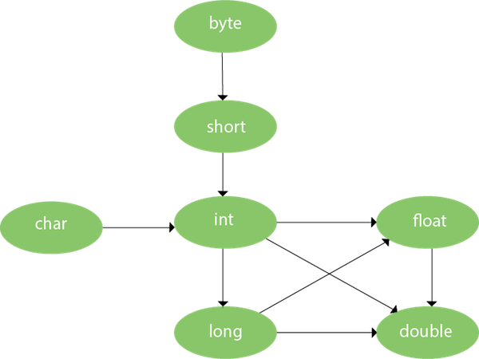

As displayed in the above diagram, byte can be promoted to short, int, long, float or double. The short datatype can be promoted to int, long, float or double. The char datatype can be promoted to int,long,float or double and so on.

### **Example of Method Overloading with TypePromotion**

1. **class** OverloadingCalculation1{
2. **void** sum(**int** a,**long** b){System.out.println(a+b);}
3. **void** sum(**int** a,**int** b,**int** c){System.out.println(a+b+c);}
5. **public** **static** **void** main(String args[]){
6. OverloadingCalculation1 obj=**new** OverloadingCalculation1();
7. obj.sum(20,20);//now second int literal will be promoted to long
8. obj.sum(20,20,20);
10. }
11. }

[**Test it Now**](https://www.javatpoint.com/opr/test.jsp?filename=OverloadingCalculation1)

Output:40

60

### **Example of Method Overloading with Type Promotion if matching found**

If there are matching type arguments in the method, type promotion is not performed.

1. **class** OverloadingCalculation2{
2. **void** sum(**int** a,**int** b){System.out.println("int arg method invoked");}
3. **void** sum(**long** a,**long** b){System.out.println("long arg method invoked");}
5. **public** **static** **void** main(String args[]){
6. OverloadingCalculation2 obj=**new** OverloadingCalculation2();
7. obj.sum(20,20);//now int arg sum() method gets invoked
8. }
9. }

[**Test it Now**](https://www.javatpoint.com/opr/test.jsp?filename=OverloadingCalculation2)

Output:int arg method invoked

### **Example of Method Overloading with Type Promotion in case of ambiguity**

If there are no matching type arguments in the method, and each method promotes similar number of arguments, there will be ambiguity.

1. **class** OverloadingCalculation3{
2. **void** sum(**int** a,**long** b){System.out.println("a method invoked");}
3. **void** sum(**long** a,**int** b){System.out.println("b method invoked");}
5. **public** **static** **void** main(String args[]){
6. OverloadingCalculation3 obj=**new** OverloadingCalculation3();
7. obj.sum(20,20);//now ambiguity
8. }
9. }

[**Test it Now**](https://www.javatpoint.com/opr/test.jsp?filename=OverloadingCalculation3) Time Error

#### One type is not de-promoted implicitly for example double cannot be depromoted to any type implicitly.

# Method Overriding in Java

1. [Understanding the problem without method overriding](https://www.javatpoint.com/method-overriding-in-java#moverproblem)
2. [Can we override the static method](https://www.javatpoint.com/method-overriding-in-java#movercanstatic)
3. [Method overloading vs. method overriding](https://www.javatpoint.com/method-overriding-in-java#moverdiff)

If subclass (child class) has the same method as declared in the parent class, it is known as **method overriding in Java**.

In other words, If a subclass provides the specific implementation of the method that has been declared by one of its parent class, it is known as method overriding.

### **Usage of Java Method Overriding**

* Method overriding is used to provide the specific implementation of a method which is already provided by its superclass.
* Method overriding is used for runtime polymorphism

#### Rules for Java Method Overriding

1. The method must have the same name as in the parent class
2. The method must have the same parameter as in the parent class.
3. There must be an IS-A relationship (inheritance).

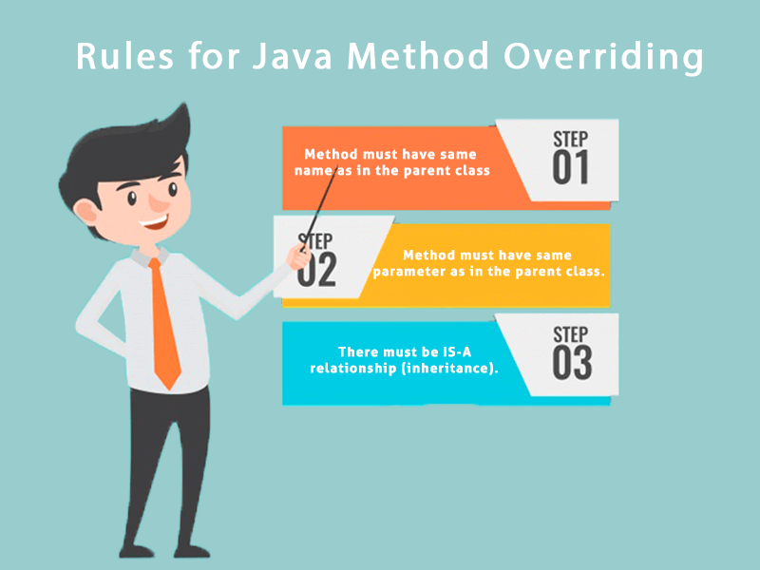

### **Understanding the problem without method overriding**

Let's understand the problem that we may face in the program if we don't use method overriding.

1. //Java Program to demonstrate why we need method overriding
2. //Here, we are calling the method of parent class with child
3. //class object.
4. //Creating a parent class
5. **class** Vehicle{
6. **void** run(){System.out.println("Vehicle is running");}
7. }
8. //Creating a child class
9. **class** Bike **extends** Vehicle{
10. **public** **static** **void** main(String args[]){
11. //creating an instance of child class
12. Bike obj = **new** Bike();
13. //calling the method with child class instance
14. obj.run();
15. }
16. }

[**Test it Now**](https://www.javatpoint.com/opr/test.jsp?filename=Bike)

Output:

31.8M

686

C++ vs Java

Vehicle is running

Problem is that I have to provide a specific implementation of run() method in subclass that is why we use method overriding.

### **Example of method overriding**

In this example, we have defined the run method in the subclass as defined in the parent class but it has some specific implementation. The name and parameter of the method are the same, and there is IS-A relationship between the classes, so there is method overriding.

1. //Java Program to illustrate the use of Java Method Overriding
2. //Creating a parent class.
3. **class** Vehicle{
4. //defining a method
5. **void** run(){System.out.println("Vehicle is running");}
6. }
7. //Creating a child class
8. **class** Bike2 **extends** Vehicle{
9. //defining the same method as in the parent class
10. **void** run(){System.out.println("Bike is running safely");}
12. **public** **static** **void** main(String args[]){
13. Bike2 obj = **new** Bike2();//creating object
14. obj.run();//calling method
15. }
16. }

[**Test it Now**](https://www.javatpoint.com/opr/test.jsp?filename=Bike2)

Output:

Bike is running safely

### **A real example of Java Method Overriding**

Consider a scenario where Bank is a class that provides functionality to get the rate of interest. However, the rate of interest varies according to banks. For example, SBI, ICICI and AXIS banks could provide 8%, 7%, and 9% rate of interest.

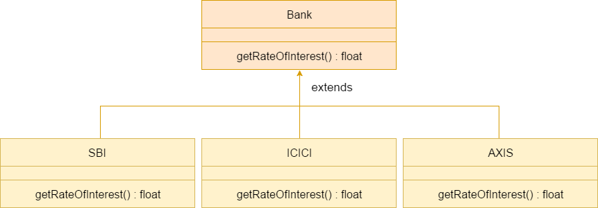

#### Java method overriding is mostly used in Runtime Polymorphism which we will learn in next pages.

1. //Java Program to demonstrate the real scenario of Java Method Overriding
2. //where three classes are overriding the method of a parent class.
3. //Creating a parent class.
4. **class** Bank{
5. **int** getRateOfInterest(){**return** 0;}
6. }
7. //Creating child classes.
8. **class** SBI **extends** Bank{
9. **int** getRateOfInterest(){**return** 8;}
10. }
12. **class** ICICI **extends** Bank{
13. **int** getRateOfInterest(){**return** 7;}
14. }
15. **class** AXIS **extends** Bank{
16. **int** getRateOfInterest(){**return** 9;}
17. }
18. //Test class to create objects and call the methods
19. **class** Test2{
20. **public** **static** **void** main(String args[]){
21. SBI s=**new** SBI();
22. ICICI i=**new** ICICI();
23. AXIS a=**new** AXIS();
24. System.out.println("SBI Rate of Interest: "+s.getRateOfInterest());
25. System.out.println("ICICI Rate of Interest: "+i.getRateOfInterest());
26. System.out.println("AXIS Rate of Interest: "+a.getRateOfInterest());
27. }
28. }

[**Test it Now**](https://www.javatpoint.com/opr/test.jsp?filename=Test2)

Output:

SBI Rate of Interest: 8

ICICI Rate of Interest: 7

AXIS Rate of Interest: 9

### **Can we override static method?**

No, a static method cannot be overridden. It can be proved by runtime polymorphism, so we will learn it later.

### **Why can we not override static method?**

It is because the static method is bound with class whereas instance method is bound with an object. Static belongs to the class area, and an instance belongs to the heap area.

### **Can we override java main method?**

No, because the main is a static method.

# Covariant Return Type

The covariant return type specifies that the return type may vary in the same direction as the subclass.

Before Java5, it was not possible to override any method by changing the return type. But now, since Java5, it is possible to override method by changing the return type if subclass overrides any method whose return type is Non-Primitive but it changes its return type to subclass type. Let's take a simple example:

#### Note: If you are beginner to java, skip this topic and return to it after OOPs concepts.

### **Simple example of Covariant Return Type**

**FileName:** B1.java

1. **class** A{
2. A get(){**return** **this**;}
3. }
5. **class** B1 **extends** A{
6. @Override
7. B1 get(){**return** **this**;}
8. **void** message(){System.out.println("welcome to covariant return type");}
10. **public** **static** **void** main(String args[]){
11. **new** B1().get().message();
12. }
13. }

[**Test it Now**](https://www.javatpoint.com/opr/test.jsp?filename=B1)

**Output:**

HTML Tutorial

welcome to covariant return type

As you can see in the above example, the return type of the get() method of A class is A but the return type of the get() method of B class is B. Both methods have different return type but it is method overriding. This is known as covariant return type.

## Advantages of Covariant Return Type

Following are the advantages of the covariant return type.

1) Covariant return type assists to stay away from the confusing type casts in the class hierarchy and makes the code more usable, readable, and maintainable.

2) In the method overriding, the covariant return type provides the liberty to have more to the point return types.

3) Covariant return type helps in preventing the run-time ClassCastExceptions on returns.

Let's take an example to understand the advantages of the covariant return type.

**FileName:** CovariantExample.java

1. **class** A1
2. {
3. A1 foo()
4. {
5. **return** **this**;
6. }
8. **void** print()
9. {
10. System.out.println("Inside the class A1");
11. }
12. }

15. // A2 is the child class of A1
16. **class** A2 **extends** A1
17. {
18. @Override
19. A1 foo()
20. {
21. **return** **this**;
22. }
24. **void** print()
25. {
26. System.out.println("Inside the class A2");
27. }
28. }
30. // A3 is the child class of A2
31. **class** A3 **extends** A2
32. {
33. @Override
34. A1 foo()
35. {
36. **return** **this**;
37. }
39. @Override
40. **void** print()
41. {
42. System.out.println("Inside the class A3");
43. }
44. }
46. **public** **class** CovariantExample
47. {
48. // main method
49. **public** **static** **void** main(String argvs[])
50. {
51. A1 a1 = **new** A1();
53. // this is ok
54. a1.foo().print();
56. A2 a2 = **new** A2();
58. // we need to do the type casting to make it
59. // more clear to reader about the kind of object created
60. ((A2)a2.foo()).print();
62. A3 a3 = **new** A3();
64. // doing the type casting
65. ((A3)a3.foo()).print();
67. }
68. }

**Output:**

Inside the class A1

Inside the class A2

Inside the class A3

**Explanation:** In the above program, class A3 inherits class A2, and class A2 inherits class A1. Thus, A1 is the parent of classes A2 and A3. Hence, any object of classes A2 and A3 is also of type A1. As the return type of the method foo() is the same in every class, we do not know the exact type of object the method is actually returning. We can only deduce that returned object will be of type A1, which is the most generic class. We can not say for sure that returned object will be of A2 or A3. It is where we need to do the typecasting to find out the specific type of object returned from the method foo(). It not only makes the code verbose; it also requires precision from the programmer to ensure that typecasting is done properly; otherwise, there are fair chances of getting the ClassCastException. To exacerbate it, think of a situation where the hierarchical structure goes down to 10 - 15 classes or even more, and in each class, the method foo() has the same return type. That is enough to give a nightmare to the reader and writer of the code.

The better way to write the above is:

**FileName:** CovariantExample.java

1. **class** A1
2. {
3. A1 foo()
4. {
5. **return** **this**;
6. }
8. **void** print()
9. {
10. System.out.println("Inside the class A1");
11. }
12. }

15. // A2 is the child class of A1
16. **class** A2 **extends** A1
17. {
18. @Override
19. A2 foo()
20. {
21. **return** **this**;
22. }
24. **void** print()
25. {
26. System.out.println("Inside the class A2");
27. }
28. }
30. // A3 is the child class of A2
31. **class** A3 **extends** A2
32. {
33. @Override
34. A3 foo()
35. {
36. **return** **this**;
37. }
39. @Override
40. **void** print()
41. {
42. System.out.println("Inside the class A3");
43. }
44. }
46. **public** **class** CovariantExample
47. {
48. // main method
49. **public** **static** **void** main(String argvs[])
50. {
51. A1 a1 = **new** A1();
53. a1.foo().print();
55. A2 a2 = **new** A2();
57. a2.foo().print();
59. A3 a3 = **new** A3();
61. a3.foo().print();
63. }
64. }

**Output:**

Inside the class A1

Inside the class A2

Inside the class A3

**Explanation:** In the above program, no typecasting is needed as the return type is specific. Hence, there is no confusion about knowing the type of object getting returned from the method foo(). Also, even if we write the code for the 10 - 15 classes, there would be no confusion regarding the return types of the methods. All this is possible because of the covariant return type.

### **How is Covariant return types implemented?**

Java doesn't allow the return type-based overloading, but JVM always allows return type-based overloading. JVM uses the full signature of a method for lookup/resolution. Full signature means it includes return type in addition to argument types. i.e., a class can have two or more methods differing only by return type. javac uses this fact to implement covariant return types.

**Output:**

The number 1 is not the powerful number.

The number 2 is not the powerful number.

The number 3 is not the powerful number.

The number 4 is the powerful number.

The number 5 is not the powerful number.

The number 6 is not the powerful number.

The number 7 is not the powerful number.

The number 8 is the powerful number.

The number 9 is the powerful number.

The number 10 is not the powerful number.

The number 11 is not the powerful number.

The number 12 is not the powerful number.

The number 13 is not the powerful number.

The number 14 is not the powerful number.

The number 15 is not the powerful number.

The number 16 is the powerful number.

The number 17 is not the powerful number.

The number 18 is not the powerful number.

The number 19 is not the powerful number.

The number 20 is the powerful number.

**Explanation:** For every number from 1 to 20, the method isPowerfulNo() is invoked with the help of for-loop. For every number, a vector primeFactors is created for storing its prime divisors. Then, we check whether square of every number present in the vector primeFactors divides the number or not. If all square of all the number present in the vector primeFactors divides the number completely, the number is a powerful number; otherwise, not.

Super Keyword in Java

The **super** keyword in Java is a reference variable which is used to refer immediate parent class object.

Whenever you create the instance of subclass, an instance of parent class is created implicitly which is referred by super reference variable.

Usage of Java super Keyword

1. super can be used to refer immediate parent class instance variable.
2. super can be used to invoke immediate parent class method.
3. super() can be used to invoke immediate parent class constructor.

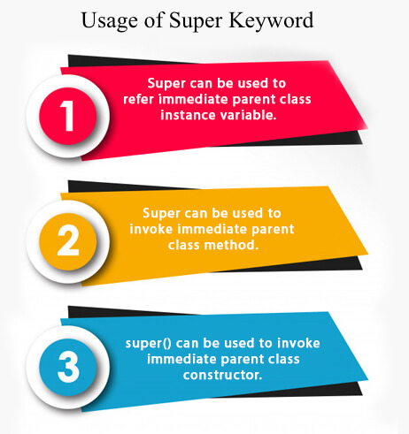

1) super is used to refer immediate parent class instance variable.

We can use super keyword to access the data member or field of parent class. It is used if parent class and child class have same fields.

1. **class** Animal{
2. String color="white";
3. }
4. **class** Dog **extends** Animal{
5. String color="black";
6. **void** printColor(){
7. System.out.println(color);//prints color of Dog class
8. System.out.println(**super**.color);//prints color of Animal class
9. }
10. }
11. **class** TestSuper1{
12. **public** **static** **void** main(String args[]){
13. Dog d=**new** Dog();
14. d.printColor();
15. }}

[**Test it Now**](https://www.javatpoint.com/opr/test.jsp?filename=TestSuper1)

Output:

C++ vs Java

black

white

In the above example, Animal and Dog both classes have a common property color. If we print color property, it will print the color of current class by default. To access the parent property, we need to use super keyword.

2) super can be used to invoke parent class method

The super keyword can also be used to invoke parent class method. It should be used if subclass contains the same method as parent class. In other words, it is used if method is overridden.

1. **class** Animal{
2. **void** eat(){System.out.println("eating...");}
3. }
4. **class** Dog **extends** Animal{
5. **void** eat(){System.out.println("eating bread...");}
6. **void** bark(){System.out.println("barking...");}
7. **void** work(){
8. **super**.eat();
9. bark();
10. }
11. }
12. **class** TestSuper2{
13. **public** **static** **void** main(String args[]){
14. Dog d=**new** Dog();
15. d.work();
16. }}

[**Test it Now**](https://www.javatpoint.com/opr/test.jsp?filename=TestSuper2)

Output:

eating...

barking...

In the above example Animal and Dog both classes have eat() method if we call eat() method from Dog class, it will call the eat() method of Dog class by default because priority is given to local.

To call the parent class method, we need to use super keyword.

3) super is used to invoke parent class constructor.

The super keyword can also be used to invoke the parent class constructor. Let's see a simple example:

1. **class** Animal{
2. Animal(){System.out.println("animal is created");}
3. }
4. **class** Dog **extends** Animal{
5. Dog(){
6. **super**();
7. System.out.println("dog is created");
8. }
9. }
10. **class** TestSuper3{
11. **public** **static** **void** main(String args[]){
12. Dog d=**new** Dog();
13. }}

[**Test it Now**](https://www.javatpoint.com/opr/test.jsp?filename=TestSuper3)

Output:

animal is created

dog is created

Note: super() is added in each class constructor automatically by compiler if there is no super() or this().

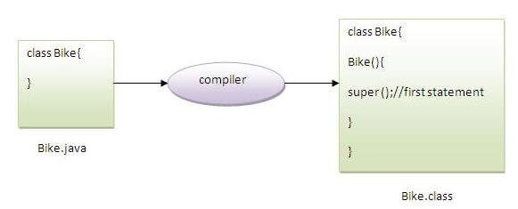

As we know well that default constructor is provided by compiler automatically if there is no constructor. But, it also adds super() as the first statement.

**Another example of super keyword where super() is provided by the compiler implicitly.**

1. **class** Animal{
2. Animal(){System.out.println("animal is created");}
3. }
4. **class** Dog **extends** Animal{
5. Dog(){
6. System.out.println("dog is created");
7. }
8. }
9. **class** TestSuper4{
10. **public** **static** **void** main(String args[]){
11. Dog d=**new** Dog();
12. }}

[**Test it Now**](https://www.javatpoint.com/opr/test.jsp?filename=TestSuper4)

Output:

animal is created

dog is created

super example: real use

Let's see the real use of super keyword. Here, Emp class inherits Person class so all the properties of Person will be inherited to Emp by default. To initialize all the property, we are using parent class constructor from child class. In such way, we are reusing the parent class constructor.

1. **class** Person{
2. **int** id;
3. String name;
4. Person(**int** id,String name){
5. **this**.id=id;
6. **this**.name=name;
7. }
8. }
9. **class** Emp **extends** Person{
10. **float** salary;
11. Emp(**int** id,String name,**float** salary){
12. **super**(id,name);//reusing parent constructor
13. **this**.salary=salary;
14. }
15. **void** display(){System.out.println(id+" "+name+" "+salary);}
16. }
17. **class** TestSuper5{
18. **public** **static** **void** main(String[] args){
19. Emp e1=**new** Emp(1,"ankit",45000f);
20. e1.display();
21. }}

[**Test it Now**](https://www.javatpoint.com/opr/test.jsp?filename=TestSuper5)

Output:

1 ankit 45000

# Instance initializer block

1. [Instance initializer block](https://www.javatpoint.com/instance-initializer-block)
2. [Example of Instance initializer block](https://www.javatpoint.com/instance-initializer-block" \l "instanceinitializerex)
3. [What is invoked firstly instance initializer block or constructor?](https://www.javatpoint.com/instance-initializer-block" \l "instanceinitializerfirstly)
4. [Rules for instance initializer block](https://www.javatpoint.com/instance-initializer-block" \l "instanceinitializerrules)
5. [Program of instance initializer block that is invoked after super()](https://www.javatpoint.com/instance-initializer-block" \l "instanceinitializersuper)

|  |
| --- |
| **Instance Initializer block** is used to initialize the instance data member. It run each time when object of the class is created. |
| The initialization of the instance variable can be done directly but there can be performed extra operations while initializing the instance variable in the instance initializer block. |

#### Que) What is the use of instance initializer block while we can directly assign a value in instance data member? For example:

1. **class** Bike{
2. **int** speed=100;
3. }

## Why use instance initializer block?

|  |
| --- |
| Suppose I have to perform some operations while assigning value to instance data member e.g. a for loop to fill a complex array or error handling etc. |

### **Example of instance initializer block**

|  |
| --- |
| Let's see the simple example of instance initializer block that performs initialization. |

1. **class** Bike7{
2. **int** speed;
4. Bike7(){System.out.println("speed is "+speed);}
6. {speed=100;}
8. **public** **static** **void** main(String args[]){
9. Bike7 b1=**new** Bike7();
10. Bike7 b2=**new** Bike7();
11. }
12. }

**[Test it Now](https://www.javatpoint.com/opr/test.jsp?filename=Bike7" \t "_blank)**

Output:speed is 100

speed is 100

|  |
| --- |
| There are three places in java where you can perform operations:   1. method 2. constructor 3. block |

## What is invoked first, instance initializer block or constructor?

1. **class** Bike8{
2. **int** speed;
4. Bike8(){System.out.println("constructor is invoked");}
6. {System.out.println("instance initializer block invoked");}
8. **public** **static** **void** main(String args[]){
9. Bike8 b1=**new** Bike8();
10. Bike8 b2=**new** Bike8();
11. }
12. }

**[Test it Now](https://www.javatpoint.com/opr/test.jsp?filename=Bike8" \t "_blank)**

Output:instance initializer block invoked

constructor is invoked

instance initializer block invoked

constructor is invoked

|  |
| --- |
| In the above example, it seems that instance initializer block is firstly invoked but NO. Instance intializer block is invoked at the time of object creation. The java compiler copies the instance initializer block in the constructor after the first statement super(). So firstly, constructor is invoked. Let's understand it by the figure given below: |

#### Note: The java compiler copies the code of instance initializer block in every constructor.

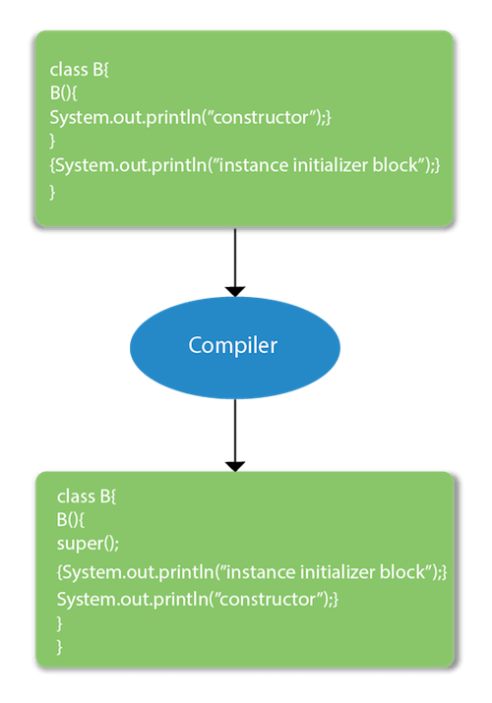

## Rules for instance initializer block :

|  |
| --- |
| There are mainly three rules for the instance initializer block. They are as follows: |

1. The instance initializer block is created when instance of the class is created.
2. The instance initializer block is invoked after the parent class constructor is invoked (i.e. after super() constructor call).
3. The instance initializer block comes in the order in which they appear.

## Program of instance initializer block that is invoked after super()

1. **class** A{
2. A(){
3. System.out.println("parent class constructor invoked");
4. }
5. }
6. **class** B2 **extends** A{
7. B2(){
8. **super**();
9. System.out.println("child class constructor invoked");
10. }
12. {System.out.println("instance initializer block is invoked");}
14. **public** **static** **void** main(String args[]){
15. B2 b=**new** B2();
16. }
17. }

**[Test it Now](https://www.javatpoint.com/opr/test.jsp?filename=B2" \t "_blank)**

Output:parent class constructor invoked

instance initializer block is invoked

child class constructor invoked

## Another example of instance block

1. **class** A{
2. A(){
3. System.out.println("parent class constructor invoked");
4. }
5. }
7. **class** B3 **extends** A{
8. B3(){
9. **super**();
10. System.out.println("child class constructor invoked");
11. }
13. B3(**int** a){
14. **super**();
15. System.out.println("child class constructor invoked "+a);
16. }
18. {System.out.println("instance initializer block is invoked");}
20. **public** **static** **void** main(String args[]){
21. B3 b1=**new** B3();
22. B3 b2=**new** B3(10);
23. }
24. }

**[Test it Now](https://www.javatpoint.com/opr/test.jsp?filename=B3" \t "_blank)**

parent class constructor invoked

instance initializer block is invoked

child class constructor invoked

parent class constructor invoked

instance initializer block is invoked

child class constructor invoked 10

# Final Keyword In Java

1. [Final variable](https://www.javatpoint.com/final-keyword#finalv)
2. [Final method](https://www.javatpoint.com/final-keyword#finalm)
3. [Final class](https://www.javatpoint.com/final-keyword#finalc)
4. [Is final method inherited ?](https://www.javatpoint.com/final-keyword#finalisinherited)
5. [Blank final variable](https://www.javatpoint.com/final-keyword#finalblank)
6. [Static blank final variable](https://www.javatpoint.com/final-keyword#finalstaticblank)
7. [Final parameter](https://www.javatpoint.com/final-keyword#finalpara)
8. [Can you declare a final constructor](https://www.javatpoint.com/final-keyword#finalcons)

The **final keyword** in java is used to restrict the user. The java final keyword can be used in many context. Final can be:

1. variable
2. method
3. class

The final keyword can be applied with the variables, a final variable that have no value it is called blank final variable or uninitialized final variable. It can be initialized in the constructor only. The blank final variable can be static also which will be initialized in the static block only. We will have detailed learning of these. Let's first learn the basics of final keyword.

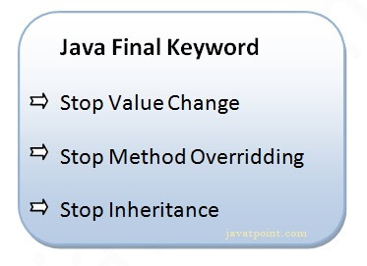

## 1) Java final variable

If you make any variable as final, you cannot change the value of final variable(It will be constant).

### **Example of final variable**

There is a final variable speedlimit, we are going to change the value of this variable, but It can't be changed because final variable once assigned a value can never be changed.

Difference between JDK, JRE, and JVM

1. **class** Bike9{
2. **final** **int** speedlimit=90;//final variable
3. **void** run(){
4. speedlimit=400;
5. }
6. **public** **static** **void** main(String args[]){
7. Bike9 obj=**new**  Bike9();
8. obj.run();
9. }
10. }//end of class

[**Test it Now**](https://www.javatpoint.com/opr/test.jsp?filename=Bike9)

Output:Compile Time Error

## 2) Java final method

If you make any method as final, you cannot override it.

### **Example of final method**

1. **class** Bike{
2. **final** **void** run(){System.out.println("running");}
3. }
5. **class** Honda **extends** Bike{
6. **void** run(){System.out.println("running safely with 100kmph");}
8. **public** **static** **void** main(String args[]){
9. Honda honda= **new** Honda();
10. honda.run();
11. }
12. }

[**Test it Now**](https://www.javatpoint.com/opr/test.jsp?filename=Honda)

Output:Compile Time Error

## 3) Java final class

If you make any class as final, you cannot extend it.

### **Example of final class**

1. **final** **class** Bike{}
3. **class** Honda1 **extends** Bike{
4. **void** run(){System.out.println("running safely with 100kmph");}
6. **public** **static** **void** main(String args[]){
7. Honda1 honda= **new** Honda1();
8. honda.run();
9. }
10. }

[**Test it Now**](https://www.javatpoint.com/opr/test.jsp?filename=Honda1)

Output:Compile Time Error

### **Q) Is final method inherited?**

Ans) Yes, final method is inherited but you cannot override it. For Example:

1. **class** Bike{
2. **final** **void** run(){System.out.println("running...");}
3. }
4. **class** Honda2 **extends** Bike{
5. **public** **static** **void** main(String args[]){
6. **new** Honda2().run();
7. }
8. }

[**Test it Now**](https://www.javatpoint.com/opr/test.jsp?filename=Honda2)

Output:running...

### **Q) What is blank or uninitialized final variable?**

A final variable that is not initialized at the time of declaration is known as blank final variable.

If you want to create a variable that is initialized at the time of creating object and once initialized may not be changed, it is useful. For example PAN CARD number of an employee.

It can be initialized only in constructor.

### **Example of blank final variable**

1. **class** Student{
2. **int** id;
3. String name;
4. **final** String PAN\_CARD\_NUMBER;
5. ...
6. }

### **Que) Can we initialize blank final variable?**

Yes, but only in constructor. For example:

1. **class** Bike10{
2. **final** **int** speedlimit;//blank final variable
4. Bike10(){
5. speedlimit=70;
6. System.out.println(speedlimit);
7. }
9. **public** **static** **void** main(String args[]){
10. **new** Bike10();
11. }
12. }

[**Test it Now**](https://www.javatpoint.com/opr/test.jsp?filename=Bike10)

Output: 70

### **static blank final variable**

A static final variable that is not initialized at the time of declaration is known as static blank final variable. It can be initialized only in static block.

### **Example of static blank final variable**

1. **class** A{
2. **static** **final** **int** data;//static blank final variable
3. **static**{ data=50;}
4. **public** **static** **void** main(String args[]){
5. System.out.println(A.data);
6. }
7. }

### **Q) What is final parameter?**

If you declare any parameter as final, you cannot change the value of it.

1. **class** Bike11{
2. **int** cube(**final** **int** n){
3. n=n+2;//can't be changed as n is final
4. n\*n\*n;
5. }
6. **public** **static** **void** main(String args[]){
7. Bike11 b=**new** Bike11();
8. b.cube(5);
9. }
10. }

[**Test it Now**](https://www.javatpoint.com/opr/test.jsp?filename=Bike11)

Output: Compile Time Error

### **Q) Can we declare a constructor final?**

No, because constructor is never inherited.

# Polymorphism in Java

**Polymorphism in Java** is a concept by which we can perform a single action in different ways. Polymorphism is derived from 2 Greek words: poly and morphs. The word "poly" means many and "morphs" means forms. So polymorphism means many forms.

There are two types of polymorphism in Java: compile-time polymorphism and runtime polymorphism. We can perform polymorphism in java by method overloading and method overriding.

If you overload a static method in Java, it is the example of compile time polymorphism. Here, we will focus on runtime polymorphism in java.

## Runtime Polymorphism in Java

**Runtime polymorphism** or **Dynamic Method Dispatch** is a process in which a call to an overridden method is resolved at runtime rather than compile-time.

33.3M

572

Hello Java Program for Beginners

In this process, an overridden method is called through the reference variable of a superclass. The determination of the method to be called is based on the object being referred to by the reference variable.

Let's first understand the upcasting before Runtime Polymorphism.

### **Upcasting**

If the reference variable of Parent class refers to the object of Child class, it is known as upcasting. For example:

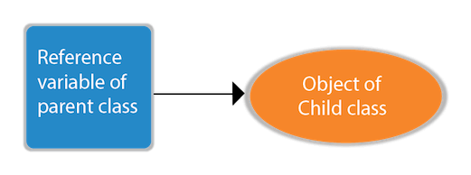

1. **class** A{}
2. **class** B **extends** A{}
3. A a=**new** B();//upcasting

For upcasting, we can use the reference variable of class type or an interface type. For Example:

1. **interface** I{}
2. **class** A{}
3. **class** B **extends** A **implements** I{}

Here, the relationship of B class would be:

B IS-A A

B IS-A I

B IS-A Object

Since Object is the root class of all classes in Java, so we can write B IS-A Object.

### **Example of Java Runtime Polymorphism**

In this example, we are creating two classes Bike and Splendor. Splendor class extends Bike class and overrides its run() method. We are calling the run method by the reference variable of Parent class. Since it refers to the subclass object and subclass method overrides the Parent class method, the subclass method is invoked at runtime.

Since method invocation is determined by the JVM not compiler, it is known as runtime polymorphism.

1. **class** Bike{
2. **void** run(){System.out.println("running");}
3. }
4. **class** Splendor **extends** Bike{
5. **void** run(){System.out.println("running safely with 60km");}
7. **public** **static** **void** main(String args[]){
8. Bike b = **new** Splendor();//upcasting
9. b.run();
10. }
11. }

[**Test it Now**](https://www.javatpoint.com/opr/test.jsp?filename=Splender)

Output:

running safely with 60km.

## Java Runtime Polymorphism Example: Bank

Consider a scenario where Bank is a class that provides a method to get the rate of interest. However, the rate of interest may differ according to banks. For example, SBI, ICICI, and AXIS banks are providing 8.4%, 7.3%, and 9.7% rate of interest.



#### Note: This example is also given in method overriding but there was no upcasting.

1. **class** Bank{
2. **float** getRateOfInterest(){**return** 0;}
3. }
4. **class** SBI **extends** Bank{
5. **float** getRateOfInterest(){**return** 8.4f;}
6. }
7. **class** ICICI **extends** Bank{
8. **float** getRateOfInterest(){**return** 7.3f;}
9. }
10. **class** AXIS **extends** Bank{
11. **float** getRateOfInterest(){**return** 9.7f;}
12. }
13. **class** TestPolymorphism{
14. **public** **static** **void** main(String args[]){
15. Bank b;
16. b=**new** SBI();
17. System.out.println("SBI Rate of Interest: "+b.getRateOfInterest());
18. b=**new** ICICI();
19. System.out.println("ICICI Rate of Interest: "+b.getRateOfInterest());
20. b=**new** AXIS();
21. System.out.println("AXIS Rate of Interest: "+b.getRateOfInterest());
22. }
23. }

[**Test it Now**](https://www.javatpoint.com/opr/test.jsp?filename=TestPolymorphism)

Output:

SBI Rate of Interest: 8.4

ICICI Rate of Interest: 7.3

AXIS Rate of Interest: 9.7

## Java Runtime Polymorphism Example: Shape

1. **class** Shape{
2. **void** draw(){System.out.println("drawing...");}
3. }
4. **class** Rectangle **extends** Shape{
5. **void** draw(){System.out.println("drawing rectangle...");}
6. }
7. **class** Circle **extends** Shape{
8. **void** draw(){System.out.println("drawing circle...");}
9. }
10. **class** Triangle **extends** Shape{
11. **void** draw(){System.out.println("drawing triangle...");}
12. }
13. **class** TestPolymorphism2{
14. **public** **static** **void** main(String args[]){
15. Shape s;
16. s=**new** Rectangle();
17. s.draw();
18. s=**new** Circle();
19. s.draw();
20. s=**new** Triangle();
21. s.draw();
22. }
23. }

[**Test it Now**](https://www.javatpoint.com/opr/test.jsp?filename=TestPolymorphism2)

Output:

drawing rectangle...

drawing circle...

drawing triangle...

## Java Runtime Polymorphism Example: Animal

1. **class** Animal{
2. **void** eat(){System.out.println("eating...");}
3. }
4. **class** Dog **extends** Animal{
5. **void** eat(){System.out.println("eating bread...");}
6. }
7. **class** Cat **extends** Animal{
8. **void** eat(){System.out.println("eating rat...");}
9. }
10. **class** Lion **extends** Animal{
11. **void** eat(){System.out.println("eating meat...");}
12. }
13. **class** TestPolymorphism3{
14. **public** **static** **void** main(String[] args){
15. Animal a;
16. a=**new** Dog();
17. a.eat();
18. a=**new** Cat();
19. a.eat();
20. a=**new** Lion();
21. a.eat();
22. }}

[**Test it Now**](https://www.javatpoint.com/opr/test.jsp?filename=TestPolymorphism3)

Output:

eating bread...

eating rat...

eating meat...

## Java Runtime Polymorphism with Data Member

A method is overridden, not the data members, so runtime polymorphism can't be achieved by data members.

In the example given below, both the classes have a data member speedlimit. We are accessing the data member by the reference variable of Parent class which refers to the subclass object. Since we are accessing the data member which is not overridden, hence it will access the data member of the Parent class always.

#### Rule: Runtime polymorphism can't be achieved by data members.

1. **class** Bike{
2. **int** speedlimit=90;
3. }
4. **class** Honda3 **extends** Bike{
5. **int** speedlimit=150;
7. **public** **static** **void** main(String args[]){
8. Bike obj=**new** Honda3();
9. System.out.println(obj.speedlimit);//90
10. }

[**Test it Now**](https://www.javatpoint.com/opr/test.jsp?filename=Honda3)

Output:

90

## Java Runtime Polymorphism with Multilevel Inheritance

Let's see the simple example of Runtime Polymorphism with multilevel inheritance.

1. **class** Animal{
2. **void** eat(){System.out.println("eating");}
3. }
4. **class** Dog **extends** Animal{
5. **void** eat(){System.out.println("eating fruits");}
6. }
7. **class** BabyDog **extends** Dog{
8. **void** eat(){System.out.println("drinking milk");}
9. **public** **static** **void** main(String args[]){
10. Animal a1,a2,a3;
11. a1=**new** Animal();
12. a2=**new** Dog();
13. a3=**new** BabyDog();
14. a1.eat();
15. a2.eat();
16. a3.eat();
17. }
18. }

[**Test it Now**](https://www.javatpoint.com/opr/test.jsp?filename=BabyDog)

Output:

eating

eating fruits

drinking Milk

### **Try for Output**

1. **class** Animal{
2. **void** eat(){System.out.println("animal is eating...");}
3. }
4. **class** Dog **extends** Animal{
5. **void** eat(){System.out.println("dog is eating...");}
6. }
7. **class** BabyDog1 **extends** Dog{
8. **public** **static** **void** main(String args[]){
9. Animal a=**new** BabyDog1();
10. a.eat();
11. }}

[**Test it Now**](https://www.javatpoint.com/opr/test.jsp?filename=BabyDog1)

Output:

Dog is eating

Since, BabyDog is not overriding the eat() method, so eat() method of Dog class is invoked.

# Static Binding and Dynamic Binding



Connecting a method call to the method body is known as binding.

There are two types of binding

1. Static Binding (also known as Early Binding).
2. Dynamic Binding (also known as Late Binding).

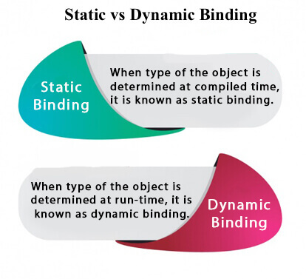

### **Understanding Type**

Let's understand the type of instance.

#### 1) variables have a type

Each variable has a type, it may be primitive and non-primitive.

22.5M

429

Prime Ministers of India | List of Prime Minister of India (1947-2020)

1. **int** data=30;

Here data variable is a type of int.

#### 2) References have a type

1. **class** Dog{
2. **public** **static** **void** main(String args[]){
3. Dog d1;//Here d1 is a type of Dog
4. }
5. }

#### 3) Objects have a type

|  |
| --- |
| An object is an instance of particular java class,but it is also an instance of its superclass. |

1. **class** Animal{}
3. **class** Dog **extends** Animal{
4. **public** **static** **void** main(String args[]){
5. Dog d1=**new** Dog();
6. }
7. }

|  |
| --- |
| Here d1 is an instance of Dog class, but it is also an instance of Animal. |

### **static binding**

When type of the object is determined at compiled time(by the compiler), it is known as static binding.

If there is any private, final or static method in a class, there is static binding.

### **Example of static binding**

1. **class** Dog{
2. **private** **void** eat(){System.out.println("dog is eating...");}
4. **public** **static** **void** main(String args[]){
5. Dog d1=**new** Dog();
6. d1.eat();
7. }
8. }

### **Dynamic binding**

When type of the object is determined at run-time, it is known as dynamic binding.

### **Example of dynamic binding**

1. **class** Animal{
2. **void** eat(){System.out.println("animal is eating...");}
3. }
5. **class** Dog **extends** Animal{
6. **void** eat(){System.out.println("dog is eating...");}
8. **public** **static** **void** main(String args[]){
9. Animal a=**new** Dog();
10. a.eat();
11. }
12. }

**[Test it Now](https://www.javatpoint.com/opr/test.jsp?filename=Dog" \t "_blank)**

Output:dog is eating...

|  |
| --- |
| In the above example object type cannot be determined by the compiler, because the instance of Dog is also an instance of Animal.So compiler doesn't know its type, only its base type. |

# Java instanceof

1. [java instanceof](https://www.javatpoint.com/downcasting-with-instanceof-operator#instanceof)
2. [Example of instanceof operator](https://www.javatpoint.com/downcasting-with-instanceof-operator#instanceofex)
3. [Applying the instanceof operator with a variable the have null value](https://www.javatpoint.com/downcasting-with-instanceof-operator#instanceofnull)
4. [Downcasting with instanceof operator](https://www.javatpoint.com/downcasting-with-instanceof-operator#instanceofdowncasting)
5. [Downcasting without instanceof operator](https://www.javatpoint.com/downcasting-with-instanceof-operator#instanceofdowncastingwithout)

The **java instanceof operator** is used to test whether the object is an instance of the specified type (class or subclass or interface).

The instanceof in java is also known as type *comparison operator* because it compares the instance with type. It returns either true or false. If we apply the instanceof operator with any variable that has null value, it returns false.

### **Simple example of java instanceof**

Let's see the simple example of instance operator where it tests the current class.

1. **class** Simple1{
2. **public** **static** **void** main(String args[]){
3. Simple1 s=**new** Simple1();
4. System.out.println(s **instanceof** Simple1);//true
5. }
6. }

[**Test it Now**](https://www.javatpoint.com/opr/test.jsp?filename=Simple1)

Output:true

An object of subclass type is also a type of parent class. For example, if Dog extends Animal then object of Dog can be referred by either Dog or Animal class.

10 Sec

Java Try Catch

## Another example of java instanceof operator

1. **class** Animal{}
2. **class** Dog1 **extends** Animal{//Dog inherits Animal
4. **public** **static** **void** main(String args[]){
5. Dog1 d=**new** Dog1();
6. System.out.println(d **instanceof** Animal);//true
7. }
8. }

[**Test it Now**](https://www.javatpoint.com/opr/test.jsp?filename=Dog1)

Output:true

## instanceof in java with a variable that have null value

If we apply instanceof operator with a variable that have null value, it returns false. Let's see the example given below where we apply instanceof operator with the variable that have null value.

1. **class** Dog2{
2. **public** **static** **void** main(String args[]){
3. Dog2 d=**null**;
4. System.out.println(d **instanceof** Dog2);//false
5. }
6. }

[**Test it Now**](https://www.javatpoint.com/opr/test.jsp?filename=Dog2)

Output:false

## Downcasting with java instanceof operator

When Subclass type refers to the object of Parent class, it is known as downcasting. If we perform it directly, compiler gives Compilation error. If you perform it by typecasting, ClassCastException is thrown at runtime. But if we use instanceof operator, downcasting is possible.

1. Dog d=**new** Animal();//Compilation error

If we perform downcasting by typecasting, ClassCastException is thrown at runtime.

1. Dog d=(Dog)**new** Animal();
2. //Compiles successfully but ClassCastException is thrown at runtime

### **Possibility of downcasting with instanceof**

Let's see the example, where downcasting is possible by instanceof operator.

1. **class** Animal { }
3. **class** Dog3 **extends** Animal {
4. **static** **void** method(Animal a) {
5. **if**(a **instanceof** Dog3){
6. Dog3 d=(Dog3)a;//downcasting
7. System.out.println("ok downcasting performed");
8. }
9. }
11. **public** **static** **void** main (String [] args) {
12. Animal a=**new** Dog3();
13. Dog3.method(a);
14. }
16. }

[**Test it Now**](https://www.javatpoint.com/opr/test.jsp?filename=Dog3)

Output:ok downcasting performed

### **Downcasting without the use of java instanceof**

Downcasting can also be performed without the use of instanceof operator as displayed in the following example:

1. **class** Animal { }
2. **class** Dog4 **extends** Animal {
3. **static** **void** method(Animal a) {
4. Dog4 d=(Dog4)a;//downcasting
5. System.out.println("ok downcasting performed");
6. }
7. **public** **static** **void** main (String [] args) {
8. Animal a=**new** Dog4();
9. Dog4.method(a);
10. }
11. }

[**Test it Now**](https://www.javatpoint.com/opr/test.jsp?filename=Dog4)

Output:ok downcasting performed

Let's take closer look at this, actual object that is referred by a, is an object of Dog class. So if we downcast it, it is fine. But what will happen if we write:

1. Animal a=**new** Animal();
2. Dog.method(a);
3. //Now ClassCastException but not in case of instanceof operator

### **Understanding Real use of instanceof in java**

Let's see the real use of instanceof keyword by the example given below.

1. **interface** Printable{}
2. **class** A **implements** Printable{
3. **public** **void** a(){System.out.println("a method");}
4. }
5. **class** B **implements** Printable{
6. **public** **void** b(){System.out.println("b method");}
7. }
9. **class** Call{
10. **void** invoke(Printable p){//upcasting
11. **if**(p **instanceof** A){
12. A a=(A)p;//Downcasting
13. a.a();
14. }
15. **if**(p **instanceof** B){
16. B b=(B)p;//Downcasting
17. b.b();
18. }
20. }
21. }//end of Call class
23. **class** Test4{
24. **public** **static** **void** main(String args[]){
25. Printable p=**new** B();
26. Call c=**new** Call();
27. c.invoke(p);
28. }
29. }

[**Test it Now**](https://www.javatpoint.com/opr/test.jsp?filename=Test4)

Output: b method

# Abstract class in Java

A class which is declared with the abstract keyword is known as an abstract class in [Java](https://www.javatpoint.com/java-tutorial). It can have abstract and non-abstract methods (method with the body).

Before learning the Java abstract class, let's understand the abstraction in Java first.

### **Abstraction in Java**

**Abstraction** is a process of hiding the implementation details and showing only functionality to the user.

Another way, it shows only essential things to the user and hides the internal details, for example, sending SMS where you type the text and send the message. You don't know the internal processing about the message delivery.

32.4M

741

Features of Java - Javatpoint

Abstraction lets you focus on what the [object](https://www.javatpoint.com/object-and-class-in-java) does instead of how it does it.

### **Ways to achieve Abstraction**

There are two ways to achieve abstraction in java

1. Abstract class (0 to 100%)
2. Interface (100%)

### **Abstract class in Java**

A class which is declared as abstract is known as an **abstract class**. It can have abstract and non-abstract methods. It needs to be extended and its method implemented. It cannot be instantiated.

#### Points to Remember

* An abstract class must be declared with an abstract keyword.
* It can have abstract and non-abstract methods.
* It cannot be instantiated.
* It can have [constructors](https://www.javatpoint.com/java-constructor) and static methods also.
* It can have final methods which will force the subclass not to change the body of the method.

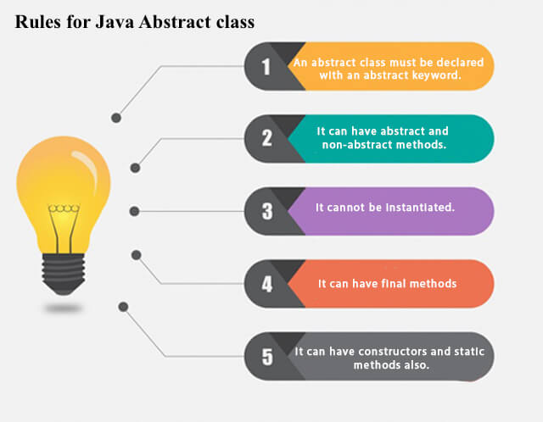

**Example of abstract class**

1. **abstract** **class** A{}

### **Abstract Method in Java**

A method which is declared as abstract and does not have implementation is known as an abstract method.

**Example of abstract method**

1. **abstract** **void** printStatus();//no method body and abstract

### **Example of Abstract class that has an abstract method**

In this example, Bike is an abstract class that contains only one abstract method run. Its implementation is provided by the Honda class.

1. **abstract** **class** Bike{
2. **abstract** **void** run();
3. }
4. **class** Honda4 **extends** Bike{
5. **void** run(){System.out.println("running safely");}
6. **public** **static** **void** main(String args[]){
7. Bike obj = **new** Honda4();
8. obj.run();
9. }
10. }

[**Test it Now**](https://www.javatpoint.com/opr/test.jsp?filename=Honda4)

running safely

### **Understanding the real scenario of Abstract class**

In this example, Shape is the abstract class, and its implementation is provided by the Rectangle and Circle classes.

Mostly, we don't know about the implementation class (which is hidden to the end user), and an object of the implementation class is provided by the **factory method**.

A **factory method** is a method that returns the instance of the class. We will learn about the factory method later.

In this example, if you create the instance of Rectangle class, draw() method of Rectangle class will be invoked.

*File: TestAbstraction1.java*

1. **abstract** **class** Shape{
2. **abstract** **void** draw();
3. }
4. //In real scenario, implementation is provided by others i.e. unknown by end user
5. **class** Rectangle **extends** Shape{
6. **void** draw(){System.out.println("drawing rectangle");}
7. }
8. **class** Circle1 **extends** Shape{
9. **void** draw(){System.out.println("drawing circle");}
10. }
11. //In real scenario, method is called by programmer or user
12. **class** TestAbstraction1{
13. **public** **static** **void** main(String args[]){
14. Shape s=**new** Circle1();//In a real scenario, object is provided through method, e.g., getShape() method
15. s.draw();
16. }
17. }

[**Test it Now**](https://www.javatpoint.com/opr/test.jsp?filename=TestAbstraction1)

drawing circle

### **Another example of Abstract class in java**

*File: TestBank.java*

1. **abstract** **class** Bank{
2. **abstract** **int** getRateOfInterest();
3. }
4. **class** SBI **extends** Bank{
5. **int** getRateOfInterest(){**return** 7;}
6. }
7. **class** PNB **extends** Bank{
8. **int** getRateOfInterest(){**return** 8;}
9. }
11. **class** TestBank{
12. **public** **static** **void** main(String args[]){
13. Bank b;
14. b=**new** SBI();
15. System.out.println("Rate of Interest is: "+b.getRateOfInterest()+" %");
16. b=**new** PNB();
17. System.out.println("Rate of Interest is: "+b.getRateOfInterest()+" %");
18. }}

[**Test it Now**](https://www.javatpoint.com/opr/test.jsp?filename=TestBank)

Rate of Interest is: 7 %

Rate of Interest is: 8 %

### **Abstract class having constructor, data member and methods**

An abstract class can have a data member, abstract method, method body (non-abstract method), constructor, and even main() method.

*File: TestAbstraction2.java*

1. //Example of an abstract class that has abstract and non-abstract methods
2. **abstract** **class** Bike{
3. Bike(){System.out.println("bike is created");}
4. **abstract** **void** run();
5. **void** changeGear(){System.out.println("gear changed");}
6. }
7. //Creating a Child class which inherits Abstract class
8. **class** Honda **extends** Bike{
9. **void** run(){System.out.println("running safely..");}
10. }
11. //Creating a Test class which calls abstract and non-abstract methods
12. **class** TestAbstraction2{
13. **public** **static** **void** main(String args[]){
14. Bike obj = **new** Honda();
15. obj.run();
16. obj.changeGear();
17. }
18. }

[**Test it Now**](https://www.javatpoint.com/opr/test.jsp?filename=TestAbstraction2)

bike is created

running safely..

gear changed

#### Rule: If there is an abstract method in a class, that class must be abstract.

1. **class** Bike12{
2. **abstract** **void** run();
3. }

[**Test it Now**](https://www.javatpoint.com/opr/test.jsp?filename=Bike12)

compile time error

#### Rule: If you are extending an abstract class that has an abstract method, you must either provide the implementation of the method or make this class abstract.

### **Another real scenario of abstract class**

The abstract class can also be used to provide some implementation of the [interface](https://www.javatpoint.com/interface-in-java). In such case, the end user may not be forced to override all the methods of the interface.

#### *Note: If you are beginner to java, learn interface first and skip this example.*

1. **interface** A{
2. **void** a();
3. **void** b();
4. **void** c();
5. **void** d();
6. }
8. **abstract** **class** B **implements** A{
9. **public** **void** c(){System.out.println("I am c");}
10. }
12. **class** M **extends** B{
13. **public** **void** a(){System.out.println("I am a");}
14. **public** **void** b(){System.out.println("I am b");}
15. **public** **void** d(){System.out.println("I am d");}
16. }
18. **class** Test5{
19. **public** **static** **void** main(String args[]){
20. A a=**new** M();
21. a.a();
22. a.b();
23. a.c();
24. a.d();
25. }}

[**Test it Now**](https://www.javatpoint.com/opr/test.jsp?filename=Test5)

Output:I am a

I am b

I am c

I am d

# Interface in Java

1. [Interface](https://www.javatpoint.com/interface-in-java)
2. [Example of Interface](https://www.javatpoint.com/interface-in-java#interfaceex)
3. [Multiple inheritance by Interface](https://www.javatpoint.com/interface-in-java#interfacemultiple)
4. [Why multiple inheritance is supported in Interface while it is not supported in case of class.](https://www.javatpoint.com/interface-in-java#interfacewhynot)
5. [Marker Interface](https://www.javatpoint.com/interface-in-java#interfacemarker)
6. [Nested Interface](https://www.javatpoint.com/nested-interface)

An **interface in Java** is a blueprint of a class. It has static constants and abstract methods.

The interface in Java is a mechanism to achieve [*abstraction*](https://www.javatpoint.com/abstract-class-in-java). There can be only abstract methods in the Java interface, not method body. It is used to achieve abstraction and multiple [inheritance in Java](https://www.javatpoint.com/inheritance-in-java).

In other words, you can say that interfaces can have abstract methods and variables. It cannot have a method body.

Java Interface also **represents the IS-A relationship**.

Competitive questions on Structures in Hindi

Keep Watching

It cannot be instantiated just like the abstract class.

Since Java 8, we can have **default and static methods** in an interface.

Since Java 9, we can have **private methods** in an interface.

## Why use Java interface?

There are mainly three reasons to use interface. They are given below.

* It is used to achieve abstraction.
* By interface, we can support the functionality of multiple inheritance.
* It can be used to achieve loose coupling.

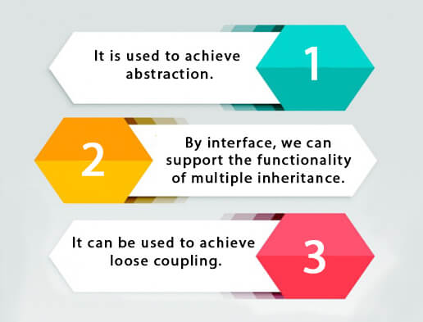

## How to declare an interface?

An interface is declared by using the interface keyword. It provides total abstraction; means all the methods in an interface are declared with the empty body, and all the fields are public, static and final by default. A class that implements an interface must implement all the methods declared in the interface.

### **Syntax:**

1. **interface** <interface\_name>{
3. // declare constant fields
4. // declare methods that abstract
5. // by default.
6. }

## Java 8 Interface Improvement

Since [Java 8](https://www.javatpoint.com/java-8-features), interface can have default and static methods which is discussed later.

## Internal addition by the compiler

#### The Java compiler adds public and abstract keywords before the interface method. Moreover, it adds public, static and final keywords before data members.

In other words, Interface fields are public, static and final by default, and the methods are public and abstract.

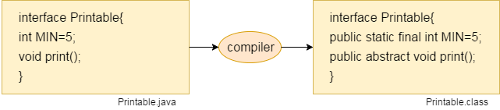

#### The relationship between classes and interfaces

As shown in the figure given below, a class extends another class, an interface extends another interface, but a **class implements an interface**.

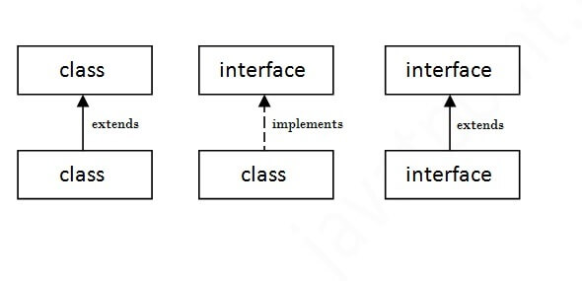

## Java Interface Example

In this example, the Printable interface has only one method, and its implementation is provided in the A6 class.

1. **interface** printable{
2. **void** print();
3. }
4. **class** A6 **implements** printable{
5. **public** **void** print(){System.out.println("Hello");}
7. **public** **static** **void** main(String args[]){
8. A6 obj = **new** A6();
9. obj.print();
10. }
11. }

[**Test it Now**](https://www.javatpoint.com/opr/test.jsp?filename=A6)

Output:

Hello

## Java Interface Example: Drawable

In this example, the Drawable interface has only one method. Its implementation is provided by Rectangle and Circle classes. In a real scenario, an interface is defined by someone else, but its implementation is provided by different implementation providers. Moreover, it is used by someone else. The implementation part is hidden by the user who uses the interface.

*File: TestInterface1.java*

1. //Interface declaration: by first user
2. **interface** Drawable{
3. **void** draw();
4. }
5. //Implementation: by second user
6. **class** Rectangle **implements** Drawable{
7. **public** **void** draw(){System.out.println("drawing rectangle");}
8. }
9. **class** Circle **implements** Drawable{
10. **public** **void** draw(){System.out.println("drawing circle");}
11. }
12. //Using interface: by third user
13. **class** TestInterface1{
14. **public** **static** **void** main(String args[]){
15. Drawable d=**new** Circle();//In real scenario, object is provided by method e.g. getDrawable()
16. d.draw();
17. }}

[**Test it Now**](https://www.javatpoint.com/opr/test.jsp?filename=TestInterface1)

Output:

drawing circle

## Java Interface Example: Bank

Let's see another example of java interface which provides the implementation of Bank interface.

*File: TestInterface2.java*

1. **interface** Bank{
2. **float** rateOfInterest();
3. }
4. **class** SBI **implements** Bank{
5. **public** **float** rateOfInterest(){**return** 9.15f;}
6. }
7. **class** PNB **implements** Bank{
8. **public** **float** rateOfInterest(){**return** 9.7f;}
9. }
10. **class** TestInterface2{
11. **public** **static** **void** main(String[] args){
12. Bank b=**new** SBI();
13. System.out.println("ROI: "+b.rateOfInterest());
14. }}

[**Test it Now**](https://www.javatpoint.com/opr/test.jsp?filename=TestInterface2)

Output:

ROI: 9.15

## Multiple inheritance in Java by interface

If a class implements multiple interfaces, or an interface extends multiple interfaces, it is known as multiple inheritance.

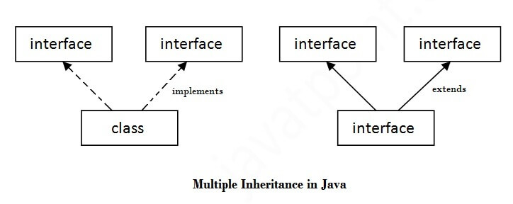

1. **interface** Printable{
2. **void** print();
3. }
4. **interface** Showable{
5. **void** show();
6. }
7. **class** A7 **implements** Printable,Showable{
8. **public** **void** print(){System.out.println("Hello");}
9. **public** **void** show(){System.out.println("Welcome");}
11. **public** **static** **void** main(String args[]){
12. A7 obj = **new** A7();
13. obj.print();
14. obj.show();
15. }
16. }

[**Test it Now**](https://www.javatpoint.com/opr/test.jsp?filename=A7)

Output:Hello

Welcome

## Q) Multiple inheritance is not supported through class in java, but it is possible by an interface, why?

As we have explained in the inheritance chapter, multiple inheritance is not supported in the case of [class](https://www.javatpoint.com/object-and-class-in-java) because of ambiguity. However, it is supported in case of an interface because there is no ambiguity. It is because its implementation is provided by the implementation class. For example:

1. **interface** Printable{
2. **void** print();
3. }
4. **interface** Showable{
5. **void** print();
6. }
8. **class** TestInterface3 **implements** Printable, Showable{
9. **public** **void** print(){System.out.println("Hello");}
10. **public** **static** **void** main(String args[]){
11. TestInterface3 obj = **new** TestInterface3();
12. obj.print();
13. }
14. }

[**Test it Now**](https://www.javatpoint.com/opr/test.jsp?filename=TestInterface3)

Output:

Hello

As you can see in the above example, Printable and Showable interface have same methods but its implementation is provided by class TestTnterface1, so there is no ambiguity.

## Interface inheritance

A class implements an interface, but one interface extends another interface.

1. **interface** Printable{
2. **void** print();
3. }
4. **interface** Showable **extends** Printable{
5. **void** show();
6. }
7. **class** TestInterface4 **implements** Showable{
8. **public** **void** print(){System.out.println("Hello");}
9. **public** **void** show(){System.out.println("Welcome");}
11. **public** **static** **void** main(String args[]){
12. TestInterface4 obj = **new** TestInterface4();
13. obj.print();
14. obj.show();
15. }
16. }

[**Test it Now**](https://www.javatpoint.com/opr/test.jsp?filename=TestInterface4)

Output:

Hello

Welcome

## Java 8 Default Method in Interface

Since Java 8, we can have method body in interface. But we need to make it default method. Let's see an example:

*File: TestInterfaceDefault.java*

1. **interface** Drawable{
2. **void** draw();
3. **default** **void** msg(){System.out.println("default method");}
4. }
5. **class** Rectangle **implements** Drawable{
6. **public** **void** draw(){System.out.println("drawing rectangle");}
7. }
8. **class** TestInterfaceDefault{
9. **public** **static** **void** main(String args[]){
10. Drawable d=**new** Rectangle();
11. d.draw();
12. d.msg();
13. }}

[**Test it Now**](https://www.javatpoint.com/opr/test.jsp?filename=TestInterfaceDefault)

Output:

drawing rectangle

default method

## Java 8 Static Method in Interface

Since Java 8, we can have static method in interface. Let's see an example:

*File: TestInterfaceStatic.java*

1. **interface** Drawable{
2. **void** draw();
3. **static** **int** cube(**int** x){**return** x\*x\*x;}
4. }
5. **class** Rectangle **implements** Drawable{
6. **public** **void** draw(){System.out.println("drawing rectangle");}
7. }
9. **class** TestInterfaceStatic{
10. **public** **static** **void** main(String args[]){
11. Drawable d=**new** Rectangle();
12. d.draw();
13. System.out.println(Drawable.cube(3));
14. }}

[**Test it Now**](https://www.javatpoint.com/opr/test.jsp?filename=TestInterfaceStatic)

Output:

drawing rectangle

27

## Q) What is marker or tagged interface?

An interface which has no member is known as a marker or tagged interface, for example, [Serializable](https://www.javatpoint.com/serialization-in-java), Cloneable, Remote, etc. They are used to provide some essential information to the JVM so that JVM may perform some useful operation.

1. //How Serializable interface is written?
2. **public** **interface** Serializable{
3. }

#### Nested Interface in Java

Note: An interface can have another interface which is known as a nested interface. We will learn it in detail in the [nested classes](https://www.javatpoint.com/java-inner-class) chapter. For example:

1. **interface** printable{
2. **void** print();
3. **interface** MessagePrintable{
4. **void** msg();
5. }
6. }

# Difference between abstract class and interface

Abstract class and interface both are used to achieve abstraction where we can declare the abstract methods. Abstract class and interface both can't be instantiated.

But there are many differences between abstract class and interface that are given below.

|  |  |
| --- | --- |
| **Abstract class** | **Interface** |
| 1) Abstract class can **have abstract and non-abstract** methods. | Interface can have **only abstract** methods. Since Java 8, it can have **default and static methods** also. |
| 2) Abstract class **doesn't support multiple inheritance**. | Interface **supports multiple inheritance**. |
| 3) Abstract class **can have final, non-final, static and non-static variables**. | Interface has **only static and final variables**. |
| 4) Abstract class **can provide the implementation of interface**. | Interface **can't provide the implementation of abstract class**. |
| 5) The **abstract keyword** is used to declare abstract class. | The **interface keyword** is used to declare interface. |
| 6) An **abstract class** can extend another Java class and implement multiple Java interfaces. | An **interface** can extend another Java interface only. |
| 7) An **abstract class** can be extended using keyword "extends". | An **interface** can be implemented using keyword "implements". |
| 8) A Java **abstract class** can have class members like private, protected, etc. | Members of a Java interface are public by default. |
| 9)**Example:** public abstract class Shape{ public abstract void draw(); } | **Example:** public interface Drawable{ void draw(); } |

Simply, abstract class achieves partial abstraction (0 to 100%) whereas interface achieves fully abstraction (100%).

### **Example of abstract class and interface in Java**

Let's see a simple example where we are using interface and abstract class both.

26.7M

568

How to find Nth Highest Salary in SQL

1. //Creating interface that has 4 methods
2. **interface** A{
3. **void** a();//bydefault, public and abstract
4. **void** b();
5. **void** c();
6. **void** d();
7. }
9. //Creating abstract class that provides the implementation of one method of A interface
10. **abstract** **class** B **implements** A{
11. **public** **void** c(){System.out.println("I am C");}
12. }
14. //Creating subclass of abstract class, now we need to provide the implementation of rest of the methods
15. **class** M **extends** B{
16. **public** **void** a(){System.out.println("I am a");}
17. **public** **void** b(){System.out.println("I am b");}
18. **public** **void** d(){System.out.println("I am d");}
19. }
21. //Creating a test class that calls the methods of A interface
22. **class** Test5{
23. **public** **static** **void** main(String args[]){
24. A a=**new** M();
25. a.a();
26. a.b();
27. a.c();
28. a.d();
29. }}

**[Test it Now](https://www.javatpoint.com/opr/test.jsp?filename=Test5" \t "_blank)**

Output:

I am a

I am b

I am c

I am d

# Java Package

1. [Java Package](https://www.javatpoint.com/package)
2. [Example of package](https://www.javatpoint.com/package#packageex)
3. [Accessing package](https://www.javatpoint.com/package#packageaccess)
   1. [By import packagename.\*](https://www.javatpoint.com/package#packageaccess1)
   2. [By import packagename.classname](https://www.javatpoint.com/package#packageaccess2)
   3. [By fully qualified name](https://www.javatpoint.com/package#packageaccess3)
4. [Subpackage](https://www.javatpoint.com/package#packagesub)
5. [Sending class file to another directory](https://www.javatpoint.com/package#packageanotherdirectory)
6. [-classpath switch](https://www.javatpoint.com/package#packageclasspathswitch)
7. [4 ways to load the class file or jar file](https://www.javatpoint.com/package#packagewaystoload)
8. [How to put two public class in a package](https://www.javatpoint.com/package#packagetwopublic)
9. [Static Import](https://www.javatpoint.com/package#packagestaticimport)
10. [Package class](https://www.javatpoint.com/package-class)

A **java package** is a group of similar types of classes, interfaces and sub-packages.

Package in java can be categorized in two form, built-in package and user-defined package.

There are many built-in packages such as java, lang, awt, javax, swing, net, io, util, sql etc.

Here, we will have the detailed learning of creating and using user-defined packages.

27.2M

542

Java Try Catch

## Advantage of Java Package

1) Java package is used to categorize the classes and interfaces so that they can be easily maintained.

2) Java package provides access protection.

3) Java package removes naming collision.

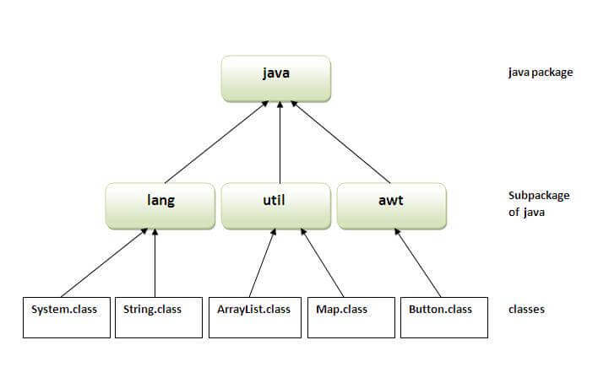

## Simple example of java package

The **package keyword** is used to create a package in java.

1. //save as Simple.java
2. **package** mypack;
3. **public** **class** Simple{
4. **public** **static** **void** main(String args[]){
5. System.out.println("Welcome to package");
6. }
7. }

## How to compile java package

If you are not using any IDE, you need to follow the **syntax** given below:

1. javac -d directory javafilename

For **example**

1. javac -d . Simple.java

The -d switch specifies the destination where to put the generated class file. You can use any directory name like /home (in case of Linux), d:/abc (in case of windows) etc. If you want to keep the package within the same directory, you can use . (dot).

## How to run java package program

You need to use fully qualified name e.g. mypack.Simple etc to run the class.

|  |
| --- |
| **To Compile:** javac -d . Simple.java |
| **To Run:** java mypack.Simple |

Output:Welcome to package

|  |
| --- |
| The -d is a switch that tells the compiler where to put the class file i.e. it represents destination. The . represents the current folder. |

## How to access package from another package?

There are three ways to access the package from outside the package.

1. import package.\*;
2. import package.classname;
3. fully qualified name.

#### 1) Using packagename.\*

If you use package.\* then all the classes and interfaces of this package will be accessible but not subpackages.

The import keyword is used to make the classes and interface of another package accessible to the current package.

## Example of package that import the packagename.\*

1. //save by A.java
2. **package** pack;
3. **public** **class** A{
4. **public** **void** msg(){System.out.println("Hello");}
5. }
6. //save by B.java
7. **package** mypack;
8. **import** pack.\*;
10. **class** B{
11. **public** **static** **void** main(String args[]){
12. A obj = **new** A();
13. obj.msg();
14. }
15. }

Output:Hello

#### 2) Using packagename.classname

If you import package.classname then only declared class of this package will be accessible.

## Example of package by import package.classname

1. //save by A.java
3. **package** pack;
4. **public** **class** A{
5. **public** **void** msg(){System.out.println("Hello");}
6. }
7. //save by B.java
8. **package** mypack;
9. **import** pack.A;
11. **class** B{
12. **public** **static** **void** main(String args[]){
13. A obj = **new** A();
14. obj.msg();
15. }
16. }

Output:Hello

#### 3) Using fully qualified name

If you use fully qualified name then only declared class of this package will be accessible. Now there is no need to import. But you need to use fully qualified name every time when you are accessing the class or interface.

It is generally used when two packages have same class name e.g. java.util and java.sql packages contain Date class.

## Example of package by import fully qualified name

1. //save by A.java
2. **package** pack;
3. **public** **class** A{
4. **public** **void** msg(){System.out.println("Hello");}
5. }
6. //save by B.java
7. **package** mypack;
8. **class** B{
9. **public** **static** **void** main(String args[]){
10. pack.A obj = **new** pack.A();//using fully qualified name
11. obj.msg();
12. }
13. }

Output:Hello

#### Note: If you import a package, subpackages will not be imported.

If you import a package, all the classes and interface of that package will be imported excluding the classes and interfaces of the subpackages. Hence, you need to import the subpackage as well.

#### Note: Sequence of the program must be package then import then class.

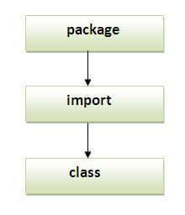

## Subpackage in java

Package inside the package is called the **subpackage**. It should be created **to categorize the package further**.

Let's take an example, Sun Microsystem has definded a package named java that contains many classes like System, String, Reader, Writer, Socket etc. These classes represent a particular group e.g. Reader and Writer classes are for Input/Output operation, Socket and ServerSocket classes are for networking etc and so on. So, Sun has subcategorized the java package into subpackages such as lang, net, io etc. and put the Input/Output related classes in io package, Server and ServerSocket classes in net packages and so on.

#### The standard of defining package is domain.company.package e.g. com.javatpoint.bean or org.sssit.dao.

### **Example of Subpackage**

1. **package** com.javatpoint.core;
2. **class** Simple{
3. **public** **static** **void** main(String args[]){
4. System.out.println("Hello subpackage");
5. }
6. }

|  |
| --- |
| **To Compile:** javac -d . Simple.java |
| **To Run:** java com.javatpoint.core.Simple |

Output:Hello subpackage

## How to send the class file to another directory or drive?

There is a scenario, I want to put the class file of A.java source file in classes folder of c: drive. For example:

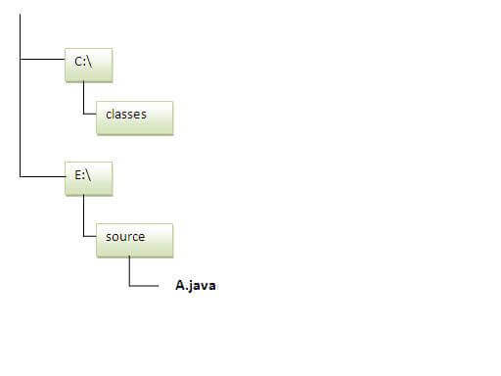

1. //save as Simple.java
2. **package** mypack;
3. **public** **class** Simple{
4. **public** **static** **void** main(String args[]){
5. System.out.println("Welcome to package");
6. }
7. }

### **To Compile:**

**e:\sources> javac -d c:\classes Simple.java**

### **To Run:**

|  |
| --- |
| To run this program from e:\source directory, you need to set classpath of the directory where the class file resides. |
| **e:\sources> set classpath=c:\classes;.;** |
| **e:\sources> java mypack.Simple** |

### **Another way to run this program by -classpath switch of java:**

The -classpath switch can be used with javac and java tool.

To run this program from e:\source directory, you can use -classpath switch of java that tells where to look for class file. For example:

**e:\sources> java -classpath c:\classes mypack.Simple**

Output:Welcome to package

### **Ways to load the class files or jar files**

|  |
| --- |
| There are two ways to load the class files temporary and permanent. |

* Temporary
  + By setting the classpath in the command prompt
  + By -classpath switch
* Permanent
  + By setting the classpath in the environment variables
  + By creating the jar file, that contains all the class files, and copying the jar file in the jre/lib/ext folder.

#### Rule: There can be only one public class in a java source file and it must be saved by the public class name.

1. //save as C.java otherwise Compilte Time Error
3. **class** A{}
4. **class** B{}
5. **public** **class** C{}

### **How to put two public classes in a package?**

|  |
| --- |
| If you want to put two public classes in a package, have two java source files containing one public class, but keep the package name same. For example: |

1. //save as A.java
3. **package** javatpoint;
4. **public** **class** A{}
5. //save as B.java
7. **package** javatpoint;
8. **public** **class** B{}

# Access Modifiers in Java

1. [Private access modifier](https://www.javatpoint.com/access-modifiers#accessprivate)
2. [Role of private constructor](https://www.javatpoint.com/access-modifiers#accessprivatecons)
3. [Default access modifier](https://www.javatpoint.com/access-modifiers#accessdefault)
4. [Protected access modifier](https://www.javatpoint.com/access-modifiers#accessprotected)
5. [Public access modifier](https://www.javatpoint.com/access-modifiers#accesspublic)
6. [Access Modifier with Method Overriding](https://www.javatpoint.com/access-modifiers#accessoverriding)

There are two types of modifiers in Java: **access modifiers** and **non-access modifiers**.

The access modifiers in Java specifies the accessibility or scope of a field, method, constructor, or class. We can change the access level of fields, constructors, methods, and class by applying the access modifier on it.

There are four types of Java access modifiers:

1. **Private**: The access level of a private modifier is only within the class. It cannot be accessed from outside the class.
2. **Default**: The access level of a default modifier is only within the package. It cannot be accessed from outside the package. If you do not specify any access level, it will be the default.
3. **Protected**: The access level of a protected modifier is within the package and outside the package through child class. If you do not make the child class, it cannot be accessed from outside the package.
4. **Public**: The access level of a public modifier is everywhere. It can be accessed from within the class, outside the class, within the package and outside the package.

There are many non-access modifiers, such as static, abstract, synchronized, native, volatile, transient, etc. Here, we are going to learn the access modifiers only.

Competitive questions on Structures in Hindi

Keep Watching

### **Understanding Java Access Modifiers**

Let's understand the access modifiers in Java by a simple table.

|  |  |  |  |  |
| --- | --- | --- | --- | --- |
| **Access Modifier** | **within class** | **within package** | **outside package by subclass only** | **outside package** |
| **Private** | Y | N | N | N |
| **Default** | Y | Y | N | N |
| **Protected** | Y | Y | Y | N |
| **Public** | Y | Y | Y | Y |

### **1) Private**

The private access modifier is accessible only within the class.

**Simple example of private access modifier**

In this example, we have created two classes A and Simple. A class contains private data member and private method. We are accessing these private members from outside the class, so there is a compile-time error.

1. **class** A{
2. **private** **int** data=40;
3. **private** **void** msg(){System.out.println("Hello java");}
4. }
6. **public** **class** Simple{
7. **public** **static** **void** main(String args[]){
8. A obj=**new** A();
9. System.out.println(obj.data);//Compile Time Error
10. obj.msg();//Compile Time Error
11. }
12. }

### **Role of Private Constructor**

If you make any class constructor private, you cannot create the instance of that class from outside the class. For example:

1. **class** A{
2. **private** A(){}//private constructor
3. **void** msg(){System.out.println("Hello java");}
4. }
5. **public** **class** Simple{
6. **public** **static** **void** main(String args[]){
7. A obj=**new** A();//Compile Time Error
8. }
9. }

#### Note: A class cannot be private or protected except nested class.

### **2) Default**

If you don't use any modifier, it is treated as **default** by default. The default modifier is accessible only within package. It cannot be accessed from outside the package. It provides more accessibility than private. But, it is more restrictive than protected, and public.

**Example of default access modifier**

In this example, we have created two packages pack and mypack. We are accessing the A class from outside its package, since A class is not public, so it cannot be accessed from outside the package.

1. //save by A.java
2. **package** pack;
3. **class** A{
4. **void** msg(){System.out.println("Hello");}
5. }
6. //save by B.java
7. **package** mypack;
8. **import** pack.\*;
9. **class** B{
10. **public** **static** **void** main(String args[]){
11. A obj = **new** A();//Compile Time Error
12. obj.msg();//Compile Time Error
13. }
14. }

In the above example, the scope of class A and its method msg() is default so it cannot be accessed from outside the package.

### **3) Protected**

The **protected access modifier** is accessible within package and outside the package but through inheritance only.

The protected access modifier can be applied on the data member, method and constructor. It can't be applied on the class.

It provides more accessibility than the default modifer.

**Example of protected access modifier**

In this example, we have created the two packages pack and mypack. The A class of pack package is public, so can be accessed from outside the package. But msg method of this package is declared as protected, so it can be accessed from outside the class only through inheritance.

1. //save by A.java
2. **package** pack;
3. **public** **class** A{
4. **protected** **void** msg(){System.out.println("Hello");}
5. }
6. //save by B.java
7. **package** mypack;
8. **import** pack.\*;
10. **class** B **extends** A{
11. **public** **static** **void** main(String args[]){
12. B obj = **new** B();
13. obj.msg();
14. }
15. }

Output:Hello

### **4) Public**

The **public access modifier** is accessible everywhere. It has the widest scope among all other modifiers.

**Example of public access modifier**

1. //save by A.java
3. **package** pack;
4. **public** **class** A{
5. **public** **void** msg(){System.out.println("Hello");}
6. }
7. //save by B.java
9. **package** mypack;
10. **import** pack.\*;
12. **class** B{
13. **public** **static** **void** main(String args[]){
14. A obj = **new** A();
15. obj.msg();
16. }
17. }

Output:Hello

### **Java Access Modifiers with Method Overriding**

If you are overriding any method, overridden method (i.e. declared in subclass) must not be more restrictive.

1. **class** A{
2. **protected** **void** msg(){System.out.println("Hello java");}
3. }
5. **public** **class** Simple **extends** A{
6. **void** msg(){System.out.println("Hello java");}//C.T.Error
7. **public** **static** **void** main(String args[]){
8. Simple obj=**new** Simple();
9. obj.msg();
10. }
11. }

The default modifier is more restrictive than protected. That is why, there is a compile-time error.

# Encapsulation in Java

**Encapsulation in Java** is a process of wrapping code and data together into a single unit, for example, a capsule which is mixed of several medicines.



We can create a fully encapsulated class in Java by making all the data members of the class private. Now we can use setter and getter methods to set and get the data in it.

The **Java Bean** class is the example of a fully encapsulated class.

### **Advantage of Encapsulation in Java**

By providing only a setter or getter method, you can make the class **read-only or write-only**. In other words, you can skip the getter or setter methods.

Prime Ministers of India | List of Prime Minister of India (1947-2020)

It provides you the **control over the data**. Suppose you want to set the value of id which should be greater than 100 only, you can write the logic inside the setter method. You can write the logic not to store the negative numbers in the setter methods.

It is a way to achieve **data hiding** in Java because other class will not be able to access the data through the private data members.

The encapsulate class is **easy to test**. So, it is better for unit testing.

The standard IDE's are providing the facility to generate the getters and setters. So, it is **easy and fast to create an encapsulated class** in Java.

### **Simple Example of Encapsulation in Java**

Let's see the simple example of encapsulation that has only one field with its setter and getter methods.

*File: Student.java*

1. //A Java class which is a fully encapsulated class.
2. //It has a private data member and getter and setter methods.
3. **package** com.javatpoint;
4. **public** **class** Student{
5. //private data member
6. **private** String name;
7. //getter method for name
8. **public** String getName(){
9. **return** name;
10. }
11. //setter method for name
12. **public** **void** setName(String name){
13. **this**.name=name
14. }
15. }

*File: Test.java*

1. //A Java class to test the encapsulated class.
2. **package** com.javatpoint;
3. **class** Test{
4. **public** **static** **void** main(String[] args){
5. //creating instance of the encapsulated class
6. Student s=**new** Student();
7. //setting value in the name member
8. s.setName("vijay");
9. //getting value of the name member
10. System.out.println(s.getName());
11. }
12. }

Compile By: javac -d . Test.java

Run By: java com.javatpoint.Test

Output:

vijay

### **Read-Only class**

1. //A Java class which has only getter methods.
2. **public** **class** Student{
3. //private data member
4. **private** String college="AKG";
5. //getter method for college
6. **public** String getCollege(){
7. **return** college;
8. }
9. }

Now, you can't change the value of the college data member which is "AKG".

1. s.setCollege("KITE");//will render compile time error

### **Write-Only class**

1. //A Java class which has only setter methods.
2. **public** **class** Student{
3. //private data member
4. **private** String college;
5. //getter method for college
6. **public** **void** setCollege(String college){
7. **this**.college=college;
8. }
9. }

Now, you can't get the value of the college, you can only change the value of college data member.

1. System.out.println(s.getCollege());//Compile Time Error, because there is no such method
2. System.out.println(s.college);//Compile Time Error, because the college data member is private.
3. //So, it can't be accessed from outside the class

### **Another Example of Encapsulation in Java**

Let's see another example of encapsulation that has only four fields with its setter and getter methods.

*File: Account.java*

1. //A Account class which is a fully encapsulated class.
2. //It has a private data member and getter and setter methods.
3. **class** Account {
4. //private data members
5. **private** **long** acc\_no;
6. **private** String name,email;
7. **private** **float** amount;
8. //public getter and setter methods
9. **public** **long** getAcc\_no() {
10. **return** acc\_no;
11. }
12. **public** **void** setAcc\_no(**long** acc\_no) {
13. **this**.acc\_no = acc\_no;
14. }
15. **public** String getName() {
16. **return** name;
17. }
18. **public** **void** setName(String name) {
19. **this**.name = name;
20. }
21. **public** String getEmail() {
22. **return** email;
23. }
24. **public** **void** setEmail(String email) {
25. **this**.email = email;
26. }
27. **public** **float** getAmount() {
28. **return** amount;
29. }
30. **public** **void** setAmount(**float** amount) {
31. **this**.amount = amount;
32. }
34. }

*File: TestAccount.java*

1. //A Java class to test the encapsulated class Account.
2. **public** **class** TestEncapsulation {
3. **public** **static** **void** main(String[] args) {
4. //creating instance of Account class
5. Account acc=**new** Account();
6. //setting values through setter methods
7. acc.setAcc\_no(7560504000L);
8. acc.setName("Sonoo Jaiswal");
9. acc.setEmail("sonoojaiswal@javatpoint.com");
10. acc.setAmount(500000f);
11. //getting values through getter methods
12. System.out.println(acc.getAcc\_no()+" "+acc.getName()+" "+acc.getEmail()+" "+acc.getAmount());
13. }
14. }

[**Test it Now**](https://compiler.javatpoint.com/opr/test.jsp?filename=TestEncapsulation)

Output:

7560504000 Sonoo Jaiswal sonoojaiswal@javatpoint.com 500000.0

# Object class in Java

The **Object class** is the parent class of all the classes in java by default. In other words, it is the topmost class of java.

The Object class is beneficial if you want to refer any object whose type you don't know. Notice that parent class reference variable can refer the child class object, know as upcasting.

Let's take an example, there is getObject() method that returns an object but it can be of any type like Employee,Student etc, we can use Object class reference to refer that object. For example:

1. Object obj=getObject();//we don't know what object will be returned from this method

The Object class provides some common behaviors to all the objects such as object can be compared, object can be cloned, object can be notified etc.

History of Java

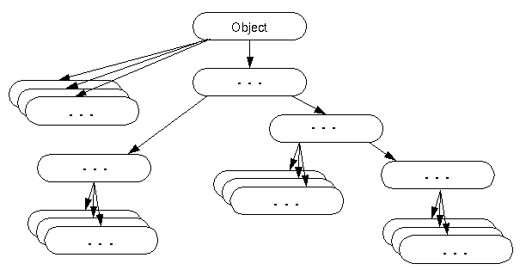

### **Methods of Object class**

|  |
| --- |
| The Object class provides many methods. They are as follows: |

|  |  |
| --- | --- |
| **Method** | **Description** |
| public final Class getClass() | returns the Class class object of this object. The Class class can further be used to get the metadata of this class. |
| public int hashCode() | returns the hashcode number for this object. |
| public boolean equals(Object obj) | compares the given object to this object. |
| protected Object clone() throws CloneNotSupportedException | creates and returns the exact copy (clone) of this object. |
| public String toString() | returns the string representation of this object. |
| public final void notify() | wakes up single thread, waiting on this object's monitor. |
| public final void notifyAll() | wakes up all the threads, waiting on this object's monitor. |
| public final void wait(long timeout)throws InterruptedException | causes the current thread to wait for the specified milliseconds, until another thread notifies (invokes notify() or notifyAll() method). |
| public final void wait(long timeout,int nanos)throws InterruptedException | causes the current thread to wait for the specified milliseconds and nanoseconds, until another thread notifies (invokes notify() or notifyAll() method). |
| public final void wait()throws InterruptedException | causes the current thread to wait, until another thread notifies (invokes notify() or notifyAll() method). |
| protected void finalize()throws Throwable | is invoked by the garbage collector before object is being garbage collected. |

# Java Arrays

Normally, an array is a collection of similar type of elements which has contiguous memory location.

**Java array** is an object which contains elements of a similar data type. Additionally, The elements of an array are stored in a contiguous memory location. It is a data structure where we store similar elements. We can store only a fixed set of elements in a Java array.

Array in Java is index-based, the first element of the array is stored at the 0th index, 2nd element is stored on 1st index and so on.

Unlike C/C++, we can get the length of the array using the length member. In C/C++, we need to use the sizeof operator.

22.8M

430

Prime Ministers of India | List of Prime Minister of India (1947-2020)

In Java, array is an object of a dynamically generated class. Java array inherits the Object class, and implements the Serializable as well as Cloneable interfaces. We can store primitive values or objects in an array in Java. Like C/C++, we can also create single dimentional or multidimentional arrays in Java.

Moreover, Java provides the feature of anonymous arrays which is not available in C/C++.

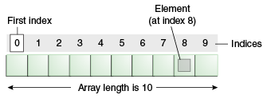

### **Advantages**

* **Code Optimization:** It makes the code optimized, we can retrieve or sort the data efficiently.
* **Random access:** We can get any data located at an index position.

### **Disadvantages**

* **Size Limit:** We can store only the fixed size of elements in the array. It doesn't grow its size at runtime. To solve this problem, collection framework is used in Java which grows automatically.

### **Types of Array in java**

There are two types of array.

* Single Dimensional Array
* Multidimensional Array

## Single Dimensional Array in Java

**Syntax to Declare an Array in Java**

1. dataType[] arr; (or)
2. dataType []arr; (or)
3. dataType arr[];

**Instantiation of an Array in Java**

1. arrayRefVar=**new** datatype[size];

### **Example of Java Array**

Let's see the simple example of java array, where we are going to declare, instantiate, initialize and traverse an array.

1. //Java Program to illustrate how to declare, instantiate, initialize
2. //and traverse the Java array.
3. **class** Testarray{
4. **public** **static** **void** main(String args[]){
5. **int** a[]=**new** **int**[5];//declaration and instantiation
6. a[0]=10;//initialization
7. a[1]=20;
8. a[2]=70;
9. a[3]=40;
10. a[4]=50;
11. //traversing array
12. **for**(**int** i=0;i<a.length;i++)//length is the property of array
13. System.out.println(a[i]);
14. }}

[**Test it Now**](https://www.javatpoint.com/opr/test.jsp?filename=Testarray)

Output:

10

20

70

40

50

## Declaration, Instantiation and Initialization of Java Array

We can declare, instantiate and initialize the java array together by:

1. **int** a[]={33,3,4,5};//declaration, instantiation and initialization

Let's see the simple example to print this array.

1. //Java Program to illustrate the use of declaration, instantiation
2. //and initialization of Java array in a single line
3. **class** Testarray1{
4. **public** **static** **void** main(String args[]){
5. **int** a[]={33,3,4,5};//declaration, instantiation and initialization
6. //printing array
7. **for**(**int** i=0;i<a.length;i++)//length is the property of array
8. System.out.println(a[i]);
9. }}

[**Test it Now**](https://www.javatpoint.com/opr/test.jsp?filename=Testarray1)

Output:

33

3

4

5

## For-each Loop for Java Array

We can also print the Java array using [**for-each loop**](https://www.javatpoint.com/for-each-loop). The Java for-each loop prints the array elements one by one. It holds an array element in a variable, then executes the body of the loop.

The syntax of the for-each loop is given below:

1. **for**(data\_type variable:array){
2. //body of the loop
3. }

Let us see the example of print the elements of Java array using the for-each loop.

1. //Java Program to print the array elements using for-each loop
2. **class** Testarray1{
3. **public** **static** **void** main(String args[]){
4. **int** arr[]={33,3,4,5};
5. //printing array using for-each loop
6. **for**(**int** i:arr)
7. System.out.println(i);
8. }}

Output:

33

3

4

5

## Passing Array to a Method in Java

We can pass the java array to method so that we can reuse the same logic on any array.

Let's see the simple example to get the minimum number of an array using a method.

1. //Java Program to demonstrate the way of passing an array
2. //to method.
3. **class** Testarray2{
4. //creating a method which receives an array as a parameter
5. **static** **void** min(**int** arr[]){
6. **int** min=arr[0];
7. **for**(**int** i=1;i<arr.length;i++)
8. **if**(min>arr[i])
9. min=arr[i];
11. System.out.println(min);
12. }
14. **public** **static** **void** main(String args[]){
15. **int** a[]={33,3,4,5};//declaring and initializing an array
16. min(a);//passing array to method
17. }}

[**Test it Now**](https://www.javatpoint.com/opr/test.jsp?filename=Testarray2)

Output:

3

## Anonymous Array in Java

Java supports the feature of an anonymous array, so you don't need to declare the array while passing an array to the method.

1. //Java Program to demonstrate the way of passing an anonymous array
2. //to method.
3. **public** **class** TestAnonymousArray{
4. //creating a method which receives an array as a parameter
5. **static** **void** printArray(**int** arr[]){
6. **for**(**int** i=0;i<arr.length;i++)
7. System.out.println(arr[i]);
8. }
10. **public** **static** **void** main(String args[]){
11. printArray(**new** **int**[]{10,22,44,66});//passing anonymous array to method
12. }}

[**Test it Now**](https://www.javatpoint.com/opr/test.jsp?filename=TestAnonymousArray)

Output:

10

22

44

66

## Returning Array from the Method

We can also return an array from the method in Java.

1. //Java Program to return an array from the method
2. **class** TestReturnArray{
3. //creating method which returns an array
4. **static** **int**[] get(){
5. **return** **new** **int**[]{10,30,50,90,60};
6. }
8. **public** **static** **void** main(String args[]){
9. //calling method which returns an array
10. **int** arr[]=get();
11. //printing the values of an array
12. **for**(**int** i=0;i<arr.length;i++)
13. System.out.println(arr[i]);
14. }}

[**Test it Now**](https://www.javatpoint.com/opr/test.jsp?filename=TestReturnArray)

Output:

10

30

50

90

60

## ArrayIndexOutOfBoundsException

The Java Virtual Machine (JVM) throws an ArrayIndexOutOfBoundsException if length of the array in negative, equal to the array size or greater than the array size while traversing the array.

1. //Java Program to demonstrate the case of
2. //ArrayIndexOutOfBoundsException in a Java Array.
3. **public** **class** TestArrayException{
4. **public** **static** **void** main(String args[]){
5. **int** arr[]={50,60,70,80};
6. **for**(**int** i=0;i<=arr.length;i++){
7. System.out.println(arr[i]);
8. }
9. }}

[**Test it Now**](https://www.javatpoint.com/opr/test.jsp?filename=TestArrayException)

Output:

Exception in thread "main" java.lang.ArrayIndexOutOfBoundsException: 4

at TestArrayException.main(TestArrayException.java:5)

50

60

70

80

## Multidimensional Array in Java

In such case, data is stored in row and column based index (also known as matrix form).

**Syntax to Declare Multidimensional Array in Java**

1. dataType[][] arrayRefVar; (or)
2. dataType [][]arrayRefVar; (or)
3. dataType arrayRefVar[][]; (or)
4. dataType []arrayRefVar[];

**Example to instantiate Multidimensional Array in Java**

1. **int**[][] arr=**new** **int**[3][3];//3 row and 3 column

**Example to initialize Multidimensional Array in Java**

1. arr[0][0]=1;
2. arr[0][1]=2;
3. arr[0][2]=3;
4. arr[1][0]=4;
5. arr[1][1]=5;
6. arr[1][2]=6;
7. arr[2][0]=7;
8. arr[2][1]=8;
9. arr[2][2]=9;

### **Example of Multidimensional Java Array**

Let's see the simple example to declare, instantiate, initialize and print the 2Dimensional array.

1. //Java Program to illustrate the use of multidimensional array
2. **class** Testarray3{
3. **public** **static** **void** main(String args[]){
4. //declaring and initializing 2D array
5. **int** arr[][]={{1,2,3},{2,4,5},{4,4,5}};
6. //printing 2D array
7. **for**(**int** i=0;i<3;i++){
8. **for**(**int** j=0;j<3;j++){
9. System.out.print(arr[i][j]+" ");
10. }
11. System.out.println();
12. }
13. }}

[**Test it Now**](https://www.javatpoint.com/opr/test.jsp?filename=Testarray3)

Output:

1 2 3

2 4 5

4 4 5

## Jagged Array in Java

If we are creating odd number of columns in a 2D array, it is known as a jagged array. In other words, it is an array of arrays with different number of columns.

1. //Java Program to illustrate the jagged array
2. **class** TestJaggedArray{
3. **public** **static** **void** main(String[] args){
4. //declaring a 2D array with odd columns
5. **int** arr[][] = **new** **int**[3][];
6. arr[0] = **new** **int**[3];
7. arr[1] = **new** **int**[4];
8. arr[2] = **new** **int**[2];
9. //initializing a jagged array
10. **int** count = 0;
11. **for** (**int** i=0; i<arr.length; i++)
12. **for**(**int** j=0; j<arr[i].length; j++)
13. arr[i][j] = count++;
15. //printing the data of a jagged array
16. **for** (**int** i=0; i<arr.length; i++){
17. **for** (**int** j=0; j<arr[i].length; j++){
18. System.out.print(arr[i][j]+" ");
19. }
20. System.out.println();//new line
21. }
22. }
23. }

[**Test it Now**](https://www.javatpoint.com/opr/test.jsp?filename=TestJaggedArray)

Output:

0 1 2

3 4 5 6

7 8

## What is the class name of Java array?

In Java, an array is an object. For array object, a proxy class is created whose name can be obtained by getClass().getName() method on the object.

1. //Java Program to get the class name of array in Java
2. **class** Testarray4{
3. **public** **static** **void** main(String args[]){
4. //declaration and initialization of array
5. **int** arr[]={4,4,5};
6. //getting the class name of Java array
7. Class c=arr.getClass();
8. String name=c.getName();
9. //printing the class name of Java array
10. System.out.println(name);
12. }}

[**Test it Now**](https://www.javatpoint.com/opr/test.jsp?filename=Testarray4)

Output:

I

## Copying a Java Array

We can copy an array to another by the arraycopy() method of System class.

**Syntax of arraycopy method**

1. **public** **static** **void** arraycopy(
2. Object src, **int** srcPos,Object dest, **int** destPos, **int** length
3. )

### **Example of Copying an Array in Java**

1. //Java Program to copy a source array into a destination array in Java
2. **class** TestArrayCopyDemo {
3. **public** **static** **void** main(String[] args) {
4. //declaring a source array
5. **char**[] copyFrom = { 'd', 'e', 'c', 'a', 'f', 'f', 'e',
6. 'i', 'n', 'a', 't', 'e', 'd' };
7. //declaring a destination array
8. **char**[] copyTo = **new** **char**[7];
9. //copying array using System.arraycopy() method
10. System.arraycopy(copyFrom, 2, copyTo, 0, 7);
11. //printing the destination array
12. System.out.println(String.valueOf(copyTo));
13. }
14. }

[**Test it Now**](https://www.javatpoint.com/opr/test.jsp?filename=TestArrayCopyDemo)

Output:

caffein

## Cloning an Array in Java

Since, Java array implements the Cloneable interface, we can create the clone of the Java array. If we create the clone of a single-dimensional array, it creates the deep copy of the Java array. It means, it will copy the actual value. But, if we create the clone of a multidimensional array, it creates the shallow copy of the Java array which means it copies the references.

1. //Java Program to clone the array
2. **class** Testarray1{
3. **public** **static** **void** main(String args[]){
4. **int** arr[]={33,3,4,5};
5. System.out.println("Printing original array:");
6. **for**(**int** i:arr)
7. System.out.println(i);
9. System.out.println("Printing clone of the array:");
10. **int** carr[]=arr.clone();
11. **for**(**int** i:carr)
12. System.out.println(i);
14. System.out.println("Are both equal?");
15. System.out.println(arr==carr);
17. }}

Output:

Printing original array:

33

3

4

5

Printing clone of the array:

33

3

4

5

Are both equal?

false

## Addition of 2 Matrices in Java

Let's see a simple example that adds two matrices.

1. //Java Program to demonstrate the addition of two matrices in Java
2. **class** Testarray5{
3. **public** **static** **void** main(String args[]){
4. //creating two matrices
5. **int** a[][]={{1,3,4},{3,4,5}};
6. **int** b[][]={{1,3,4},{3,4,5}};
8. //creating another matrix to store the sum of two matrices
9. **int** c[][]=**new** **int**[2][3];
11. //adding and printing addition of 2 matrices
12. **for**(**int** i=0;i<2;i++){
13. **for**(**int** j=0;j<3;j++){
14. c[i][j]=a[i][j]+b[i][j];
15. System.out.print(c[i][j]+" ");
16. }
17. System.out.println();//new line
18. }
20. }}

[**Test it Now**](https://www.javatpoint.com/opr/test.jsp?filename=Testarray5)

Output:

2 6 8

6 8 10

## Multiplication of 2 Matrices in Java

In the case of matrix multiplication, a one-row element of the first matrix is multiplied by all the columns of the second matrix which can be understood by the image given below.

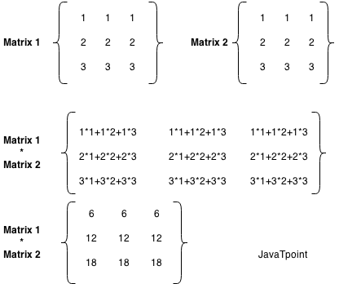

Let's see a simple example to multiply two matrices of 3 rows and 3 columns.

1. //Java Program to multiply two matrices
2. **public** **class** MatrixMultiplicationExample{
3. **public** **static** **void** main(String args[]){
4. //creating two matrices
5. **int** a[][]={{1,1,1},{2,2,2},{3,3,3}};
6. **int** b[][]={{1,1,1},{2,2,2},{3,3,3}};
8. //creating another matrix to store the multiplication of two matrices
9. **int** c[][]=**new** **int**[3][3];  //3 rows and 3 columns
11. //multiplying and printing multiplication of 2 matrices
12. **for**(**int** i=0;i<3;i++){
13. **for**(**int** j=0;j<3;j++){
14. c[i][j]=0;
15. **for**(**int** k=0;k<3;k++)
16. {
17. c[i][j]+=a[i][k]\*b[k][j];
18. }//end of k loop
19. System.out.print(c[i][j]+" ");  //printing matrix element
20. }//end of j loop
21. System.out.println();//new line
22. }
23. }}

[**Test it Now**](https://compiler.javatpoint.com/opr/test.jsp?filename=MatrixMultiplicationExample)

Output:

6 6 6

12 12 12

18 18 18

# Java Annotations

Java **Annotation** is a tag that represents the *metadata* i.e. attached with class, interface, methods or fields to indicate some additional information which can be used by java compiler and JVM.

Annotations in Java are used to provide additional information, so it is an alternative option for XML and Java marker interfaces.

First, we will learn some built-in annotations then we will move on creating and using custom annotations.

## Built-In Java Annotations

There are several built-in annotations in Java. Some annotations are applied to Java code and some to other annotations.

32.4M

696

C++ vs Java

## Built-In Java Annotations used in Java code

* @Override
* @SuppressWarnings
* @Deprecated

## Built-In Java Annotations used in other annotations

* @Target
* @Retention
* @Inherited
* @Documented

## Understanding Built-In Annotations

Let's understand the built-in annotations first.

## @Override

@Override annotation assures that the subclass method is overriding the parent class method. If it is not so, compile time error occurs.

Sometimes, we does the silly mistake such as spelling mistakes etc. So, it is better to mark @Override annotation that provides assurity that method is overridden.

1. **class** Animal{
2. **void** eatSomething(){System.out.println("eating something");}
3. }
5. **class** Dog **extends** Animal{
6. @Override
7. **void** eatsomething(){System.out.println("eating foods");}//should be eatSomething
8. }
10. **class** TestAnnotation1{
11. **public** **static** **void** main(String args[]){
12. Animal a=**new** Dog();
13. a.eatSomething();
14. }}

[**Test it Now**](https://www.javatpoint.com/opr/test.jsp?filename=TestAnnotation1)

Output:Comple Time Error

## @SuppressWarnings

@SuppressWarnings annotation: is used to suppress warnings issued by the compiler.

1. **import** java.util.\*;
2. **class** TestAnnotation2{
3. @SuppressWarnings("unchecked")
4. **public** **static** **void** main(String args[]){
5. ArrayList list=**new** ArrayList();
6. list.add("sonoo");
7. list.add("vimal");
8. list.add("ratan");
10. **for**(Object obj:list)
11. System.out.println(obj);
13. }}

[**Test it Now**](https://www.javatpoint.com/opr/test.jsp?filename=TestAnnotation2)

Now no warning at compile time.

If you remove the @SuppressWarnings("unchecked") annotation, it will show warning at compile time because we are using non-generic collection.

## @Deprecated

@Deprecated annoation marks that this method is deprecated so compiler prints warning. It informs user that it may be removed in the future versions. So, it is better not to use such methods.

1. **class** A{
2. **void** m(){System.out.println("hello m");}
4. @Deprecated
5. **void** n(){System.out.println("hello n");}
6. }
8. **class** TestAnnotation3{
9. **public** **static** **void** main(String args[]){
11. A a=**new** A();
12. a.n();
13. }}

[**Test it Now**](https://www.javatpoint.com/opr/test.jsp?filename=TestAnnotation3)

## At Compile Time:

Note: Test.java uses or overrides a deprecated API.

Note: Recompile with -Xlint:deprecation for details.

## At Runtime:

hello n

## Java Custom Annotations

**Java Custom annotations** or Java User-defined annotations are easy to create and use. The *@interface* element is used to declare an annotation. For example:

1. **@interface** MyAnnotation{}

Here, MyAnnotation is the custom annotation name.

## Points to remember for java custom annotation signature

There are few points that should be remembered by the programmer.

1. Method should not have any throws clauses
2. Method should return one of the following: primitive data types, String, Class, enum or array of these data types.
3. Method should not have any parameter.
4. We should attach @ just before interface keyword to define annotation.
5. It may assign a default value to the method.

## Types of Annotation

There are three types of annotations.

1. Marker Annotation
2. Single-Value Annotation
3. Multi-Value Annotation

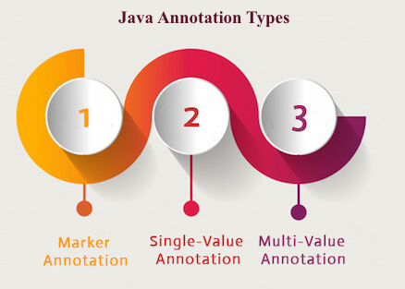

## 1) Marker Annotation

An annotation that has no method, is called marker annotation. For example:

1. **@interface** MyAnnotation{}

The @Override and @Deprecated are marker annotations.

## 2) Single-Value Annotation

An annotation that has one method, is called single-value annotation. For example:

1. **@interface** MyAnnotation{
2. **int** value();
3. }

We can provide the default value also. For example:

1. **@interface** MyAnnotation{
2. **int** value() **default** 0;
3. }

## How to apply Single-Value Annotation

Let's see the code to apply the single value annotation.

1. @MyAnnotation(value=10)

The value can be anything.

## 3) Multi-Value Annotation

An annotation that has more than one method, is called Multi-Value annotation. For example:

1. **@interface** MyAnnotation{
2. **int** value1();
3. String value2();
4. String value3();
5. }
6. }

We can provide the default value also. For example:

1. **@interface** MyAnnotation{
2. **int** value1() **default** 1;
3. String value2() **default** "";
4. String value3() **default** "xyz";
5. }

## How to apply Multi-Value Annotation

Let's see the code to apply the multi-value annotation.

1. @MyAnnotation(value1=10,value2="Arun Kumar",value3="Ghaziabad")

## Built-in Annotations used in custom annotations in java

* @Target
* @Retention
* @Inherited
* @Documented

## @Target

**@Target** tag is used to specify at which type, the annotation is used.

The java.lang.annotation.**ElementType** enum declares many constants to specify the type of element where annotation is to be applied such as TYPE, METHOD, FIELD etc. Let's see the constants of ElementType enum:

|  |  |
| --- | --- |
| **Element Types** | **Where the annotation can be applied** |
| TYPE | class, interface or enumeration |
| FIELD | fields |
| METHOD | methods |
| CONSTRUCTOR | constructors |
| LOCAL\_VARIABLE | local variables |
| ANNOTATION\_TYPE | annotation type |
| PARAMETER | parameter |

## Example to specify annoation for a class

1. @Target(ElementType.TYPE)
2. **@interface** MyAnnotation{
3. **int** value1();
4. String value2();
5. }

## Example to specify annotation for a class, methods or fields

1. @Target({ElementType.TYPE, ElementType.FIELD, ElementType.METHOD})
2. **@interface** MyAnnotation{
3. **int** value1();
4. String value2();
5. }

## @Retention

**@Retention** annotation is used to specify to what level annotation will be available.

|  |  |
| --- | --- |
| **RetentionPolicy** | **Availability** |
| RetentionPolicy.SOURCE | refers to the source code, discarded during compilation. It will not be available in the compiled class. |
| RetentionPolicy.CLASS | refers to the .class file, available to java compiler but not to JVM . It is included in the class file. |
| RetentionPolicy.RUNTIME | refers to the runtime, available to java compiler and JVM . |

## Example to specify the RetentionPolicy

1. @Retention(RetentionPolicy.RUNTIME)
2. @Target(ElementType.TYPE)
3. **@interface** MyAnnotation{
4. **int** value1();
5. String value2();
6. }

## Example of custom annotation: creating, applying and accessing annotation

Let's see the simple example of creating, applying and accessing annotation.

*File: Test.java*

1. //Creating annotation
2. **import** java.lang.annotation.\*;
3. **import** java.lang.reflect.\*;
5. @Retention(RetentionPolicy.RUNTIME)
6. @Target(ElementType.METHOD)
7. **@interface** MyAnnotation{
8. **int** value();
9. }
11. //Applying annotation
12. **class** Hello{
13. @MyAnnotation(value=10)
14. **public** **void** sayHello(){System.out.println("hello annotation");}
15. }
17. //Accessing annotation
18. **class** TestCustomAnnotation1{
19. **public** **static** **void** main(String args[])**throws** Exception{
21. Hello h=**new** Hello();
22. Method m=h.getClass().getMethod("sayHello");
24. MyAnnotation manno=m.getAnnotation(MyAnnotation.**class**);
25. System.out.println("value is: "+manno.value());
26. }}

[**Test it Now**](https://www.javatpoint.com/opr/test.jsp?filename=TestCustomAnnotation1)

Output:value is: 10

[download this example](https://static.javatpoint.com/src/newjdk/annotation.zip)

## How built-in annotaions are used in real scenario?

In real scenario, java programmer only need to apply annotation. He/She doesn't need to create and access annotation. Creating and Accessing annotation is performed by the implementation provider. On behalf of the annotation, java compiler or JVM performs some additional operations.

## @Inherited

By default, annotations are not inherited to subclasses. The @Inherited annotation marks the annotation to be inherited to subclasses.

1. @Inherited
2. **@interface** ForEveryone { }//Now it will be available to subclass also
4. **@interface** ForEveryone { }
5. **class** Superclass{}
7. **class** Subclass **extends** Superclass{}

## @Documented

The @Documented Marks the annotation for inclusion in the documentation.

# Generics in Java

The **Java Generics** programming is introduced in J2SE 5 to deal with type-safe objects. It makes the code stable by detecting the bugs at compile time.

Before generics, we can store any type of objects in the collection, i.e., non-generic. Now generics force the java programmer to store a specific type of objects.

## Advantage of Java Generics

There are mainly 3 advantages of generics. They are as follows:

**1) Type-safety:** We can hold only a single type of objects in generics. It doesn?t allow to store other objects.

33M

751

Features of Java - Javatpoint

Without Generics, we can store any type of objects.

1. List list = **new** ArrayList();
2. list.add(10);
3. list.add("10");
4. With Generics, it is required to specify the type of object we need to store.
5. List<Integer> list = **new** ArrayList<Integer>();
6. list.add(10);
7. list.add("10");// compile-time error

**2) Type casting is not required:** There is no need to typecast the object.

Before Generics, we need to type cast.

1. List list = **new** ArrayList();
2. list.add("hello");
3. String s = (String) list.get(0);//typecasting
4. After Generics, we don't need to typecast the object.
5. List<String> list = **new** ArrayList<String>();
6. list.add("hello");
7. String s = list.get(0);

**3) Compile-Time Checking:** It is checked at compile time so problem will not occur at runtime. The good programming strategy says it is far better to handle the problem at compile time than runtime.

1. List<String> list = **new** ArrayList<String>();
2. list.add("hello");
3. list.add(32);//Compile Time Error

**Syntax** to use generic collection

1. ClassOrInterface<Type>

**Example** to use Generics in java

1. ArrayList<String>

## Full Example of Generics in Java

Here, we are using the ArrayList class, but you can use any collection class such as ArrayList, LinkedList, HashSet, TreeSet, HashMap, Comparator etc.

1. **import** java.util.\*;
2. **class** TestGenerics1{
3. **public** **static** **void** main(String args[]){
4. ArrayList<String> list=**new** ArrayList<String>();
5. list.add("rahul");
6. list.add("jai");
7. //list.add(32);//compile time error
9. String s=list.get(1);//type casting is not required
10. System.out.println("element is: "+s);
12. Iterator<String> itr=list.iterator();
13. **while**(itr.hasNext()){
14. System.out.println(itr.next());
15. }
16. }
17. }
18. **import** java.util.\*;
19. **class** TestGenerics1{
20. **public** **static** **void** main(String args[]){
21. ArrayList<String> list=**new** ArrayList<String>();
22. list.add("rahul");
23. list.add("jai");
24. //list.add(32);//compile time error
26. String s=list.get(1);//type casting is not required
27. System.out.println("element is: "+s);
29. Iterator<String> itr=list.iterator();
30. **while**(itr.hasNext()){
31. System.out.println(itr.next());
32. }
33. }
34. }

[**Test it Now**](https://www.javatpoint.com/opr/test.jsp?filename=TestGenerics1)

**Output:**

element is: jai

rahul

jai

## Example of Java Generics using Map

Now we are going to use map elements using generics. Here, we need to pass key and value. Let us understand it by a simple example:

1. **import** java.util.\*;
2. **class** TestGenerics2{
3. **public** **static** **void** main(String args[]){
4. Map<Integer,String> map=**new** HashMap<Integer,String>();
5. map.put(1,"vijay");
6. map.put(4,"umesh");
7. map.put(2,"ankit");
9. //Now use Map.Entry for Set and Iterator
10. Set<Map.Entry<Integer,String>> set=map.entrySet();
12. Iterator<Map.Entry<Integer,String>> itr=set.iterator();
13. **while**(itr.hasNext()){
14. Map.Entry e=itr.next();//no need to typecast
15. System.out.println(e.getKey()+" "+e.getValue());
16. }
18. }}

[**Test it Now**](https://www.javatpoint.com/opr/test.jsp?filename=TestGenerics2)

**Output**

1 vijay

2 ankit

4 umesh

## Generic class

A class that can refer to any type is known as a generic class. Here, we are using the T type parameter to create the generic class of specific type.

Let's see a simple example to create and use the generic class.

### **Creating a generic class:**

1. **class** MyGen<T>{
2. T obj;
3. **void** add(T obj){**this**.obj=obj;}
4. T get(){**return** obj;}
5. }

The T type indicates that it can refer to any type (like String, Integer, and Employee). The type you specify for the class will be used to store and retrieve the data.

### **Using generic class:**

Let's see the code to use the generic class.

1. **class** TestGenerics3{
2. **public** **static** **void** main(String args[]){
3. MyGen<Integer> m=**new** MyGen<Integer>();
4. m.add(2);
5. //m.add("vivek");//Compile time error
6. System.out.println(m.get());
7. }}

[**Test it Now**](https://www.javatpoint.com/opr/test.jsp?filename=TestGenerics3)

**Output**

2

## Type Parameters

The type parameters naming conventions are important to learn generics thoroughly. The common type parameters are as follows:

1. T - Type
2. E - Element
3. K - Key
4. N - Number
5. V - Value

## Generic Method

Like the generic class, we can create a generic method that can accept any type of arguments. Here, the scope of arguments is limited to the method where it is declared. It allows static as well as non-static methods.

Let's see a simple example of java generic method to print array elements. We are using here **E** to denote the element.

1. **public** **class** TestGenerics4{
3. **public** **static** < E > **void** printArray(E[] elements) {
4. **for** ( E element : elements){
5. System.out.println(element );
6. }
7. System.out.println();
8. }
9. **public** **static** **void** main( String args[] ) {
10. Integer[] intArray = { 10, 20, 30, 40, 50 };
11. Character[] charArray = { 'J', 'A', 'V', 'A', 'T','P','O','I','N','T' };
13. System.out.println( "Printing Integer Array" );
14. printArray( intArray  );
16. System.out.println( "Printing Character Array" );
17. printArray( charArray );
18. }
19. }

[**Test it Now**](https://www.javatpoint.com/opr/test.jsp?filename=TestGenerics4)

**Output**

Printing Integer Array

10

20

30

40

50

Printing Character Array

J

A

V

A

T

P

O

I

N

T

## Wildcard in Java Generics

The ? (question mark) symbol represents the wildcard element. It means any type. If we write <? extends Number>, it means any child class of Number, e.g., Integer, Float, and double. Now we can call the method of Number class through any child class object.

We can use a wildcard as a **type of a parameter, field, return type, or local variable. However, it is not allowed to use a wildcard as a type argument for a generic method invocation, a generic class instance creation, or a supertype**.

Let's understand it by the example given below:

1. **import** java.util.\*;
2. **abstract** **class** Shape{
3. **abstract** **void** draw();
4. }
5. **class** Rectangle **extends** Shape{
6. **void** draw(){System.out.println("drawing rectangle");}
7. }
8. **class** Circle **extends** Shape{
9. **void** draw(){System.out.println("drawing circle");}
10. }
11. **class** GenericTest{
12. //creating a method that accepts only child class of Shape
13. **public** **static** **void** drawShapes(List<? **extends** Shape> lists){
14. **for**(Shape s:lists){
15. s.draw();//calling method of Shape class by child class instance
16. }
17. }
18. **public** **static** **void** main(String args[]){
19. List<Rectangle> list1=**new** ArrayList<Rectangle>();
20. list1.add(**new** Rectangle());
22. List<Circle> list2=**new** ArrayList<Circle>();
23. list2.add(**new** Circle());
24. list2.add(**new** Circle());
26. drawShapes(list1);
27. drawShapes(list2);
28. }}

**Output**

drawing rectangle

drawing circle

drawing circle

### **Upper Bounded Wildcards**

The purpose of upper bounded wildcards is to decrease the restrictions on a variable. It restricts the unknown type to be a specific type or a subtype of that type. It is used by declaring wildcard character ("?") followed by the extends (in case of, class) or implements (in case of, interface) keyword, followed by its upper bound.

### **Syntax**

1. List<? **extends** Number>

Here,

**?** is a wildcard character.

**extends**, is a keyword.

**Number**, is a class present in java.lang package

Suppose, we want to write the method for the list of Number and its subtypes (like Integer, Double). Using **List<? extends Number>** is suitable for a list of type Number or any of its subclasses whereas **List<Number>** works with the list of type Number only. So, **List<? extends Number>** is less restrictive than **List<Number>**.

### **Example of Upper Bound Wildcard**

In this example, we are using the upper bound wildcards to write the method for List<Integer> and List<Double>.

1. **import** java.util.ArrayList;
3. **public** **class** UpperBoundWildcard {

6. **private** **static** Double add(ArrayList<? **extends** Number> num) {
8. **double** sum=0.0;
10. **for**(Number n:num)
11. {
12. sum = sum+n.doubleValue();
13. }
15. **return** sum;
16. }
18. **public** **static** **void** main(String[] args) {
20. ArrayList<Integer> l1=**new** ArrayList<Integer>();
21. l1.add(10);
22. l1.add(20);
23. System.out.println("displaying the sum= "+add(l1));
25. ArrayList<Double> l2=**new** ArrayList<Double>();
26. l2.add(30.0);
27. l2.add(40.0);
28. System.out.println("displaying the sum= "+add(l2));

31. }
33. }

[**Test it Now**](https://www.javatpoint.com/opr/test.jsp?filename=UpperBoundWildcard)

**Output**

displaying the sum= 30.0

displaying the sum= 70.0

### **Unbounded Wildcards**

The unbounded wildcard type represents the list of an unknown type such as List<?>. This approach can be useful in the following scenarios: -

* When the given method is implemented by using the functionality provided in the Object class.
* When the generic class contains the methods that don't depend on the type parameter.

### **Example of Unbounded Wildcards**

1. **import** java.util.Arrays;
2. **import** java.util.List;
4. **public** **class** UnboundedWildcard {
6. **public** **static** **void** display(List<?> list)
7. {
9. **for**(Object o:list)
10. {
11. System.out.println(o);
12. }
14. }

17. **public** **static** **void** main(String[] args) {
19. List<Integer> l1=Arrays.asList(1,2,3);
20. System.out.println("displaying the Integer values");
21. display(l1);
22. List<String> l2=Arrays.asList("One","Two","Three");
23. System.out.println("displaying the String values");
24. display(l2);
25. }
27. }

[**Test it Now**](https://www.javatpoint.com/opr/test.jsp?filename=UnboundedWildcard)

**Output**

displaying the Integer values

1

2

3

displaying the String values

One

Two

Three

## Lower Bounded Wildcards

The purpose of lower bounded wildcards is to restrict the unknown type to be a specific type or a supertype of that type. It is used by declaring wildcard character ("?") followed by the super keyword, followed by its lower bound.

### **Syntax**

1. List<? **super** Integer>

Here,

**?** is a wildcard character.

**super**, is a keyword.

**Integer**, is a wrapper class.

Suppose, we want to write the method for the list of Integer and its supertype (like Number, Object). Using **List<? super Integer>** is suitable for a list of type Integer or any of its superclasses whereas **List<Integer>** works with the list of type Integer only. So, **List<? super Integer>** is less restrictive than **List<Integer>**.

### **Example of Lower Bound Wildcard**

In this example, we are using the lower bound wildcards to write the method for List<Integer> and List<Number>.

1. **import** java.util.Arrays;
2. **import** java.util.List;
4. **public** **class** LowerBoundWildcard {
6. **public** **static** **void** addNumbers(List<? **super** Integer> list) {
8. **for**(Object n:list)
9. {
10. System.out.println(n);
11. }


15. }
16. **public** **static** **void** main(String[] args) {
18. List<Integer> l1=Arrays.asList(1,2,3);
19. System.out.println("displaying the Integer values");
20. addNumbers(l1);
22. List<Number> l2=Arrays.asList(1.0,2.0,3.0);
23. System.out.println("displaying the Number values");
24. addNumbers(l2);
25. }
27. }

[**Test it Now**](https://www.javatpoint.com/opr/test.jsp?filename=LowerBoundWildcard)

**Output**

displaying the Integer values

1

2

3

displaying the Number values

1.0

2.0

3.0

# Java Lambda Expressions

Lambda expression is a new and important feature of Java which was included in Java SE 8. It provides a clear and concise way to represent one method interface using an expression. It is very useful in collection library. It helps to iterate, filter and extract data from collection.

The Lambda expression is used to provide the implementation of an interface which has functional interface. It saves a lot of code. In case of lambda expression, we don't need to define the method again for providing the implementation. Here, we just write the implementation code.

Java lambda expression is treated as a function, so compiler does not create .class file.

## Functional Interface

Lambda expression provides implementation of functional interface. An interface which has only one abstract method is called functional interface. Java provides an anotation @FunctionalInterface, which is used to declare an interface as functional interface.

32.4M

696

C++ vs Java

**Next**

**Stay**

## Why use Lambda Expression

1. To provide the implementation of Functional interface.
2. Less coding.

## Java Lambda Expression Syntax

1. (argument-list) -> {body}

Java lambda expression is consisted of three components.

**1) Argument-list:** It can be empty or non-empty as well.

**2) Arrow-token:** It is used to link arguments-list and body of expression.

**3) Body:** It contains expressions and statements for lambda expression.

**No Parameter Syntax**

1. () -> {
2. //Body of no parameter lambda
3. }

**One Parameter Syntax**

1. (p1) -> {
2. //Body of single parameter lambda
3. }

**Two Parameter Syntax**

1. (p1,p2) -> {
2. //Body of multiple parameter lambda
3. }

Let's see a scenario where we are not implementing Java lambda expression. Here, we are implementing an interface without using lambda expression.

## Without Lambda Expression

1. **interface** Drawable{
2. **public** **void** draw();
3. }
4. **public** **class** LambdaExpressionExample {
5. **public** **static** **void** main(String[] args) {
6. **int** width=10;
8. //without lambda, Drawable implementation using anonymous class
9. Drawable d=**new** Drawable(){
10. **public** **void** draw(){System.out.println("Drawing "+width);}
11. };
12. d.draw();
13. }
14. }

[**Test it Now**](https://compiler.javatpoint.com/opr/test.jsp?filename=LambdaExpressionExample)

Output:

Drawing 10

## Java Lambda Expression Example

Now, we are going to implement the above example with the help of Java lambda expression.

1. @FunctionalInterface  //It is optional
2. **interface** Drawable{
3. **public** **void** draw();
4. }
6. **public** **class** LambdaExpressionExample2 {
7. **public** **static** **void** main(String[] args) {
8. **int** width=10;
10. //with lambda
11. Drawable d2=()->{
12. System.out.println("Drawing "+width);
13. };
14. d2.draw();
15. }
16. }

[**Test it Now**](https://compiler.javatpoint.com/opr/test.jsp?filename=LambdaExpressionExample2)

Output:

Drawing 10

A lambda expression can have zero or any number of arguments. Let's see the examples:

## Java Lambda Expression Example: No Parameter

1. **interface** Sayable{
2. **public** String say();
3. }
4. **public** **class** LambdaExpressionExample3{
5. **public** **static** **void** main(String[] args) {
6. Sayable s=()->{
7. **return** "I have nothing to say.";
8. };
9. System.out.println(s.say());
10. }
11. }

[**Test it Now**](https://compiler.javatpoint.com/opr/test.jsp?filename=LambdaExpressionExample3)

Output:

I have nothing to say.

## Java Lambda Expression Example: Single Parameter

1. **interface** Sayable{
2. **public** String say(String name);
3. }
5. **public** **class** LambdaExpressionExample4{
6. **public** **static** **void** main(String[] args) {
8. // Lambda expression with single parameter.
9. Sayable s1=(name)->{
10. **return** "Hello, "+name;
11. };
12. System.out.println(s1.say("Sonoo"));
14. // You can omit function parentheses
15. Sayable s2= name ->{
16. **return** "Hello, "+name;
17. };
18. System.out.println(s2.say("Sonoo"));
19. }
20. }

[**Test it Now**](https://compiler.javatpoint.com/opr/test.jsp?filename=LambdaExpressionExample4)

Output:

Hello, Sonoo

Hello, Sonoo

## Java Lambda Expression Example: Multiple Parameters

1. **interface** Addable{
2. **int** add(**int** a,**int** b);
3. }
5. **public** **class** LambdaExpressionExample5{
6. **public** **static** **void** main(String[] args) {
8. // Multiple parameters in lambda expression
9. Addable ad1=(a,b)->(a+b);
10. System.out.println(ad1.add(10,20));
12. // Multiple parameters with data type in lambda expression
13. Addable ad2=(**int** a,**int** b)->(a+b);
14. System.out.println(ad2.add(100,200));
15. }
16. }

[**Test it Now**](https://compiler.javatpoint.com/opr/test.jsp?filename=LambdaExpressionExample5)

Output:

30

300

## Java Lambda Expression Example: with or without return keyword

In Java lambda expression, if there is only one statement, you may or may not use return keyword. You must use return keyword when lambda expression contains multiple statements.

1. **interface** Addable{
2. **int** add(**int** a,**int** b);
3. }
5. **public** **class** LambdaExpressionExample6 {
6. **public** **static** **void** main(String[] args) {
8. // Lambda expression without return keyword.
9. Addable ad1=(a,b)->(a+b);
10. System.out.println(ad1.add(10,20));
12. // Lambda expression with return keyword.
13. Addable ad2=(**int** a,**int** b)->{
14. **return** (a+b);
15. };
16. System.out.println(ad2.add(100,200));
17. }
18. }

[**Test it Now**](https://compiler.javatpoint.com/opr/test.jsp?filename=LambdaExpressionExample6)

Output:

30

300

## Java Lambda Expression Example: Foreach Loop

1. **import** java.util.\*;
2. **public** **class** LambdaExpressionExample7{
3. **public** **static** **void** main(String[] args) {
5. List<String> list=**new** ArrayList<String>();
6. list.add("ankit");
7. list.add("mayank");
8. list.add("irfan");
9. list.add("jai");
11. list.forEach(
12. (n)->System.out.println(n)
13. );
14. }
15. }

[**Test it Now**](https://compiler.javatpoint.com/opr/test.jsp?filename=LambdaExpressionExample7)

Output:

ankit

mayank

irfan

jai

## Java Lambda Expression Example: Multiple Statements

1. @FunctionalInterface
2. **interface** Sayable{
3. String say(String message);
4. }
6. **public** **class** LambdaExpressionExample8{
7. **public** **static** **void** main(String[] args) {
9. // You can pass multiple statements in lambda expression
10. Sayable person = (message)-> {
11. String str1 = "I would like to say, ";
12. String str2 = str1 + message;
13. **return** str2;
14. };
15. System.out.println(person.say("time is precious."));
16. }
17. }

[**Test it Now**](https://compiler.javatpoint.com/opr/test.jsp?filename=LambdaExpressionExample8)

Output:

I would like to say, time is precious.

## Java Lambda Expression Example: Creating Thread

You can use lambda expression to run thread. In the following example, we are implementing run method by using lambda expression.

1. **public** **class** LambdaExpressionExample9{
2. **public** **static** **void** main(String[] args) {
4. //Thread Example without lambda
5. Runnable r1=**new** Runnable(){
6. **public** **void** run(){
7. System.out.println("Thread1 is running...");
8. }
9. };
10. Thread t1=**new** Thread(r1);
11. t1.start();
12. //Thread Example with lambda
13. Runnable r2=()->{
14. System.out.println("Thread2 is running...");
15. };
16. Thread t2=**new** Thread(r2);
17. t2.start();
18. }
19. }

[**Test it Now**](https://compiler.javatpoint.com/opr/test.jsp?filename=LambdaExpressionExample9)

Output:

Thread1 is running...

Thread2 is running...

Java lambda expression can be used in the collection framework. It provides efficient and concise way to iterate, filter and fetch data. Following are some lambda and collection examples provided.

## Java Lambda Expression Example: Comparator

1. **import** java.util.ArrayList;
2. **import** java.util.Collections;
3. **import** java.util.List;
4. **class** Product{
5. **int** id;
6. String name;
7. **float** price;
8. **public** Product(**int** id, String name, **float** price) {
9. **super**();
10. **this**.id = id;
11. **this**.name = name;
12. **this**.price = price;
13. }
14. }
15. **public** **class** LambdaExpressionExample10{
16. **public** **static** **void** main(String[] args) {
17. List<Product> list=**new** ArrayList<Product>();
19. //Adding Products
20. list.add(**new** Product(1,"HP Laptop",25000f));
21. list.add(**new** Product(3,"Keyboard",300f));
22. list.add(**new** Product(2,"Dell Mouse",150f));
24. System.out.println("Sorting on the basis of name...");
26. // implementing lambda expression
27. Collections.sort(list,(p1,p2)->{
28. **return** p1.name.compareTo(p2.name);
29. });
30. **for**(Product p:list){
31. System.out.println(p.id+" "+p.name+" "+p.price);
32. }
34. }
35. }

[**Test it Now**](https://compiler.javatpoint.com/opr/test.jsp?filename=LambdaExpressionExample10)

Output:

Sorting on the basis of name...

2 Dell Mouse 150.0

1 HP Laptop 25000.0

3 Keyboard 300.0

## Java Lambda Expression Example: Filter Collection Data

1. **import** java.util.ArrayList;
2. **import** java.util.List;
3. **import** java.util.stream.Stream;
4. **class** Product{
5. **int** id;
6. String name;
7. **float** price;
8. **public** Product(**int** id, String name, **float** price) {
9. **super**();
10. **this**.id = id;
11. **this**.name = name;
12. **this**.price = price;
13. }
14. }
15. **public** **class** LambdaExpressionExample11{
16. **public** **static** **void** main(String[] args) {
17. List<Product> list=**new** ArrayList<Product>();
18. list.add(**new** Product(1,"Samsung A5",17000f));
19. list.add(**new** Product(3,"Iphone 6S",65000f));
20. list.add(**new** Product(2,"Sony Xperia",25000f));
21. list.add(**new** Product(4,"Nokia Lumia",15000f));
22. list.add(**new** Product(5,"Redmi4 ",26000f));
23. list.add(**new** Product(6,"Lenevo Vibe",19000f));
25. // using lambda to filter data
26. Stream<Product> filtered\_data = list.stream().filter(p -> p.price > 20000);
28. // using lambda to iterate through collection
29. filtered\_data.forEach(
30. product -> System.out.println(product.name+": "+product.price)
31. );
32. }
33. }

[**Test it Now**](https://compiler.javatpoint.com/opr/test.jsp?filename=LambdaExpressionExample11)

Output:

Iphone 6S: 65000.0

Sony Xperia: 25000.0

Redmi4 : 26000.0

## Java Lambda Expression Example: Event Listener

1. **import** javax.swing.JButton;
2. **import** javax.swing.JFrame;
3. **import** javax.swing.JTextField;
4. **public** **class** LambdaEventListenerExample {
5. **public** **static** **void** main(String[] args) {
6. JTextField tf=**new** JTextField();
7. tf.setBounds(50, 50,150,20);
8. JButton b=**new** JButton("click");
9. b.setBounds(80,100,70,30);
11. // lambda expression implementing here.
12. b.addActionListener(e-> {tf.setText("hello swing");});
14. JFrame f=**new** JFrame();
15. f.add(tf);f.add(b);
16. f.setDefaultCloseOperation(JFrame.EXIT\_ON\_CLOSE);
17. f.setLayout(**null**);
18. f.setSize(300, 200);
19. f.setVisible(**true**);
21. }
23. }

Output:

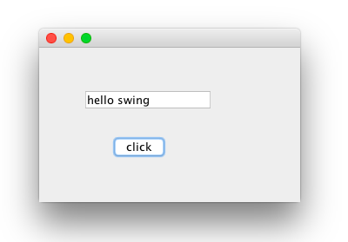

# Java 8 Stream

Java provides a new additional package in Java 8 called java.util.stream. This package consists of classes, interfaces and enum to allows functional-style operations on the elements. You can use stream by importing java.util.stream package.

Stream provides following features:

* Stream does not store elements. It simply conveys elements from a source such as a data structure, an array, or an I/O channel, through a pipeline of computational operations.
* Stream is functional in nature. Operations performed on a stream does not modify it's source. For example, filtering a Stream obtained from a collection produces a new Stream without the filtered elements, rather than removing elements from the source collection.
* Stream is lazy and evaluates code only when required.
* The elements of a stream are only visited once during the life of a stream. Like an Iterator, a new stream must be generated to revisit the same elements of the source.

You can use stream to filter, collect, print, and convert from one data structure to other etc. In the following examples, we have apply various operations with the help of stream.

## Java Stream Interface Methods

|  |  |
| --- | --- |
| **Methods** | **Description** |
| boolean allMatch(Predicate<? super T> predicate) | It returns all elements of this stream which match the provided predicate. If the stream is empty then true is returned and the predicate is not evaluated. |
| boolean anyMatch(Predicate<? super T> predicate) | It returns any element of this stream that matches the provided predicate. If the stream is empty then false is returned and the predicate is not evaluated. |
| static <T> Stream.Builder<T> builder() | It returns a builder for a Stream. |
| <R,A> R collect(Collector<? super T,A,R> collector) | It performs a mutable reduction operation on the elements of this stream using a Collector. A Collector encapsulates the functions used as arguments to collect(Supplier, BiConsumer, BiConsumer), allowing for reuse of collection strategies and composition of collect operations such as multiple-level grouping or partitioning. |
| <R> R collect(Supplier<R> supplier, BiConsumer<R,? super T> accumulator, BiConsumer<R,R> combiner) | It performs a mutable reduction operation on the elements of this stream. A mutable reduction is one in which the reduced value is a mutable result container, such as an ArrayList, and elements are incorporated by updating the state of the result rather than by replacing the result. |
| static <T> Stream<T> concat(Stream<? extends T> a, Stream<? extends T> b) | It creates a lazily concatenated stream whose elements are all the elements of the first stream followed by all the elements of the second stream. The resulting stream is ordered if both of the input streams are ordered, and parallel if either of the input streams is parallel. When the resulting stream is closed, the close handlers for both input streams are invoked. |
| long count() | It returns the count of elements in this stream. This is a special case of a reduction. |
| Stream<T> distinct() | It returns a stream consisting of the distinct elements (according to Object.equals(Object)) of this stream. |
| static <T> Stream<T> empty() | It returns an empty sequential Stream. |
| Stream<T> filter(Predicate<? super T> predicate) | It returns a stream consisting of the elements of this stream that match the given predicate. |
| Optional<T> findAny() | It returns an Optional describing some element of the stream, or an empty Optional if the stream is empty. |
| Optional<T> findFirst() | It returns an Optional describing the first element of this stream, or an empty Optional if the stream is empty. If the stream has no encounter order, then any element may be returned. |
| <R> Stream<R> flatMap(Function<? super T,? extends Stream<? extends R>> mapper) | It returns a stream consisting of the results of replacing each element of this stream with the contents of a mapped stream produced by applying the provided mapping function to each element. Each mapped stream is closed after its contents have been placed into this stream. (If a mapped stream is null an empty stream is used, instead.) |
| DoubleStream flatMapToDouble(Function<? super T,? extends DoubleStream> mapper) | It returns a DoubleStream consisting of the results of replacing each element of this stream with the contents of a mapped stream produced by applying the provided mapping function to each element. Each mapped stream is closed after its contents have placed been into this stream. (If a mapped stream is null an empty stream is used, instead.) |
| IntStream flatMapToInt(Function<? super T,? extends IntStream> mapper) | It returns an IntStream consisting of the results of replacing each element of this stream with the contents of a mapped stream produced by applying the provided mapping function to each element. Each mapped stream is closed after its contents have been placed into this stream. (If a mapped stream is null an empty stream is used, instead.) |
| LongStream flatMapToLong(Function<? super T,? extends LongStream> mapper) | It returns a LongStream consisting of the results of replacing each element of this stream with the contents of a mapped stream produced by applying the provided mapping function to each element. Each mapped stream is closed after its contents have been placed into this stream. (If a mapped stream is null an empty stream is used, instead.) |
| void forEach(Consumer<? super T> action) | It performs an action for each element of this stream. |
| void forEachOrdered(Consumer<? super T> action) | It performs an action for each element of this stream, in the encounter order of the stream if the stream has a defined encounter order. |
| static <T> Stream<T> generate(Supplier<T> s) | It returns an infinite sequential unordered stream where each element is generated by the provided Supplier. This is suitable for generating constant streams, streams of random elements, etc. |
| static <T> Stream<T> iterate(T seed,UnaryOperator<T> f) | It returns an infinite sequential ordered Stream produced by iterative application of a function f to an initial element seed, producing a Stream consisting of seed, f(seed), f(f(seed)), etc. |
| Stream<T> limit(long maxSize) | It returns a stream consisting of the elements of this stream, truncated to be no longer than maxSize in length. |
| <R> Stream<R> map(Function<? super T,? extends R> mapper) | It returns a stream consisting of the results of applying the given function to the elements of this stream. |
| DoubleStream mapToDouble(ToDoubleFunction<? super T> mapper) | It returns a DoubleStream consisting of the results of applying the given function to the elements of this stream. |
| IntStream mapToInt(ToIntFunction<? super T> mapper) | It returns an IntStream consisting of the results of applying the given function to the elements of this stream. |
| LongStream mapToLong(ToLongFunction<? super T> mapper) | It returns a LongStream consisting of the results of applying the given function to the elements of this stream. |
| Optional<T> max(Comparator<? super T> comparator) | It returns the maximum element of this stream according to the provided Comparator. This is a special case of a reduction. |
| Optional<T> min(Comparator<? super T> comparator) | It returns the minimum element of this stream according to the provided Comparator. This is a special case of a reduction. |
| boolean noneMatch(Predicate<? super T> predicate) | It returns elements of this stream match the provided predicate. If the stream is empty then true is returned and the predicate is not evaluated. |
| @SafeVarargs static <T> Stream<T> of(T... values) | It returns a sequential ordered stream whose elements are the specified values. |
| static <T> Stream<T> of(T t) | It returns a sequential Stream containing a single element. |
| Stream<T> peek(Consumer<? super T> action) | It returns a stream consisting of the elements of this stream, additionally performing the provided action on each element as elements are consumed from the resulting stream. |
| Optional<T> reduce(BinaryOperator<T> accumulator) | It performs a reduction on the elements of this stream, using an associative accumulation function, and returns an Optional describing the reduced value, if any. |
| T reduce(T identity, BinaryOperator<T> accumulator) | It performs a reduction on the elements of this stream, using the provided identity value and an associative accumulation function, and returns the reduced value. |
| <U> U reduce(U identity, BiFunction<U,? super T,U> accumulator, BinaryOperator<U> combiner) | It performs a reduction on the elements of this stream, using the provided identity, accumulation and combining functions. |
| Stream<T> skip(long n) | It returns a stream consisting of the remaining elements of this stream after discarding the first n elements of the stream. If this stream contains fewer than n elements then an empty stream will be returned. |
| Stream<T> sorted() | It returns a stream consisting of the elements of this stream, sorted according to natural order. If the elements of this stream are not Comparable, a java.lang.ClassCastException may be thrown when the terminal operation is executed. |
| Stream<T> sorted(Comparator<? super T> comparator) | It returns a stream consisting of the elements of this stream, sorted according to the provided Comparator. |
| Object[] toArray() | It returns an array containing the elements of this stream. |
| <A> A[] toArray(IntFunction<A[]> generator) | It returns an array containing the elements of this stream, using the provided generator function to allocate the returned array, as well as any additional arrays that might be required for a partitioned execution or for resizing. |

### **Java Example: Filtering Collection without using Stream**

In the following example, we are filtering data without using stream. This approach we are used before the stream package was released.

33.7M

731

Exception Handling in Java - Javatpoint

1. **import** java.util.\*;
2. **class** Product{
3. **int** id;
4. String name;
5. **float** price;
6. **public** Product(**int** id, String name, **float** price) {
7. **this**.id = id;
8. **this**.name = name;
9. **this**.price = price;
10. }
11. }
12. **public** **class** JavaStreamExample {
13. **public** **static** **void** main(String[] args) {
14. List<Product> productsList = **new** ArrayList<Product>();
15. //Adding Products
16. productsList.add(**new** Product(1,"HP Laptop",25000f));
17. productsList.add(**new** Product(2,"Dell Laptop",30000f));
18. productsList.add(**new** Product(3,"Lenevo Laptop",28000f));
19. productsList.add(**new** Product(4,"Sony Laptop",28000f));
20. productsList.add(**new** Product(5,"Apple Laptop",90000f));
21. List<Float> productPriceList = **new** ArrayList<Float>();
22. **for**(Product product: productsList){
24. // filtering data of list
25. **if**(product.price<30000){
26. productPriceList.add(product.price);    // adding price to a productPriceList
27. }
28. }
29. System.out.println(productPriceList);   // displaying data
30. }
31. }

**Output:**

[25000.0, 28000.0, 28000.0]

### **Java Stream Example: Filtering Collection by using Stream**

Here, we are filtering data by using stream. You can see that code is optimized and maintained. Stream provides fast execution.

1. **import** java.util.\*;
2. **import** java.util.stream.Collectors;
3. **class** Product{
4. **int** id;
5. String name;
6. **float** price;
7. **public** Product(**int** id, String name, **float** price) {
8. **this**.id = id;
9. **this**.name = name;
10. **this**.price = price;
11. }
12. }
13. **public** **class** JavaStreamExample {
14. **public** **static** **void** main(String[] args) {
15. List<Product> productsList = **new** ArrayList<Product>();
16. //Adding Products
17. productsList.add(**new** Product(1,"HP Laptop",25000f));
18. productsList.add(**new** Product(2,"Dell Laptop",30000f));
19. productsList.add(**new** Product(3,"Lenevo Laptop",28000f));
20. productsList.add(**new** Product(4,"Sony Laptop",28000f));
21. productsList.add(**new** Product(5,"Apple Laptop",90000f));
22. List<Float> productPriceList2 =productsList.stream()
23. .filter(p -> p.price > 30000)// filtering data
24. .map(p->p.price)        // fetching price
25. .collect(Collectors.toList()); // collecting as list
26. System.out.println(productPriceList2);
27. }
28. }

**Output:**

[90000.0]

### **Java Stream Iterating Example**

You can use stream to iterate any number of times. Stream provides predefined methods to deal with the logic you implement. In the following example, we are iterating, filtering and passed a limit to fix the iteration.

1. **import** java.util.stream.\*;
2. **public** **class** JavaStreamExample {
3. **public** **static** **void** main(String[] args){
4. Stream.iterate(1, element->element+1)
5. .filter(element->element%5==0)
6. .limit(5)
7. .forEach(System.out::println);
8. }
9. }

**Output:**

5

10

15

20

25

### **Java Stream Example: Filtering and Iterating Collection**

In the following example, we are using filter() method. Here, you can see code is optimized and very concise.

1. **import** java.util.\*;
2. **class** Product{
3. **int** id;
4. String name;
5. **float** price;
6. **public** Product(**int** id, String name, **float** price) {
7. **this**.id = id;
8. **this**.name = name;
9. **this**.price = price;
10. }
11. }
12. **public** **class** JavaStreamExample {
13. **public** **static** **void** main(String[] args) {
14. List<Product> productsList = **new** ArrayList<Product>();
15. //Adding Products
16. productsList.add(**new** Product(1,"HP Laptop",25000f));
17. productsList.add(**new** Product(2,"Dell Laptop",30000f));
18. productsList.add(**new** Product(3,"Lenevo Laptop",28000f));
19. productsList.add(**new** Product(4,"Sony Laptop",28000f));
20. productsList.add(**new** Product(5,"Apple Laptop",90000f));
21. // This is more compact approach for filtering data
22. productsList.stream()
23. .filter(product -> product.price == 30000)
24. .forEach(product -> System.out.println(product.name));
25. }
26. }

**Output:**

Dell Laptop

### **Java Stream Example : reduce() Method in Collection**

This method takes a sequence of input elements and combines them into a single summary result by repeated operation. For example, finding the sum of numbers, or accumulating elements into a list.

In the following example, we are using reduce() method, which is used to sum of all the product prices.

1. **import** java.util.\*;
2. **class** Product{
3. **int** id;
4. String name;
5. **float** price;
6. **public** Product(**int** id, String name, **float** price) {
7. **this**.id = id;
8. **this**.name = name;
9. **this**.price = price;
10. }
11. }
12. **public** **class** JavaStreamExample {
13. **public** **static** **void** main(String[] args) {
14. List<Product> productsList = **new** ArrayList<Product>();
15. //Adding Products
16. productsList.add(**new** Product(1,"HP Laptop",25000f));
17. productsList.add(**new** Product(2,"Dell Laptop",30000f));
18. productsList.add(**new** Product(3,"Lenevo Laptop",28000f));
19. productsList.add(**new** Product(4,"Sony Laptop",28000f));
20. productsList.add(**new** Product(5,"Apple Laptop",90000f));
21. // This is more compact approach for filtering data
22. Float totalPrice = productsList.stream()
23. .map(product->product.price)
24. .reduce(0.0f,(sum, price)->sum+price);   // accumulating price
25. System.out.println(totalPrice);
26. // More precise code
27. **float** totalPrice2 = productsList.stream()
28. .map(product->product.price)
29. .reduce(0.0f,Float::sum);   // accumulating price, by referring method of Float class
30. System.out.println(totalPrice2);
32. }
33. }

**Output:**

201000.0

201000.0

### **Java Stream Example: Sum by using Collectors Methods**

We can also use collectors to compute sum of numeric values. In the following example, we are using Collectors class and it?s specified methods to compute sum of all the product prices.

1. **import** java.util.\*;
2. **import** java.util.stream.Collectors;
3. **class** Product{
4. **int** id;
5. String name;
6. **float** price;
7. **public** Product(**int** id, String name, **float** price) {
8. **this**.id = id;
9. **this**.name = name;
10. **this**.price = price;
11. }
12. }
13. **public** **class** JavaStreamExample {
14. **public** **static** **void** main(String[] args) {
15. List<Product> productsList = **new** ArrayList<Product>();
16. //Adding Products
17. productsList.add(**new** Product(1,"HP Laptop",25000f));
18. productsList.add(**new** Product(2,"Dell Laptop",30000f));
19. productsList.add(**new** Product(3,"Lenevo Laptop",28000f));
20. productsList.add(**new** Product(4,"Sony Laptop",28000f));
21. productsList.add(**new** Product(5,"Apple Laptop",90000f));
22. // Using Collectors's method to sum the prices.
23. **double** totalPrice3 = productsList.stream()
24. .collect(Collectors.summingDouble(product->product.price));
25. System.out.println(totalPrice3);
27. }
28. }

**Output:**

201000.0

### **Java Stream Example: Find Max and Min Product Price**

Following example finds min and max product price by using stream. It provides convenient way to find values without using imperative approach.

1. **import** java.util.\*;
2. **class** Product{
3. **int** id;
4. String name;
5. **float** price;
6. **public** Product(**int** id, String name, **float** price) {
7. **this**.id = id;
8. **this**.name = name;
9. **this**.price = price;
10. }
11. }
12. **public** **class** JavaStreamExample {
13. **public** **static** **void** main(String[] args) {
14. List<Product> productsList = **new** ArrayList<Product>();
15. //Adding Products
16. productsList.add(**new** Product(1,"HP Laptop",25000f));
17. productsList.add(**new** Product(2,"Dell Laptop",30000f));
18. productsList.add(**new** Product(3,"Lenevo Laptop",28000f));
19. productsList.add(**new** Product(4,"Sony Laptop",28000f));
20. productsList.add(**new** Product(5,"Apple Laptop",90000f));
21. // max() method to get max Product price
22. Product productA = productsList.stream().max((product1, product2)->product1.price > product2.price ? 1: -1).get();
23. System.out.println(productA.price);
24. // min() method to get min Product price
25. Product productB = productsList.stream().min((product1, product2)->product1.price > product2.price ? 1: -1).get();
26. System.out.println(productB.price);
28. }
29. }

**Output:**

90000.0

25000.0

### **Java Stream Example: count() Method in Collection**

1. **import** java.util.\*;
2. **class** Product{
3. **int** id;
4. String name;
5. **float** price;
6. **public** Product(**int** id, String name, **float** price) {
7. **this**.id = id;
8. **this**.name = name;
9. **this**.price = price;
10. }
11. }
12. **public** **class** JavaStreamExample {
13. **public** **static** **void** main(String[] args) {
14. List<Product> productsList = **new** ArrayList<Product>();
15. //Adding Products
16. productsList.add(**new** Product(1,"HP Laptop",25000f));
17. productsList.add(**new** Product(2,"Dell Laptop",30000f));
18. productsList.add(**new** Product(3,"Lenevo Laptop",28000f));
19. productsList.add(**new** Product(4,"Sony Laptop",28000f));
20. productsList.add(**new** Product(5,"Apple Laptop",90000f));
21. // count number of products based on the filter
22. **long** count = productsList.stream()
23. .filter(product->product.price<30000)
24. .count();
25. System.out.println(count);
26. }
27. }

**Output:**

3

stream allows you to collect your result in any various forms. You can get you result as set, list or map and can perform manipulation on the elements.

### **Java Stream Example : Convert List into Set**

1. **import** java.util.\*;
2. **import** java.util.stream.Collectors;
3. **class** Product{
4. **int** id;
5. String name;
6. **float** price;
7. **public** Product(**int** id, String name, **float** price) {
8. **this**.id = id;
9. **this**.name = name;
10. **this**.price = price;
11. }
12. }
14. **public** **class** JavaStreamExample {
15. **public** **static** **void** main(String[] args) {
16. List<Product> productsList = **new** ArrayList<Product>();
18. //Adding Products
19. productsList.add(**new** Product(1,"HP Laptop",25000f));
20. productsList.add(**new** Product(2,"Dell Laptop",30000f));
21. productsList.add(**new** Product(3,"Lenevo Laptop",28000f));
22. productsList.add(**new** Product(4,"Sony Laptop",28000f));
23. productsList.add(**new** Product(5,"Apple Laptop",90000f));
25. // Converting product List into Set
26. Set<Float> productPriceList =
27. productsList.stream()
28. .filter(product->product.price < 30000)   // filter product on the base of price
29. .map(product->product.price)
30. .collect(Collectors.toSet());   // collect it as Set(remove duplicate elements)
31. System.out.println(productPriceList);
32. }
33. }

**Output:**

[25000.0, 28000.0]

### **Java Stream Example : Convert List into Map**

1. **import** java.util.\*;
2. **import** java.util.stream.Collectors;
3. **class** Product{
4. **int** id;
5. String name;
6. **float** price;
7. **public** Product(**int** id, String name, **float** price) {
8. **this**.id = id;
9. **this**.name = name;
10. **this**.price = price;
11. }
12. }
14. **public** **class** JavaStreamExample {
15. **public** **static** **void** main(String[] args) {
16. List<Product> productsList = **new** ArrayList<Product>();
18. //Adding Products
19. productsList.add(**new** Product(1,"HP Laptop",25000f));
20. productsList.add(**new** Product(2,"Dell Laptop",30000f));
21. productsList.add(**new** Product(3,"Lenevo Laptop",28000f));
22. productsList.add(**new** Product(4,"Sony Laptop",28000f));
23. productsList.add(**new** Product(5,"Apple Laptop",90000f));
25. // Converting Product List into a Map
26. Map<Integer,String> productPriceMap =
27. productsList.stream()
28. .collect(Collectors.toMap(p->p.id, p->p.name));
30. System.out.println(productPriceMap);
31. }
32. }

**Output:**

{1=HP Laptop, 2=Dell Laptop, 3=Lenevo Laptop, 4=Sony Laptop, 5=Apple Laptop}

### **Method Reference in stream**

1. **import** java.util.\*;
2. **import** java.util.stream.Collectors;
4. **class** Product{
5. **int** id;
6. String name;
7. **float** price;
9. **public** Product(**int** id, String name, **float** price) {
10. **this**.id = id;
11. **this**.name = name;
12. **this**.price = price;
13. }
15. **public** **int** getId() {
16. **return** id;
17. }
18. **public** String getName() {
19. **return** name;
20. }
21. **public** **float** getPrice() {
22. **return** price;
23. }
24. }
26. **public** **class** JavaStreamExample {
28. **public** **static** **void** main(String[] args) {
30. List<Product> productsList = **new** ArrayList<Product>();
32. //Adding Products
33. productsList.add(**new** Product(1,"HP Laptop",25000f));
34. productsList.add(**new** Product(2,"Dell Laptop",30000f));
35. productsList.add(**new** Product(3,"Lenevo Laptop",28000f));
36. productsList.add(**new** Product(4,"Sony Laptop",28000f));
37. productsList.add(**new** Product(5,"Apple Laptop",90000f));
39. List<Float> productPriceList =
40. productsList.stream()
41. .filter(p -> p.price > 30000) // filtering data
42. .map(Product::getPrice)         // fetching price by referring getPrice method
43. .collect(Collectors.toList());  // collecting as list
44. System.out.println(productPriceList);
45. }
46. }

**Output:**

[90000.0]